BELLAH MAE ANNOUNCES HEADLINE TOUR THIS OCTOBER!
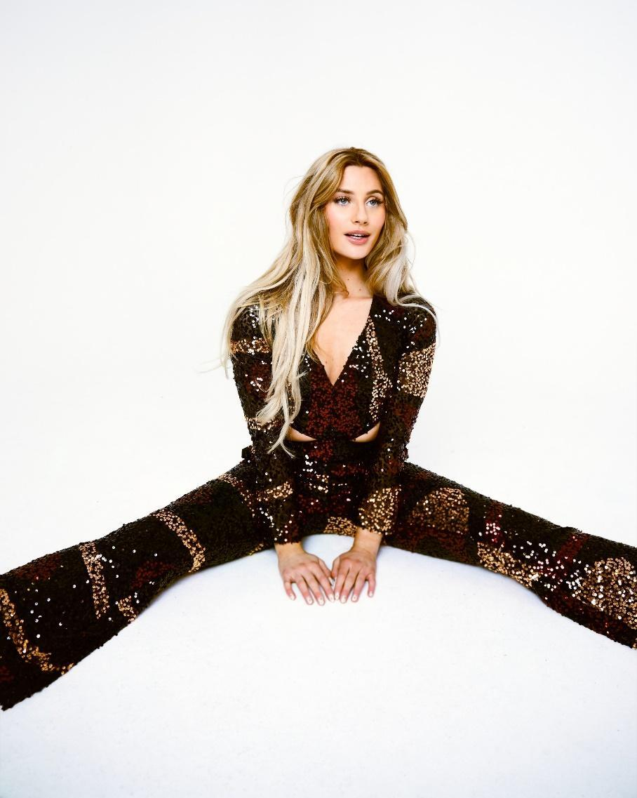
Following the release of her new single ‘On Purpose (For My Future Daughter)’ LISTEN HERE

“Recalls Taylor Swift in her country-pop prime” - The Sunday Times
“Fearlessly combines irresistible melodies with messages that pack a punch” – EUPHORIA
“Bellah Mae is the full pop-star package” – The Forty Five
“Saving Gen-Z’s broken hearted with her tales of toxic relationships” - Notion
“A new popstar just dropped” – Gigwise
“Calling to mind the nostalgic but forward-thinking sound of Olivia Rodrigo” – Wonderland
Rising singer songwriter Bellah Mae is excited to announce her debut headline tour, taking in four cities across the UK this October. She’ll be playing at Glasgow’s SWG3 Poetry Club, Manchester’s Deaf Institude, Birmingham’s O2 Institute 3 and culminating in a London show at Omeara; tickets to ‘The Hot Ex Girlfriends Club Tour’ go on general sale this Wednesday HERE.
Having recently played at British Summer Time in Hyde Park, The Great Escape festival and a sold-out headline date at The Grace in London, you can also catch Bellah live this summer at Camp Bestival, Splendour, Brighton Pride and on the BBC Introducing stage at Reading and Leeds festivals.
Last Friday, Bellah shared a slice of poignant pop in the form of new single ‘On Purpose (For My Future Daughter)’, out now on EMI Records. Revealing a more vulnerable version of herself in comparison to previously upbeat, tongue-in-cheek singles ‘Drama King’, ‘Boyfriend Of The Year’ and ‘Date Your Dad’ which have all racked up 14.6 million collective streams worldwide, Bellah’s new single centres on being intentionally hurt by someone you love and trust. Listen HERE.
Her vision was to pen a cathartic ‘heartbreak anthem’ for people to sing together; so much so that she invited a small group of fans into the studio to sing backing vocals on the record; watch the video HERE. A teaser of the track posted to TikTok in early June captured the hearts and ears of followers, garnering over fifteen million views ahead of release. This snippet has built so much anticipation for the track and perfectly demonstrates the power of Bellah’s instant relatability, with lyrics that resonate with listeners across the country.
Bellah says, “The only thing worse than being hurt by somebody you love, is when they knew what they were doing and did it on purpose. I want people to hear this song and know that I feel what they feel as do so many others, and for them to know they’re going to be ok. Sometimes it’s hard to prioritise what’s best for yourself when you’ve been in an unhealthy environment, so I try to imagine what would be best for little me or for my future daughter. She deserves love and happiness, and this song reminds me to put myself first for her.”
Adopting the storytelling specificities of country music and pairing it with humongous hooks to killer effect, Bellah Mae is quickly making a name for herself within the pop sphere. A true pop storyteller, recent track ‘Drama King’ proudly holds up a middle finger to toxic relationships and melodramatic partners, while debut single ‘Boyfriend Of The Year’ which has picked up over 10 million streams talks about watching a toxic ex-boyfriend treat their new partner with the respect they never showed you. Bellah’s distinctive writing style incorporates her influences ranging from Dolly Parton to Avril Lavigne and Miley Cyrus. Because of this, her early sound swayed more towards country music, which caught the attention of Dolly Parton’s manager Danny Nozell who has acted as a mentor for Bellah, inviting her to perform in a concert series in the UK and in Nashville.
Despite this early affinity for country, in the tradition of other Gen Z artists her music defies categorisation, incorporating ever expanding sonic touchstones to create something that feels wholly unique. With fierce ambitions, heaps of charm and an arsenal of upcoming bangers, Bellah Mae is a big one to watch for 2023!
FESTIVAL DATES:
22nd July // SPLENDOUR FESTIVAL – Wollaton Hall, Gardens and Deer Park, Nottingham, UK
30th July // CAMP BESTIVAL - Dorset, UK
5th August // FABULOSO FESTIVAL - BRIGHTION PRIDE 2023 - Brighton, UK
26th August // BBC INTRODUCING STAGE - Reading Festival – Richfield Avenue, Reading, UK
27th August // BBC INTRODUCING STAGE – Leeds Festival – Bramham Park, Leeds, UK
HEADLINE TOUR DATES
16th October // SWG3 Poetry Club – Glasgow
17th October // Deaf Institute, The Lodge - Manchester
18th October // O2 Institute 3 - Birmingham
23rd October // Omeara - London

Don’t miss a thing: TikTok // Instagram // YouTube

For more information please contact
Warren Higgins warren@chuffmedia.com

