

ROYEL OTIS NEW ALBUM hickey OUT NOW
LISTEN HERE

‘who’s your boyfriend’ MUSIC VIDEO STARRING LOLA TUNG
WATCH HERE

UK TOUR DATES ANNOUNCED INCLUDING BRIXTON ACADEMY


Royel Otis by Zora Sicher | Download HERE

“A sun-kissed exploration of young adulthood,‘Hickey’ is Royel Otis at their most self-assured…back-to-back summer anthems, guaranteed to bring a feel-good vibe to any occasion”
**** NME

Today, Australian duo Royel Otis share their new album hickey, out now on OURNESS/Capitol/Island Records, alongside confirming UK dates of their massive ‘meet me in the car’ tour in support of their sophomore record.

With 13 songs that traverse the highs and lows of messy young love, the sophomore set’s sound swings between blissful and wistful, blending together slack indie rock, jangly new wave, and swooning dream-pop. The LP comes with a music video for ‘who's your boyfriend’ directed by Lauren Dunn and featuring Lola Tung, the star of the hit Amazon Prime series The Summer I Turned Pretty. Watch the video HERE.

Cowritten by Royel Otis (Royel Maddell and Otis Pavlovic) with Amy Allen (Sabrina Carpenter,
Harry Styles) and producer Blake Slatkin (Gracie Abrams, Omar Apollo), ‘who's your boyfriend’
is a romantic new wave dream featuring soaring synth melodies, tumbling drums, and driving guitars.
The track finds Royel Otis caught in a friendship with someone who seems to want it both ways,
building to the sing-along hook, “He bailed on your birthday, and you’re calling me up a lot / So, baby,
who’s your boyfriend now? While you’re sleeping with him, is it me you’re thinking about?”

Bringing it full circle, Royel Otis’ viral cover of the Cranberries 1993 hit ‘Linger’ made it into a
recent episode of The Summer I Turned Pretty — watch a clip from the show HERE.

hickey arrives as the effortlessly infectious lead single ‘moody’ notches a seventh week atop the
Billboard Adult Alternative Airplay chart, which made Royel Otis the first new act this year to nab
a Triple A crown. The band also recently performed ‘say something’ on The Tonight Show
Starring Jimmy Fallon amid a winning run of festival appearances in the U.S. and abroad including
Glastonbury, Outside Lands, Lollapalooza, and Japan’s Fuji Rock. They hit Reading and Leeds this weekend before launching their ‘meet me in the car’ tour, spanning the U.S., Australia, and Europe. UK dates for the tour are announced today, including shows in London, Glasgow and Manchester. See full itinerary below.

About their new album, hickey, Royel Otis had this to share: “Love bites harder than any other
emotion in the world.”

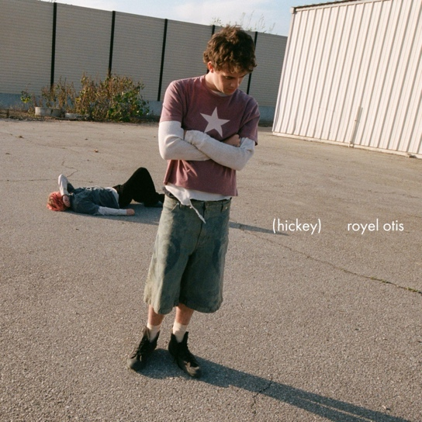

Royel Otis - hickey Tracklist

1. “i hate this tune”
2. “moody”
3. “good times”
4. “torn jeans”
5. “come on home”
6. “who's your boyfriend”
7. “car”
8. “shut up”
9. “dancing with myself”
10. “say something”
11. “she's got a gun”
12. “more to lose”
13. “jazz burger”

hickey opens on ‘i hate this tune’, an ironically catchy song that features Otis’ voice coasting over
racing rhythms: “You know I hate this tune ’cause I think of you / Fell in love with this place I could
never replace / You know I hate this tune ’cause I think of you, I do.” The album also includes the
previously released ‘car’ (which launched as a BBC Radio 1 ‘Hottest Record’) co-written with
producer Omer Fedi (Lil Nas X, The Kid LAROI). Royel Otis brought their vision to life with additional
input from Julian Bunetta, Billy Walsh, J Lloyd, and Lydia Kitto, among others.

2025 UK Live shows & festivals:

See HERE for full details & tickets.

Aug 23 Reading, UK @ Reading Festival
Aug 24 Leeds, UK @ Leeds Festival
Nov 21 London, UK @ O2 Academy Brixton
Nov 25 Glasgow, UK @ O2 Academy Glasgow
Nov 28 Manchester, UK @ O2 Victoria Warehouse

THIS IS WHERE YOU CAN FIND ROYEL OTIS ONLINE:
INSTAGRAM | TIKTOK | SPOTIFY | YOUTUBE | X

For more information and press enquiries for ROYEL OTIS please contact

Jenny Entwistle
Jenny@chuffmedia.com

