

ANNOUNCES UK & EU TOUR IN NOVEMBER

AHEAD OF NEW ALBUM
‘SELF TITLED’
OUT 04.07.25

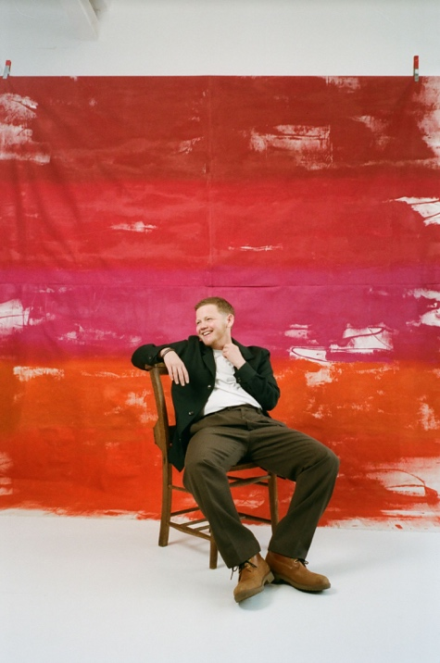

Kae Tempest today announces a UK & EU tour that will include a night at the O2 Academy Brixton on November 8th. The tour follows the release of Kae’s fifth studio album, ‘Self Titled’, set for release July 4 via Island Records.
UK TOUR DATES
NOVEMBER
8th - London, O2 Academy Brixton
9^{th.} -Bristol, O2 Academy
10th - Manchester, Albert Hall
12th - Edinburgh, Corn Exchange

Support on the tour comes from Island Records label mate Jacob Alon

The 12-track album is Kae’s most intimate and revealing project to date. Working with the Grammy-winning producer behind Adele and Stormzy for the first time on an album, sparked a union that saw a flood of new ideas and unexpected directions. Fraser encouraged Kae to be both an active participant in production and guided him to write in the first person, to tell his own story. The result is a body of work that sees Kae reconnect with his Hip Hop roots while paying a gentle homage to contemporary pop — an exhilarating album from start to finish.

At its core, ‘Self Titled’ is a love letter to Tempest’s younger self — a conversation across time, shaped by the people, places, and experiences that define him. Guest appearances include Neil Tennant, Young Fathers, Connie Constance, and Tawiah. The album is both a bold new chapter and a deep reflection, positioning Kae Tempest at the forefront of contemporary music and storytelling.

Kae Tempest has released four critically acclaimed studio albums, as well as numerous books, plays and poetry collections, including Brand New Ancients, which saw him become the first person under 40 to receive the Ted Hughes Award in 2013. For his music, Kae won the Ivor Novello Award for Best Contemporary Song in 2024, following two previous Ivor Novello nominations in 2020 and a BRIT Award nomination in 2018. He has been shortlisted for the Mercury Prize twice (For Let Them Eat Chaos in 2017 and Everybody Down in 2014). In 2023 Kae was the subject of a BBC Arena documentary ‘Being Kae Tempest’, a captivating insight into his musical and creative journey throughout a period of profound artistic and personal change. With this impressive list of accolades, it’s clear that Kae Tempest has firmly established himself as one of the most unique, thought-provoking, and critically acclaimed voices of his generation."

FULL UK & EU TOUR DATES HERE

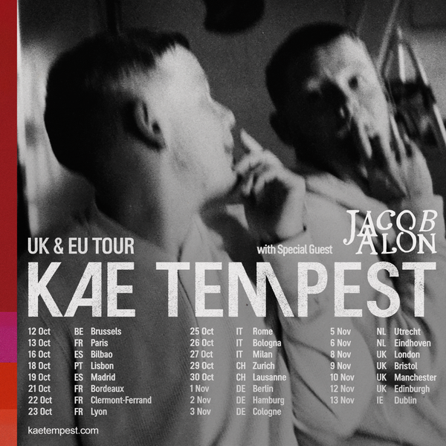

For more information please contact
Warren Higgins warren@chuffmedia.com

