REVEREND & THE MAKERS
ANNOUNCE MAJOR UK TOUR IN NOVEMBER 2024

Download press photo HERE (credit: Steve Schofield)

Reverend & The Makers have announced details of a major UK tour in November 2024. The Sheffield five-piece, fronted by Jon McClure, will embark on a nationwide run of 15 shows, opening in Lincoln on November 8th and concluding at Manchester Academy on November 28th, with a London show at the Electric Ballroom on the 20th.

Speaking about the tour announcement, lead singer Jon McClure says “I’m made up to be going on tour again - it’s been too long since we last played any shows. Having toured Heatwave In The Cold North a couple of months before its release I’m looking forward to playing more songs from that album and maybe testing out a few from the next one.”

The tour is Reverend & The Makers’ first full band tour since February 2023. It follows their seventh studio album ‘Heatwave In The Cold North’, which debuted at No. 6 in the Official Charts in May last year, giving the band their first Top 10 album since their debut album The State of Things, which reached No.5 in 2007, and their biggest single in over a decade. With an unbroken run of seven Top 20 albums to date, the band are currently in the studio working on new music, details of which will be unveiled soon.

Tickets for the tour will go on sale on Friday June 14th at 10am HERE

The tour dates are:
Fri 8 Nov - Lincoln, The Drill
Sat 9 Nov - Holmfirth, Picturedrome
Mon 11 Nov - Liverpool, O2 Academy Liverpool
Tue 12 Nov - Glasgow, SWG3 (TV Studio)
Thu 14 Nov - Wolverhampton, Wulfrun Hall
Fri 15 Nov - Shiiine On Weekender, Minehead
Sat 16 Nov – Newcastle, Newcastle University SU
Tue 19 Nov - Northampton, Roadmender
Thu 20 Nov - London, Electric Ballroom
Fri 22 Nov - Leeds, Stylus
Fri 23 Nov - Bristol, O2 Academy Bristol
Mon 25 Nov - Brighton, Concorde 2
Wed 27 Nov - Nottingham, Rock City
Thurs 28 Nov - Manchester, Manchester Academy

Reverend & The Makers are: Jon McClure (lead singer), Ed Cosens (guitar), Laura McClure (keys/vocals), Antonia Pooles (bass), Ryan Jenkinson (drums)

Connect with Reverend & The Makers

FB Twitter Instagram Tik Tok

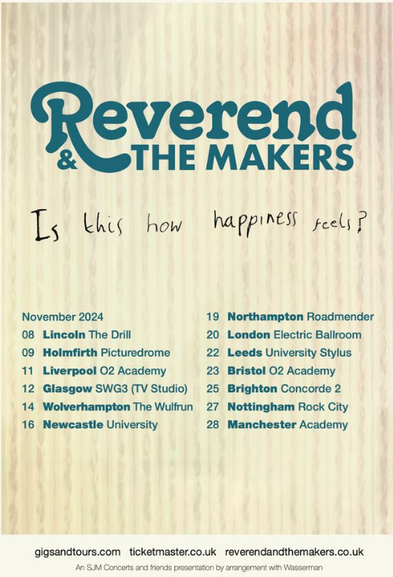

For more on info contact warren@chuffmedia.com

