**The Last Dinner Party Announce 35-Date Headline Tour Across UK, Europe and Australia**

**The Run Kicks Off At Dublin’s 3Arena on 14th November and Wraps In Oslo On 6th March 2026**

**New Album “*From The Pyre*” Released 17th October 2025**

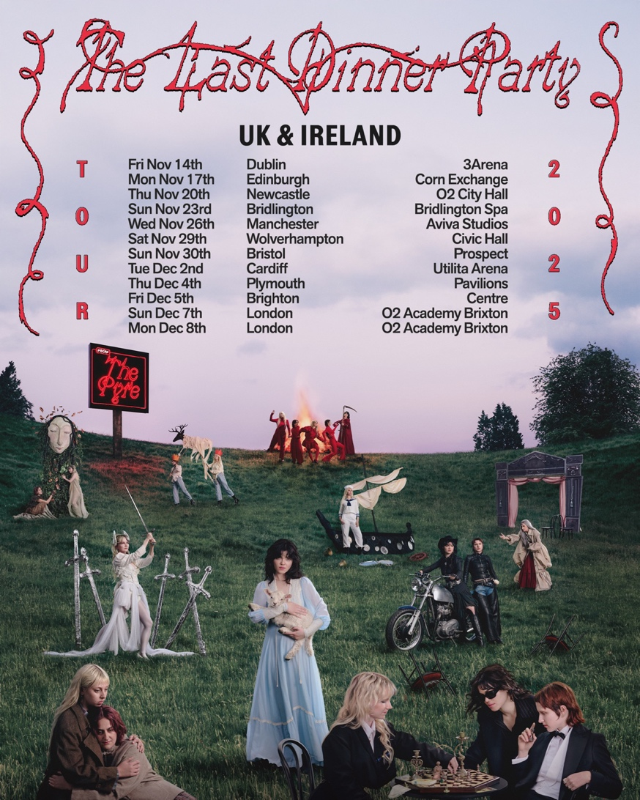

The Last Dinner Party are pleased to announce details of a huge headline tour that spans from the Autumn through to next Spring.

The 35-date run kicks off with a UK/Ireland run which starts at Dublin’s 3Arena on 14th November and concludes with two nights at O2 Academy Brixton in London on 7th and 8th December. The band then heads to Australia in January and across Europe in February, concluding at Sentrum Scene in Oslo on 6thMarch.

Tickets for the tour go on general sale from 10am local time on Friday 12th September. Fans who pre-order the album from the official store [here](https://tldp.lnk.to/officialstore), will be offered access to tour pre-sale.

**The Last Dinner Party release their second album, *From The Pyre*, on 17th October 2025 via Island EMI. It was announced alongside the release of the album’s lead single, “*This Is The Killer Speaking*”. Watch the video**[**HERE**](https://tldp.lnk.to/thisisthekillerspeaking/youtube)

The London five-piece headed into the studio early 2025 with Grammy Award winning producer Markus Dravs (Wolf Alice, Florence & The Machine, Bjork) to start work on the follow-up to their number 1 debut album, 2023’s *Prelude to Ecstasy. From The Pyre* is the sound of a band having a lot of fun rather than feeling any innate pressure to follow-up on what was an explosively successful debut record. It’s also the sound of a young band developing and maturing their songwriting together, as tight a unit as the endless months out on the road pay testament to.

The Last Dinner Party on *From The Pyre:*

*“This record is a collection of stories, and the concept of album-as-mythos binds them. ‘The Pyre’ itself is an allegorical place in which these tales originate, a place of violence and destruction but also regeneration, passion and light.*

*“The songs are character driven but still deeply personal, a commonplace life event pushed to pathological extreme. Being ghosted becomes a Western dance with a killer, and heartbreak laughs into the face of the apocalypse. Lyrics invoke rifles, scythes, sailors, saints, cowboys, floods, Mother Earth, Joan of Arc, and blazing infernos. We found this kind of evocative imagery to be the most honest and truthful way to discuss the way our experiences felt, giving each the emotional weight it deserves.”*

*“This record feels a little darker, more raw and more earthy; it takes place looking out at a sublime landscape rather than seated an opulent table. It also feels metatextual and cheeky in places, like a knowing look reflected back at ourselves.”*

With two BRIT Awards to their name (including Breakthrough Artist earlier this year), and having sold out virtually every show they played right across the globe (including three sold-out hometown shows at London’s Eventim Apollo), The Last Dinner Party’s arrival and subsequent worldwide success was one of the most thrilling introductions to a new British band in decades, and *From The Pyre*’s opening introduction suggests that unparalleled success story shows no signs of relenting.

[**Pre-order *From The Pyre* here.**](https://tldp.lnk.to/fromthepyre)

**Outstore Live Dates:**

15th October – Pryzm, Kingston (w/ Banquet Records) *Matinee* - SOLD OUT

15th October - Pryzm, Kingston (w/ Banquet Records) *Evening* - SOLD OUT

17th October – The Level, Nottingham (w/ Rough Trade) *Matinee* - SOLD OUT

17th October - The Level, Nottingham (w/ Rough Trade) *Evening* - SOLD OUT

19th October – 1865, Southampton (w/ Vinilo Records) – SOLD OUT

20th October – HMV Empire, Coventry (w/ HMV) – SOLD OUT

22nd October – Live House, Dundee (w/ Assai) – SOLD OUT

23rd October – The Dome, Liverpool (w/ Rough Trade) – SOLD OUT

**UK Headline Tour:**

14th November – 3Arena, Dublin

17th November – Corn Exchange, Edinburgh

20th November – O2 City Hall, Newcastle

23rd November – Bridlington Spa, Bridlington

26th November – Aviva Studios, Manchester

29th November – The Civic Hall, Wolverhampton

30th November – The Prospect Building, Bristol

2nd December – Utilita Arena, Cardiff

4th December – Plymouth Pavilions, Plymouth

5th December – Brighton Centre, Brighton

7th December – O2 Academy Brixton, London

8th December – O2 Academy Brixton, London

**2026**

10th January – Red Hill Auditorium, Perth

13th January – AEC Theatre, Adelaide

15th January – Sidney Myer Music Bowl, Melbourne

17th January – ICC Sydney Theatre, Sydney

19th January – Riverstage, Brisbane

22nd January – Spark Arena, Auckland

8th February – Colisieu dos Recreios, Lisbon

10th February – Sala La Riviera, Madrid

11th February – Razzmatazz, Barcelona

13th February – Fabrique, Milan

14th February – The Hall, Zurich

16th February – Zenith, Munich

17th February – Forum Karlín, Prague

19th February – Gasometer, Vienna

20th February – COS Torwar, Warsaw

22nd February – UFO im Velodrom, Berlin

23rd February – Palladium, Cologne

25th February – Le Zénith, Paris

27th February – Forest National, Brussels

1st March – AFAS Live, Amsterdam

3rd March – Vega, Copenhagen

4th March – Fållan, Stockholm

6th March – Sentrum Scene, Oslo

For more information contact [Warren@chuffmedia.com](mailto:Warren@chuffmedia.com)