NORAH JONES ANNOUNCES AUTUMN UK TOUR

9-TIME GRAMMY AWARD WINNER ADDS UK SHOWS TO HER 2023
PERFORMANCE SCHEDULE WHICH ALSO INCLUDES A SUMMER EUROPEAN TOUR

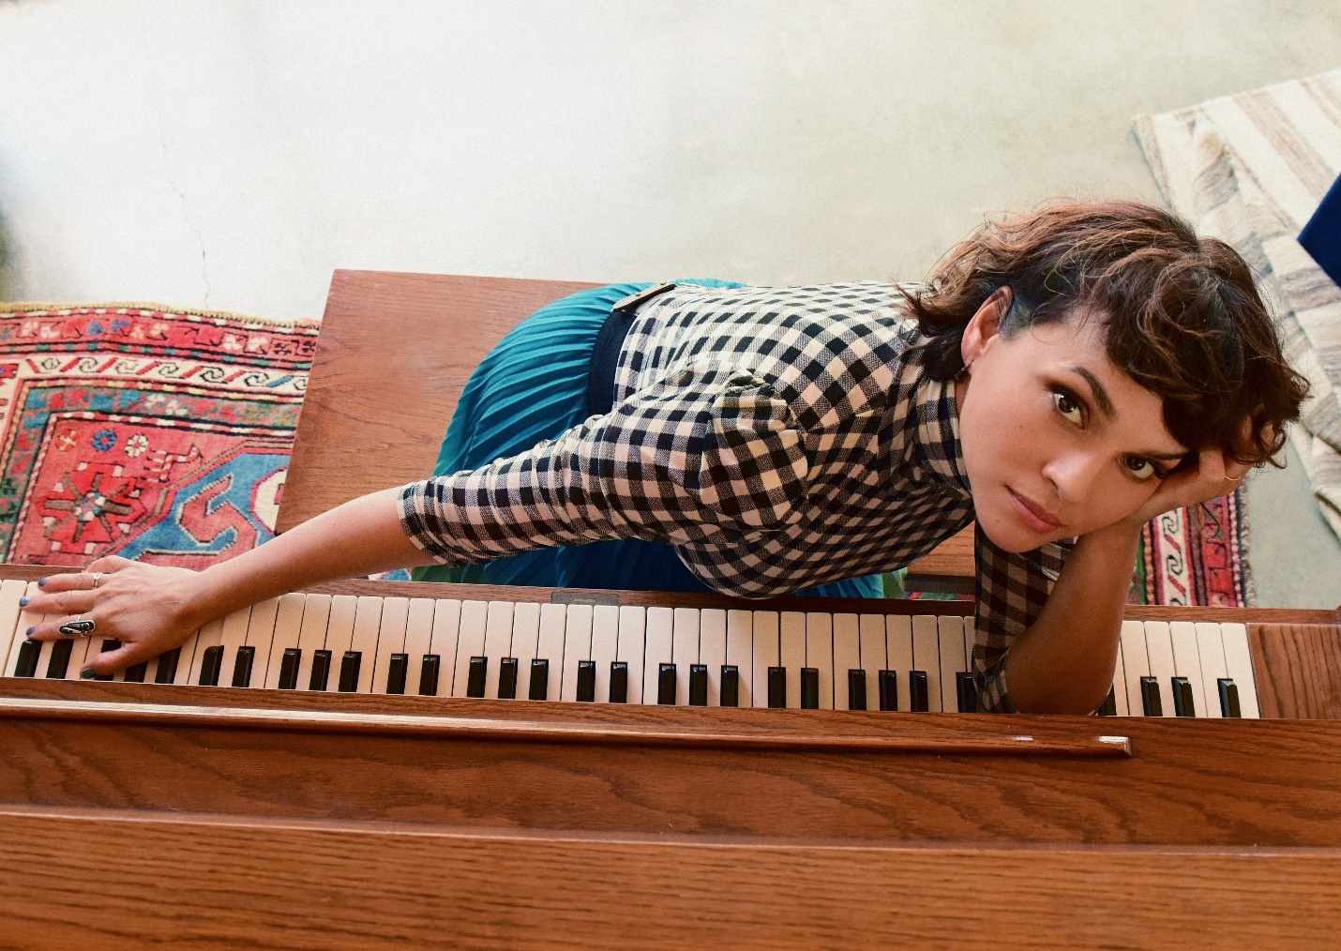

Norah Jones returns to European concert stages this year for her first tour dates on the continent since 2018. In addition to her already announced summer tour which will bring the 9-time GRAMMY-winning singer, songwriter, and pianist to France, Belgium, Italy, Croatia, Hungary, Austria, Spain, and Portugal in July, she has just announced a UK tour this November which includes performances in London, Manchester, Birmingham, and Glasgow, as well as Belfast and Dublin. Ticket pre-sales begin on Wednesday with a public on-sale Friday, March 24 at 10am GMT. Visit www.norahjones.com for more details.

NORAH JONES – 2023 TOUR DATES:
Nov. 4 – Sage – Gateshead, UK
Nov. 6 – Symphony Hall – Birmingham, UK
Nov. 7 – The Bridgewater Hall – Manchester, UK
Nov. 8 – Royal Concert Hall – Glasgow, UK
Nov. 10 – Forum – Bath, UK
Nov. 11 – Palladium – London, UK
Nov. 13 – Waterfront Hall – Belfast, UK
Nov. 14 – 3Olympia – Dublin, Ireland

* * *

Norah Jones first emerged on the world stage with the February 2002 release of Come Away With Me, her self-described “moody little record” that introduced a singular new voice and grew into a global phenomenon, sweeping the 2003 GRAMMY Awards. Since then, Jones has become a nine-time GRAMMY-winner, sold more than 50 million albums, and her songs have been streamed six billion times worldwide. She has released a series of critically acclaimed and commercially successful solo albums—Feels Like Home (2004), Not Too Late (2007), The Fall (2009), Little Broken Hearts (2012), Day Breaks (2016), Pick Me Up Off The Floor (2020), the live album ‘Til We Meet Again (2021), and her holiday album I Dream Of Christmas (2021)—as well as albums with her collective bands The Little Willies, El Madmo, and Puss N Boots featuring Sasha Dobson and Catherine Popper. The 2010 compilation …Featuring Norah Jones showcased her incredible versatility by collecting her collaborations with artists as diverse as Willie Nelson, Foo Fighters, Outkast, and Herbie Hancock. In 2018, Jones began releasing a series of singles including collaborations with artists and friends such as Mavis Staples, Jeff Tweedy, Thomas Bartlett, Tarriona Tank Ball, Rodrigo Amarante, and Brian Blade, some of which were compiled on the 2019 singles collection Begin Again. In 2022, Jones launched her podcast Norah Jones Is Playing Along which features candid conversations and impromptu musical collaborations with some her favorite musicians.

Follow Norah Jones:
Website • Facebook • Twitter • Instagram • YouTube
FOR MORE INFORMATION CONTACT WARREN@CHUFFMEDIA.COM

