YUNGBLUD
ANNOUNCES ADDITIONAL
UK SHOW ON 2026 ARENA TOUR
WILL PLAY NEWCASTLE’S
UTILITA ARENA ON APRIL 21, 2026

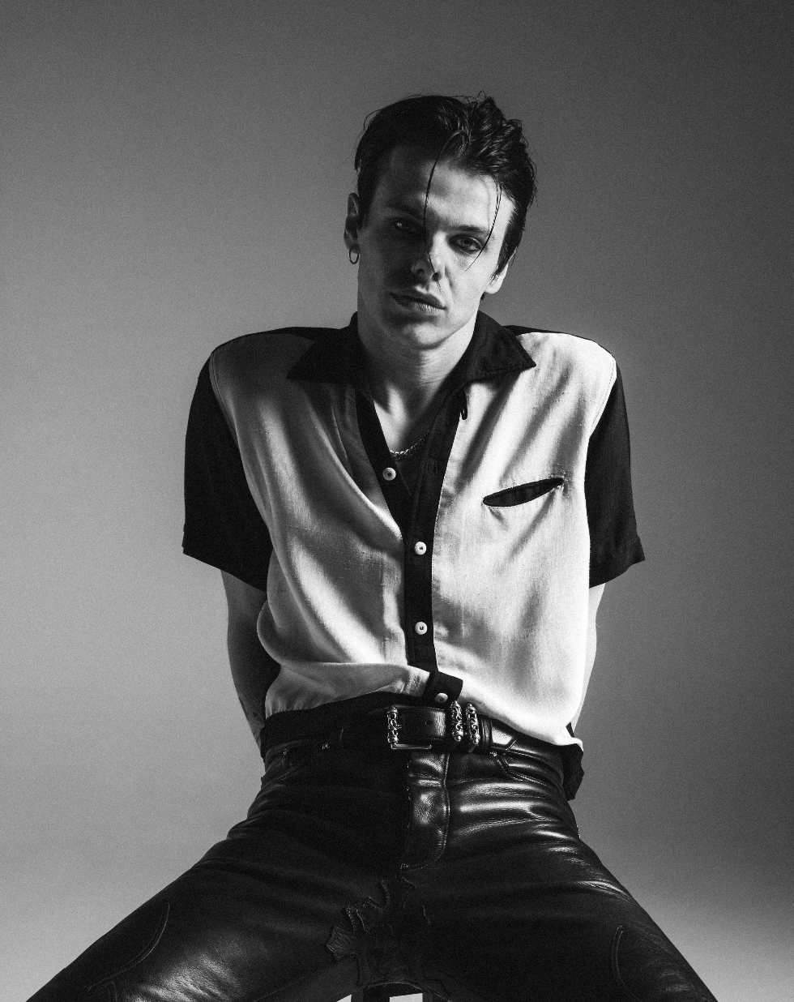
1
DOWNLOAD ASSETS HERE (PC: TOM PALLANT)

[Monday July 21, 2025] The 27 year old British artist, Yungblud, has announced an extra date for his UK tour next year due to huge demand. The creative force behind three consecutive UK Number 1 albums has announced a headline show at Newcastle’s Utilita Arena on April 21, as part of his ‘Idols UK & Ireland Tour’.
The general sale will begin at 10am BST on Friday, 25th July 2025.
The arena run, set to feature his biggest ever indoor UK headline shows, was announced in June and includes a night at London’s O2 Arena. Tickets to the tour are said to be selling fast, with the show at Utilita Arena, Cardiff already sold out.
Yungblud recently released his fourth studio album, ‘Idols’, topping the charts in the UK and receiving high praise:
“A record that spans big, soaring melodies, angsty pop-rock ballads and even the gutsy theatrics of Queen.” - The Telegraph

“A newfound maturity in songwriting and production [for Yungblud]” - The Independent on ‘Hello Heaven, Hello’

“It’s YUNGBLUD like you’ve never heard him before.” - Kerrang!

The run of shows will be Yungblud’s first full scale UK concerts since the triumphant return of this year’s BLUDFEST at Milton Keynes’ National Bowl. The day festival, curated entirely by artist, saw a guest appearance from Billy Idol, who joined the headliner onstage for a rendition of ‘White Wedding’.
Speaking about Yungblud’s headline set, Clash Magazine observed, “[Yungblud] absolutely owns the stage and runway, covering every inch as he tears through ‘Hello Heaven Hello’ and ‘Lovesick Lullaby’... Confetti cannons and flames match the celebratory air of the day and even live debuts of ‘Change’ and ‘The Greatest Parade’ go down like classics already.”
Earlier this month, Yungblud joined a supergroup onstage at Black Sabbath’s farewell concert, Back to the Beginning. He delivered a stunning performance on the 1972 track, ‘Changes’. The version has since been released as a single, raising money for three charities: Acorns Children’s Hospice, Cure Parkinson’s, and Birmingham Children’s Hospital.

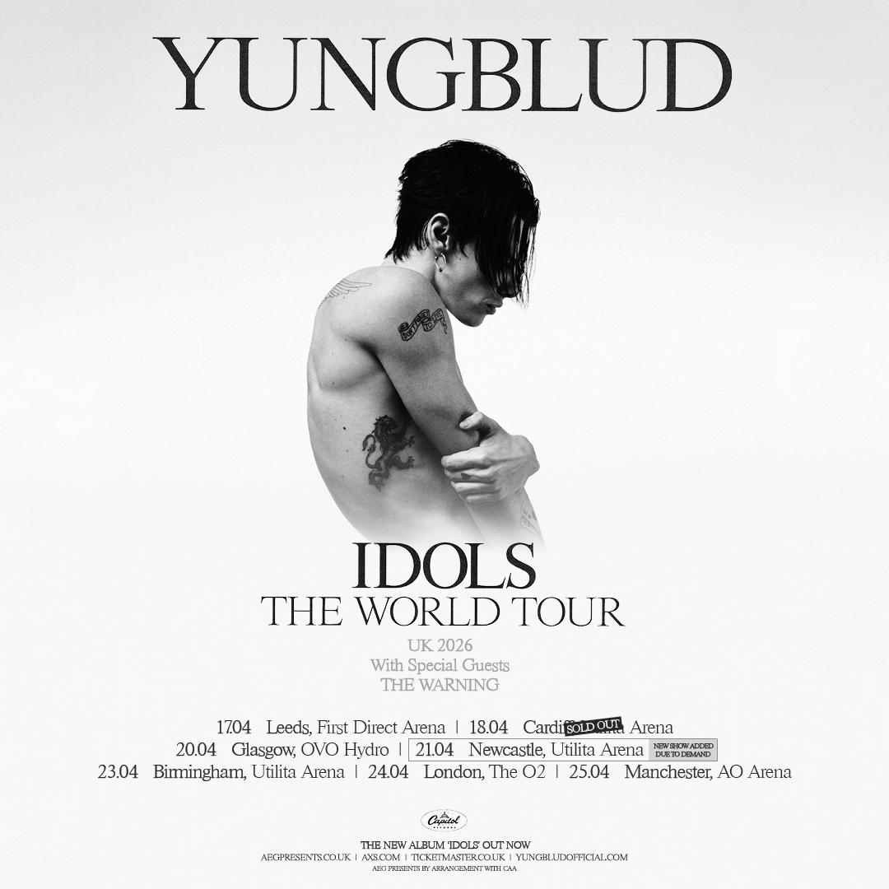

Support for the Idols UK & Ireland Tour comes from Mexico via Monterrey's The Warning.

The Idols UK &+ Ireland Tour dates are as follows:

15.04.26 Dublin, 3Arena
17.04.26 Leeds, First Direct Arena
18.04.26 Cardiff, Utilita Arena
20.04.26 Glasgow, OVO Hydro
21.04.26 Newcastle, Utilita Arena
23.04.26 Birmingham, Utilita Arena
24.04.26 London, The O2
25.04.26 Manchester, AO Arena

You can buy tickets to see Yungblud at Newcastle’s Utilita Arena here.
About Yungblud:
Yungblud is fast becoming one of the key musical voices of his generation, blending influences from Rock, Punk and Pop to monumental effect. His arena-filling performances around the world have cemented his place as one Britain’s most electrifying musical exports. He has received several accolades, including the MTV EMA for Best Alternative (2021) and the O2 Silver Clef Award for Best Live Act (2022). Known for his electrifying stage presence and boundary-pushing lyrics, Yungblud continues to challenge conventions while inspiring fans worldwide with messages of authenticity and acceptance. This year, Yungblud debuted his own curated festival Bludfest and released his first book, the instant No1 Sunday Times Best Seller, ‘You Need to Exist: A Book to Love and Destroy’ on Penguin Books.
www.yungbludofficial.com

Follow YUNGBLUD:
Instagram/ TikTok/ X / Youtube/ Facebook

For more information and press enquiries please contact

Jenny Entwistle
Jenny@chuffmedia.com

