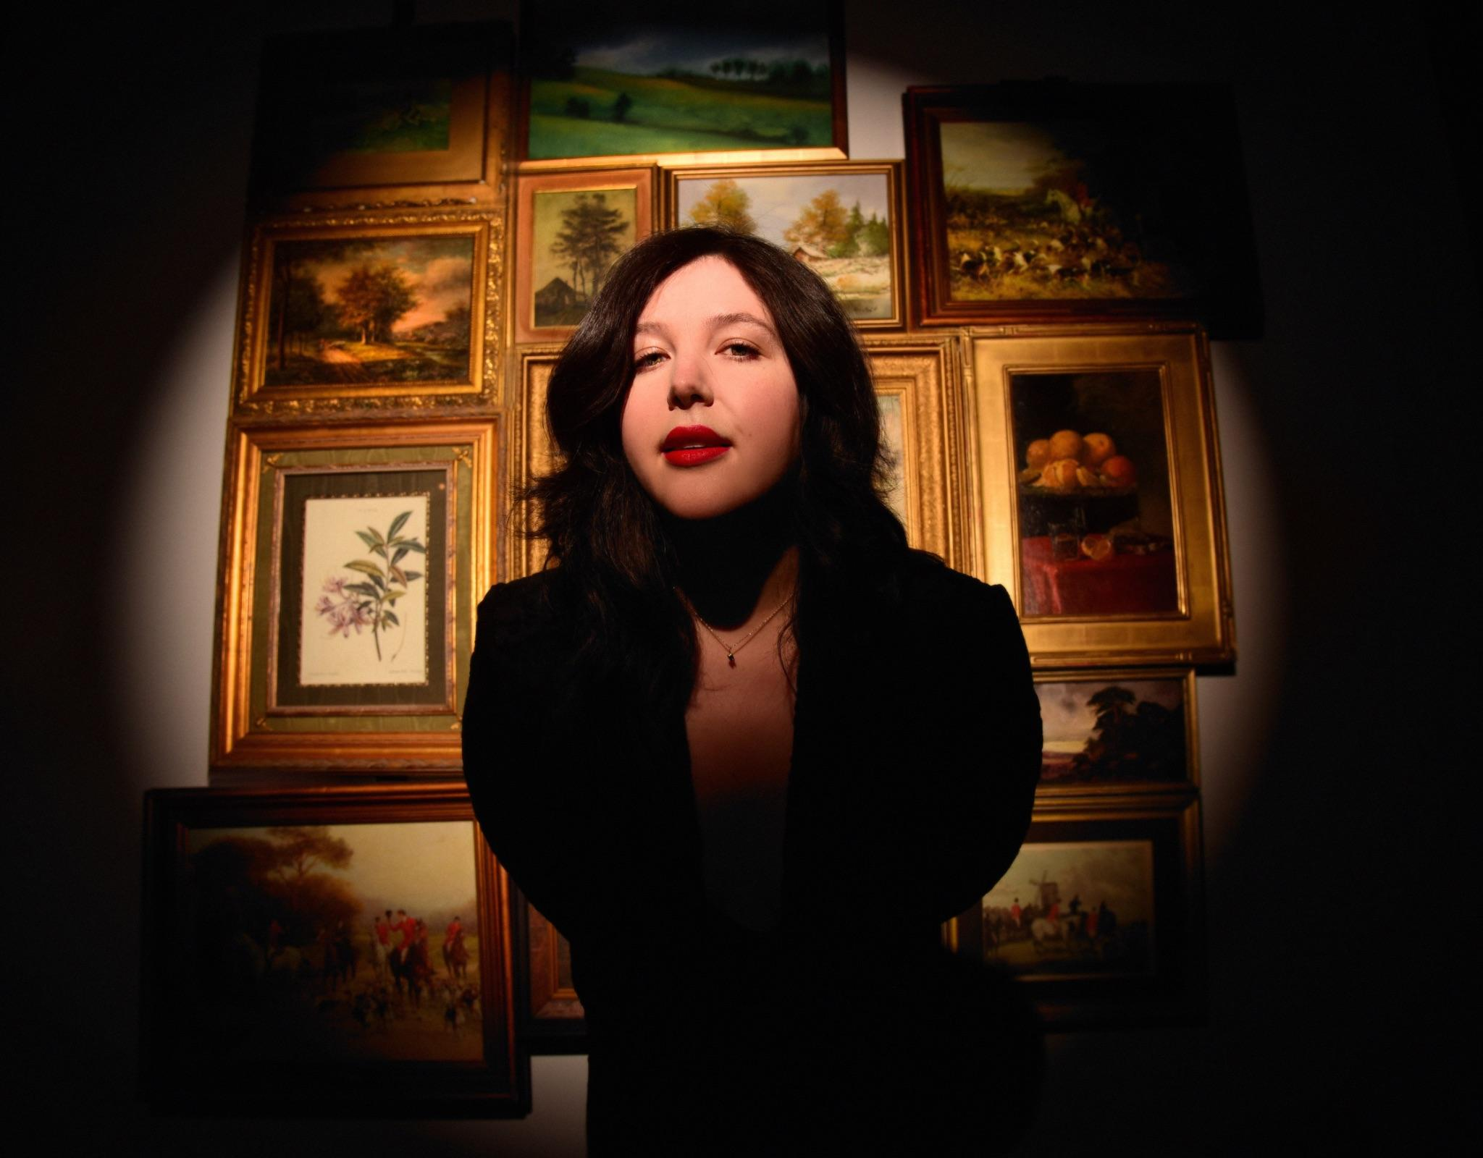

**Lucy Dacus announces intimate UK/EU shows, *An Evening With Lucy Dacus***

**Two new songs - ‘Ankles’ / ‘Limerence’ - out now**

**New album, *Forever Is A Feeling*, released March 28th**

**Watch The Music Video For ‘Ankles’** [**HERE**](https://lucydacus.lnk.to/anklesvideo)

**Listen to ‘Limerence’** [**HERE**](https://lucydacus.lnk.to/ankles)

**Photos/Packshot** [**HERE**](https://umusic.box.com/s/kq5c29nl7o7064yusbti5ejv2zhps536)

**Pre-order *Forever Is A Feeling*** [**HERE**](https://lucydacus.lnk.to/ForeverIsAFeeling_UK)

**Sign up For Live Tickets** [**HERE**](https://www.lucydac.us)

Lucy Dacus has today announced new UK/EU shows as part of her intimate tour of museums and special places. *An Evening With Lucy Dacus* kicks off in New York in February, with all US dates selling out immediately and performances now added in Paris, Amsterdam, Berlin and London in March. Tickets will be available for purchase on a lottery request system, open now on [https://www.lucydac.us](https://www.lucydac.us/%23/) and closing on February 3rd at 3PM GMT.

*An Evening With Lucy Dacus* will be an exclusive chance to preview her much-anticipated new album, *Forever Is A Feeling*. Lucy recently shared two new songs from the project; the single ‘Ankles’ - alongside a video shot in Paris, centring on a painting that’s come to life - and ‘Limerence’. The album’s cover art is a Renaissance-style portrait of Dacus by acclaimed visual artist Will St. John, with Lucy Dacus’ upcoming shows providing the perfect cultural settings to the world of this record.

Set for release on March 28th, *Forever Is A Feeling* will feature contributions including Hozier, Phoebe Bridgers, Julien Baker, Blake Mills, Bartees Strange, Madison Cunningham, Colin Pastore, Jake Finch and Melina Duterte. This marks Lucy Dacus’ first new music since boygenius were awarded three GRAMMYs and a BRIT Award for their debut album, *the record,* in 2024.

Lucy Dacus made a return to the stage this month with a performance on The Tonight Show Starring Jimmy Fallon, debuting ‘Ankles’ in custom Rodarte and accompanied by a string section. Following her intimate shows in February and March, the *Forever Is A Feeling Tour* begins in Philadelphia on April 16th, with more dates already added due to demand: support comes from special guest Katie Gavin (of Muna) and jasmine.4.t. Lucy Dacus has partnered with PLUS1 so that $1 per ticket goes to providing critical relief and long-term recovery support for individuals, families, and communities impacted by the devastating LA wildfires via the [**PLUS1 LA Fires Fund**](https://plus1-la-fires-fund.raiselysite.com/).

**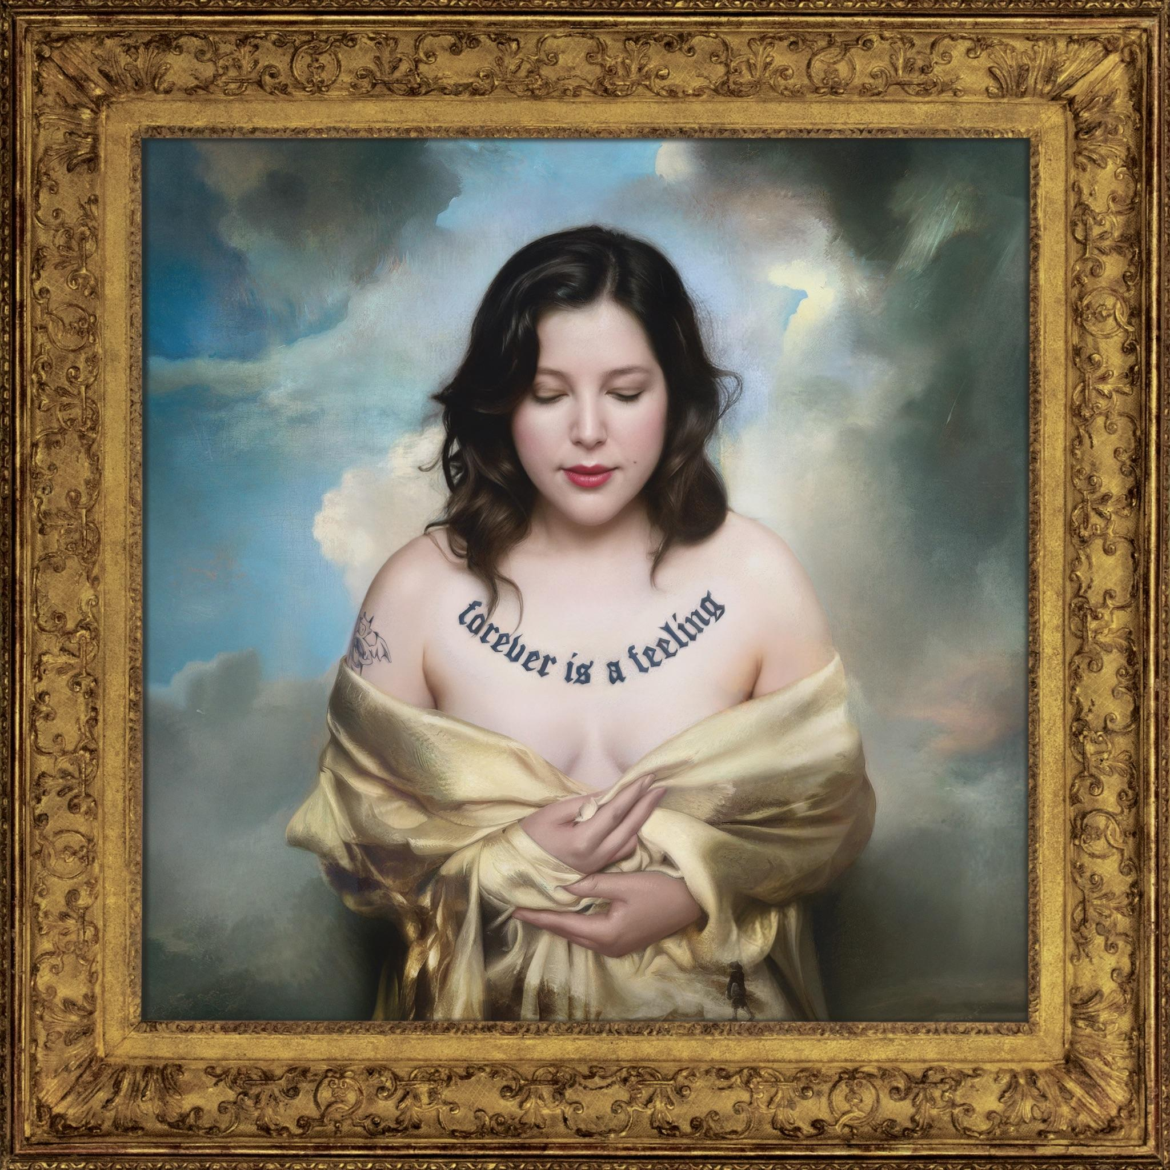***Forever Is A Feeling - artwork*

**ABOUT FOREVER IS A FEELING:**

While Dacus’s last album, ***Home Video***, explored the world of childhood and adolescence. ***Forever Is A Feeling*** is decidedly adult. The lushness of the album’s sound is matched by a new frankness in Dacus’s approach to sexuality and romance. *“So bite me on the shoulder, pull my hair,”* Dacus sings on ‘**Ankles**’. *“Pull me by the ankles to the edge of the bed, and take me like you do in your dreams.”* The sex in ‘**Ankles**’ remains fantasy—as in many of the songs, love doesn’t come easy, desire has to be resisted—but the willingness to talk about it shows a new forthrightness, a new and brave willingness to express desire. The song was originally written as a ballad, Dacus says, but on the album melancholy has been transfigured. Pulsing strings build to a thick texture of drums, guitars, a dancingly exuberant bass line, and electronics. Frustration becomes flirtatious, playful, full of the excitement of shared attraction.

Most of the songs on ***Forever Is A Feeling*** were written between Fall 2022 and Summer 2024. “*I got kicked in the head with emotions,*” says Dacus. “*Falling in love, falling out of love.*” She had to make peace with the price of the love she wanted. “*You have to destroy things in order to create things. And I did destroy a really beautiful life.*”

Forever is a feeling—and maybe onlya feeling. But that’s not to say it’s nothing. Back to the Will St. John painting, where the album’s title appears tattooed across Dacus’s chest. Tattoos are permanent marks, we think, but they can only last as long as the flesh they’re written on. “*You can’t actually capture forever*,” Dacus says. “*But I think we feel forever in moments.* *I don’t know how much time I’ve spent in forever, but I know I’ve visited*.” Love ends, tattoos fade, flesh falters; even paintings and songs aren’t forever, not really, though these songs will last a long time. To love another mortal being is to cast one’s lot with the temporary.

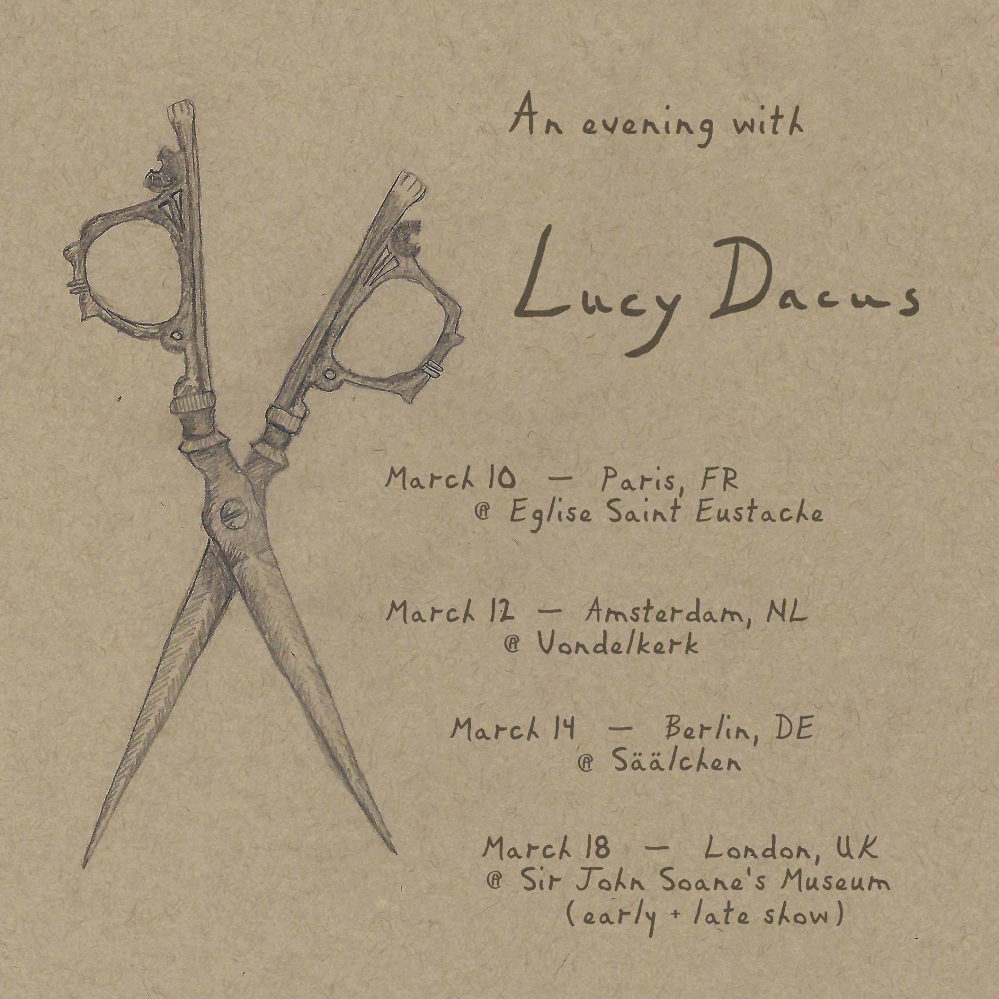

**An Evening With Lucy Dacus (new shows added)**

February 18th - St. Ann & the Holy Trinity Church - Brooklyn, NY **\*SOLD OUT\***

February 20th - The Murphy Auditorium at the Driehaus Museum - Chicago, IL **\*SOLD OUT\***

February 22nd - Legion of Honor - San Francisco, CA **\*SOLD OUT\***

February 24th - Secret Location GBD- Los Angeles, CA **\*SOLD OUT\***

March 10th - Saint Eustache Church, Paris, FR   
March 12th - Vondelkerk, Amsterdam, NL

March 14th - Säälchen at Haltzmarkt, Berlin, DE

March 18th - Sir John Soane’s Museum, London, UK (early and late show)

**Forever Is A Feeling Tour**

April 16th - The Met - Philadelphia, PA - SOLD OUT #

April 18th - The Anthem - Washington, DC - SOLD OUT #

April 19th - The Anthem - Washington DC #  
April 20th - MGM Music Hall - Boston, MA #

April 21st - MGM Music Hall - Boston, MA - SOLD OUT #

April 23rd - Radio City Music Hall - New York, NY - SOLD OUT #

April 24th - Radio City Music Hall - New York, NY - SOLD OUT #

April 25th - Massey Hall - Toronto, ON - SOLD OUT #

April 26th - Massey Hall - Toronto, ON #

April 29th - Ryman Auditorium - Nashville, TN - SOLD OUT #

April 30th - Ryman Auditorium - Nashville, TN - SOLD OUT #

May 1st - Chicago Theatre - Chicago, IL - SOLD OUT #

May 2nd - Chicago Theatre - Chicago, IL - SOLD OUT #

May 5th - Palace Theatre - St. Paul, MN - SOLD OUT #

May 6th - Palace Theatre - St. Paul, MN #

May 7th - Midland - Kansas City, MI #

May 9th - Winspear Opera House - Dallas, TX #

May 10th - Moody Amphitheatre - Austin, TX #

May 12th - Red Rocks Amphitheatre - Denver, CO #

May 14th - The Greek Theatre - Los Angeles, CA #

May 15th - The Greek Theatre - Los Angeles, CA #

# with **Katie Gavin** and **jasmine.4.t.**

**KEEP UP WITH LUCY DACUS:**

[**Instagram**](https://www.instagram.com/lucydacus/?hl=en) **|** [**Tiktok**](https://www.tiktok.com/@lucydacus?lang=en) **|** [**Website**](https://www.lucydac.us/)

For more information please contact **jenny@chuffmedia.com**