OLIVIA DEAN

ANNOUNCES 2023 UK AND EUROPE
HEADLINE TOUR

INCLUDING LONDON KOKO SHOW

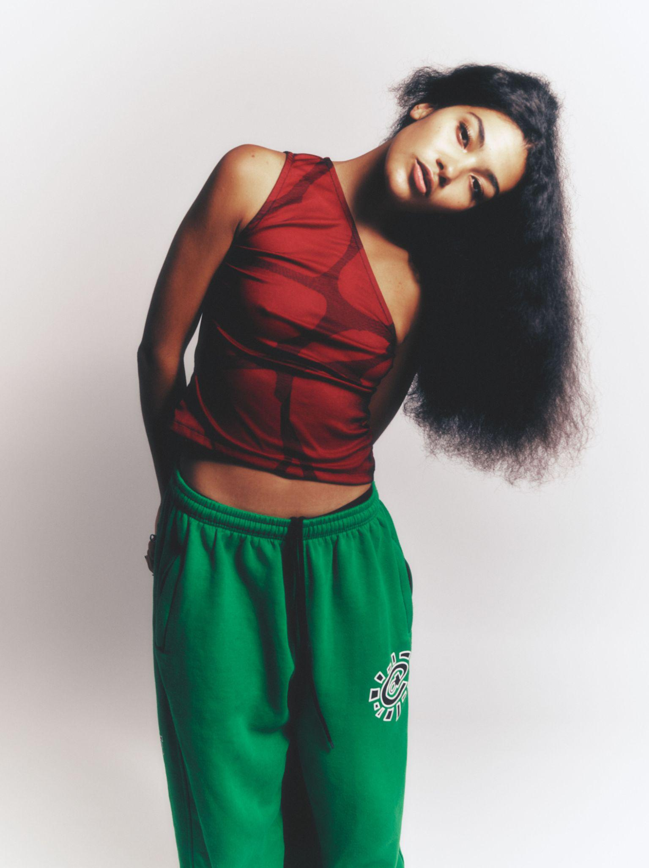
Hi-res assets here // Photo credit: PETROS

Fast-rising UK pop talent Olivia Dean has announced her biggest ever run of headline shows, set to take place across the UK and Europe in March 2023. She’ll play seven UK headline dates, including London’s KOKO, followed by a run of Europe shows, including nights in Paris and Amsterdam.

Sign up here for early access to tickets. Pre-sale takes place from 10am GMT, Wednesday 9th November. General tickets will be on sale from 10am GMT, Friday 11th November, with France and Belgium dates on general sale at 10am GMT Monday 14th November.

SIGN UP FOR PRESALE TICKET ACCESS

Olivia recently made her much-anticipated return with her new single and accompanying video ‘Danger’, a playful, tongue in cheek track which playfully captures the no-turning-back-now feeling of being stood on the cusp of falling for someone, knowing that you’re going to let yourself fall. Today Olivia also shares a behind the scenes look at the creation of the video for ‘Danger’, directed by Malin Osafo, diving into the inspiration behind and making of the visuals.

WATCH BEHIND THE SCENES OF THE ‘DANGER’ VIDEO

Following performances at Glastonbury, Rock en Seine, Standon Calling and Cross The Tracks festivals this summer, Olivia has been busy working on her long-awaited debut album, expected for release in 2023.

Olivia Dean 2023 tour dates
7 March - Trinity, Bristol
8 March - King Tut’s, Glasgow
9 March - Wardrobe, Leeds
11 March - O2 Institute 2, Birmingham
12 March - Gorilla, Manchester
13 March - O2 Academy 2, Oxford
15 March - KOKO, London
20 March - Tolhuistuin, Amsterdam
21 March - Ancienne Belgique, Club, Brussels
22 March - Badaboum, Paris
24 March - Baketown, Berlin

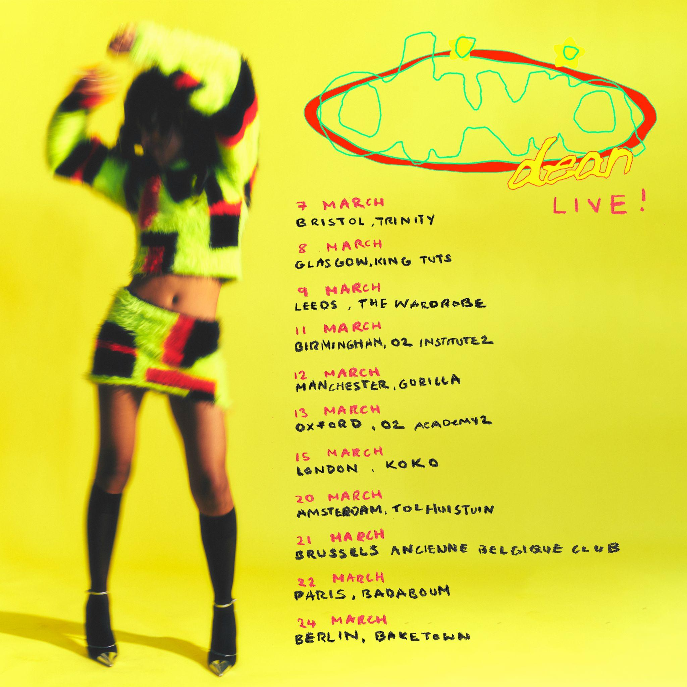

About Olivia Dean

Born and raised in Walthamstow, Olivia Dean is one the UK’s brightest rising stars, praised for her endearing, down-to-earth lyrics and magnetic, feel-good live performances. To date, Dean has released three acclaimed EPs Ok Love You Bye, What Am I Gonna Do On Sundays? and Growth and in 2021 achieved her first top 20 single with her cover of ‘The Christmas Song’, recorded for Amazon Originals.

Since 2019 Olivia has been gathering fans apace, with over 1.68 million monthly Spotify listeners and supporters across BBC Radio 1, Beats 1, The Guardian, Sunday Times Style, Dazed, The FADER, NME, ELLE, gal-dem, Vanity Fair, Clash and more tipping her for greatness. She has become a regular feature at fashion week, is a Chanel ambassador and has starred on the cover of fashion titles from Wonderland to Puss Puss.

During the pandemic, Dean connected with fans by performing from the side of her bright yellow truck, which she toured in offering free shows to communities around the UK. Her first official gig back at the Camden Jazz Cafe sold out instantly and went on to be watched over 7 million times after it went viral on Tiktok. 2023 is set to be Olivia’s biggest year to date, with the expected release of her debut album and her biggest shows to date.

Praise for Olivia Dean:

“With a talent and musicality that sound both natural and effortless, she’s got to be a hot tip”
- Sunday Times Culture

“The self-love ballad is tricky, but the Londoner balances defiance with genuine romance, the psychedelic soul evoking tweeting birds and dappled sun rays.” - The Guardian

“delivered by her silken vocals draped over tender, soul-filled production in a way that could both break and mend hearts.” - Dazed

“destined for musical success... Our kinda gal.” - Sunday Times Style

"A gorgeous collection of soul-laced songs... that are anchored by Dean’s remarkable voice." - NME

“Dean’s songs are self-love singles that empower young women. Her relatable internetisms, compelling storytelling and powerhouse pop vocals come with just the right amount of tongue-in-cheek humour.” - ELLE

“With harmonies floating like a soft feather in the morning breeze, this soothing track proves this Londoner is one to watch” - gal-dem

“Olivia Dean has a talent for writing songs about the triumphs and tribulations of a relationship” - Hypebae

Follow Olivia Dean on Instagram / Facebook / Twitter

For all media enquiries please contact Warren@chuffmedia.com on 07762 130510

