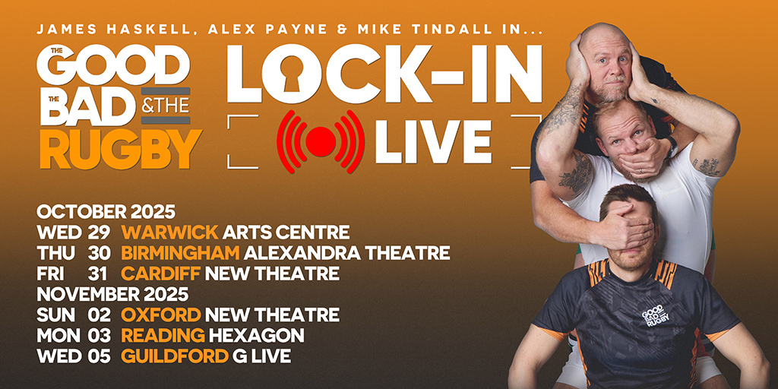

GBR REBOOTS AND RE-SUITS FOR ANOTHER WORLD TOUR!

“We’re on the road again - in part because our wives want us out of the house and Hask needs the cash right now. But mainly for the laughs. As the three legs of a bar stool, going on tour is one non-stop laugh.

On our kit list includes big egos, Mike Leadfoot’s driving, motorway sandwiches, back stage arguments, Travel Lodge soaps, World Class moaning and the most underwhelming riders in the history of live entertainment - proudly sponsored by Jaffa cakes.

But we promise if you buy a ticket, come show time we’ll be ‘tits and teeth’ as they say in the industry. There will be Lions and World Cup debriefs, stories of our weirdest, darkest, greatest and most unforgettable days and those who have entertained, frightened, stunned and broken us during a combined 60 years in the game.

The best nights out involve a Lock In. This is no different.

See you there!

Unless Mike loses his driving license yet again”

LOCK-IN LIVE ON SALE NOW:

29-Oct-25 Warwick Arts Centre
30-Oct-25 Birmingham Alexandra Theatre
31-Oct-25 Cardiff New Theatre
2-Nov-25 Oxford New Theatre
3-Nov-25 Reading Hexagon
5-Nov-25 Guildford G-Live

Myticket.co.uk / goodbadrugby.com

The Good, The Bad & The Rugby is a weekly podcast starring England legends James Haskell and Mike Tindall, alongside noted broadcaster Alex Payne, that debuted at No. 1 in the Apple charts before releasing its first episode. Featuring some of the biggest names across rugby, as well as the wider sporting and pop-cultural realms, it has attracted a cult following due to its rare ability to draw in the core rugby fan while cutting through and engaging a wider audience too.

Such success is due to the show’s USP: the special connection between Alex (Good), James (Bad) and Mike (Rugby), as well as their guests. These relationships allow the guys to capture the personalities and characters of guests, inside and outside rugby, digging beneath the veneer to unearth real, raw stories. There is no defining an episode, no silly gimmicks; it’s an intoxicating cocktail of humour, sadness, anger. A rollercoaster of emotions slotted into an hour and a half.

For more info contact warren@chuffmedia.com / 07762130510

