**THE KILLERS**

**ANNOUNCE 2024 TOUR DATES**

***Rebel Diamonds -* Released 8th December**

**\*\*** [Pre-order Now](https://thekillersuk.lnk.to/RebelDiamonds) **pasted-image.tiff

Ahead of the release of their brand new compilation album, ***Rebel Diamonds***, on **8th December**, **The Killers** are thrilled to announce details of a celebratory UK/Ireland tour in summer 2024. The ***Rebel Diamonds Tour*** will celebrate the band’s 20 years of hits in a series of arena shows, including multiple nights at London’s The O2.

The new dates are the first time **The Killers** have played arena shows in the UK since 2017’s *Wonderful Wonderful* tour, and follow the band’s most recent stadium tour, which saw them play to 400,000 fans at sold out shows including two euphoric nights at London’s Emirates Stadium in June 2022, and last year’s standout headline shows at Reading & Leeds Festivals.

**The Killers** will play:

Friday 14th June DUBLIN, 3Arena

Saturday 15th DUBLIN, 3Arena

Tuesday 18th MANCHESTER, Co-Op Live

Wednesday 19th MANCHESTER, Co-Op Live

Friday 21st MANCHESTER, Co-Op Live

Tuesday 25th GLASGOW, Ovo Hydro

Wednesday 26th GLASGOW, Ovo Hydro

Thursday 4th July LONDON, The O2

Friday 5th LONDON, The O2

Sunday 7th LONDON, The O2

**Tickets for the Rebel Diamonds Tour go on sale at 09:30 on Friday 8th December, from** [**www.ticketmaster.co.uk**](http://www.ticketmaster.co.uk) **/** [**www.gigsandtours.com**](http://www.gigsandtours.com)**, coinciding with the release of the band’s celebratory ‘best of’ album, *Rebel Diamonds*.**

***Rebel Diamonds*** is an album of highlights featuring 20 tracks, including the modern day classics “**Mr. Brightside,**” **“When You Were Young,” “All These Things That I’ve Done,” “Human,” “Read My Mind”, “The Man”** and more, through to the band’s most recently released, critically-lauded single, “**Your Side of Town,**” and one brand new anthem, **“Spirit”**.

***Rebel Diamonds*** is a curated dive into an impressive catalogue of songwriting and musicianship - one that has solidified the band as one of the most important voices in rock ‘n’ roll over the last two decades. The album features at least one song from each of the band’s seven studio albums. From the groundbreaking debut ***Hot Fuss****,* celebrating its 20th anniversary in 2024,to the band’s latest full length LP, 2021’s ***Pressure Machine****, Rebel Diamonds* showcases the group’s versatility and staying power across the ever-changing alternative music landscape. The collection is made up of songs that embody who The Killers are as a band, additionally including some favourites of theirs that have resonated over the years - tracks like **“Be Still,”** from 2012’s album *Battle Born* or **“Dying Breed”** from 2020’s album *Imploding The Mirage* or **“A Dustland Fairytale”** from 2008’s *Day & Age*, which the band recently re-recorded and performed with Bruce Springsteen.

“See it’s been said that what’s remembered lives,” reflects lead singer **Brandon Flowers** in the preview video for the record [HERE](https://thekillers.lnk.to/RebelDiamondsTrailer), “and we’ve racked up stadiums full of memories the past twenty years, enough to fill lifetimes. Twenty songs for twenty years – *Rebel Diamonds*.”

**The Killers** are **Brandon Flowers** (vocals), **Ronnie Vannucci Jr.** (drums), **Dave Keuning** 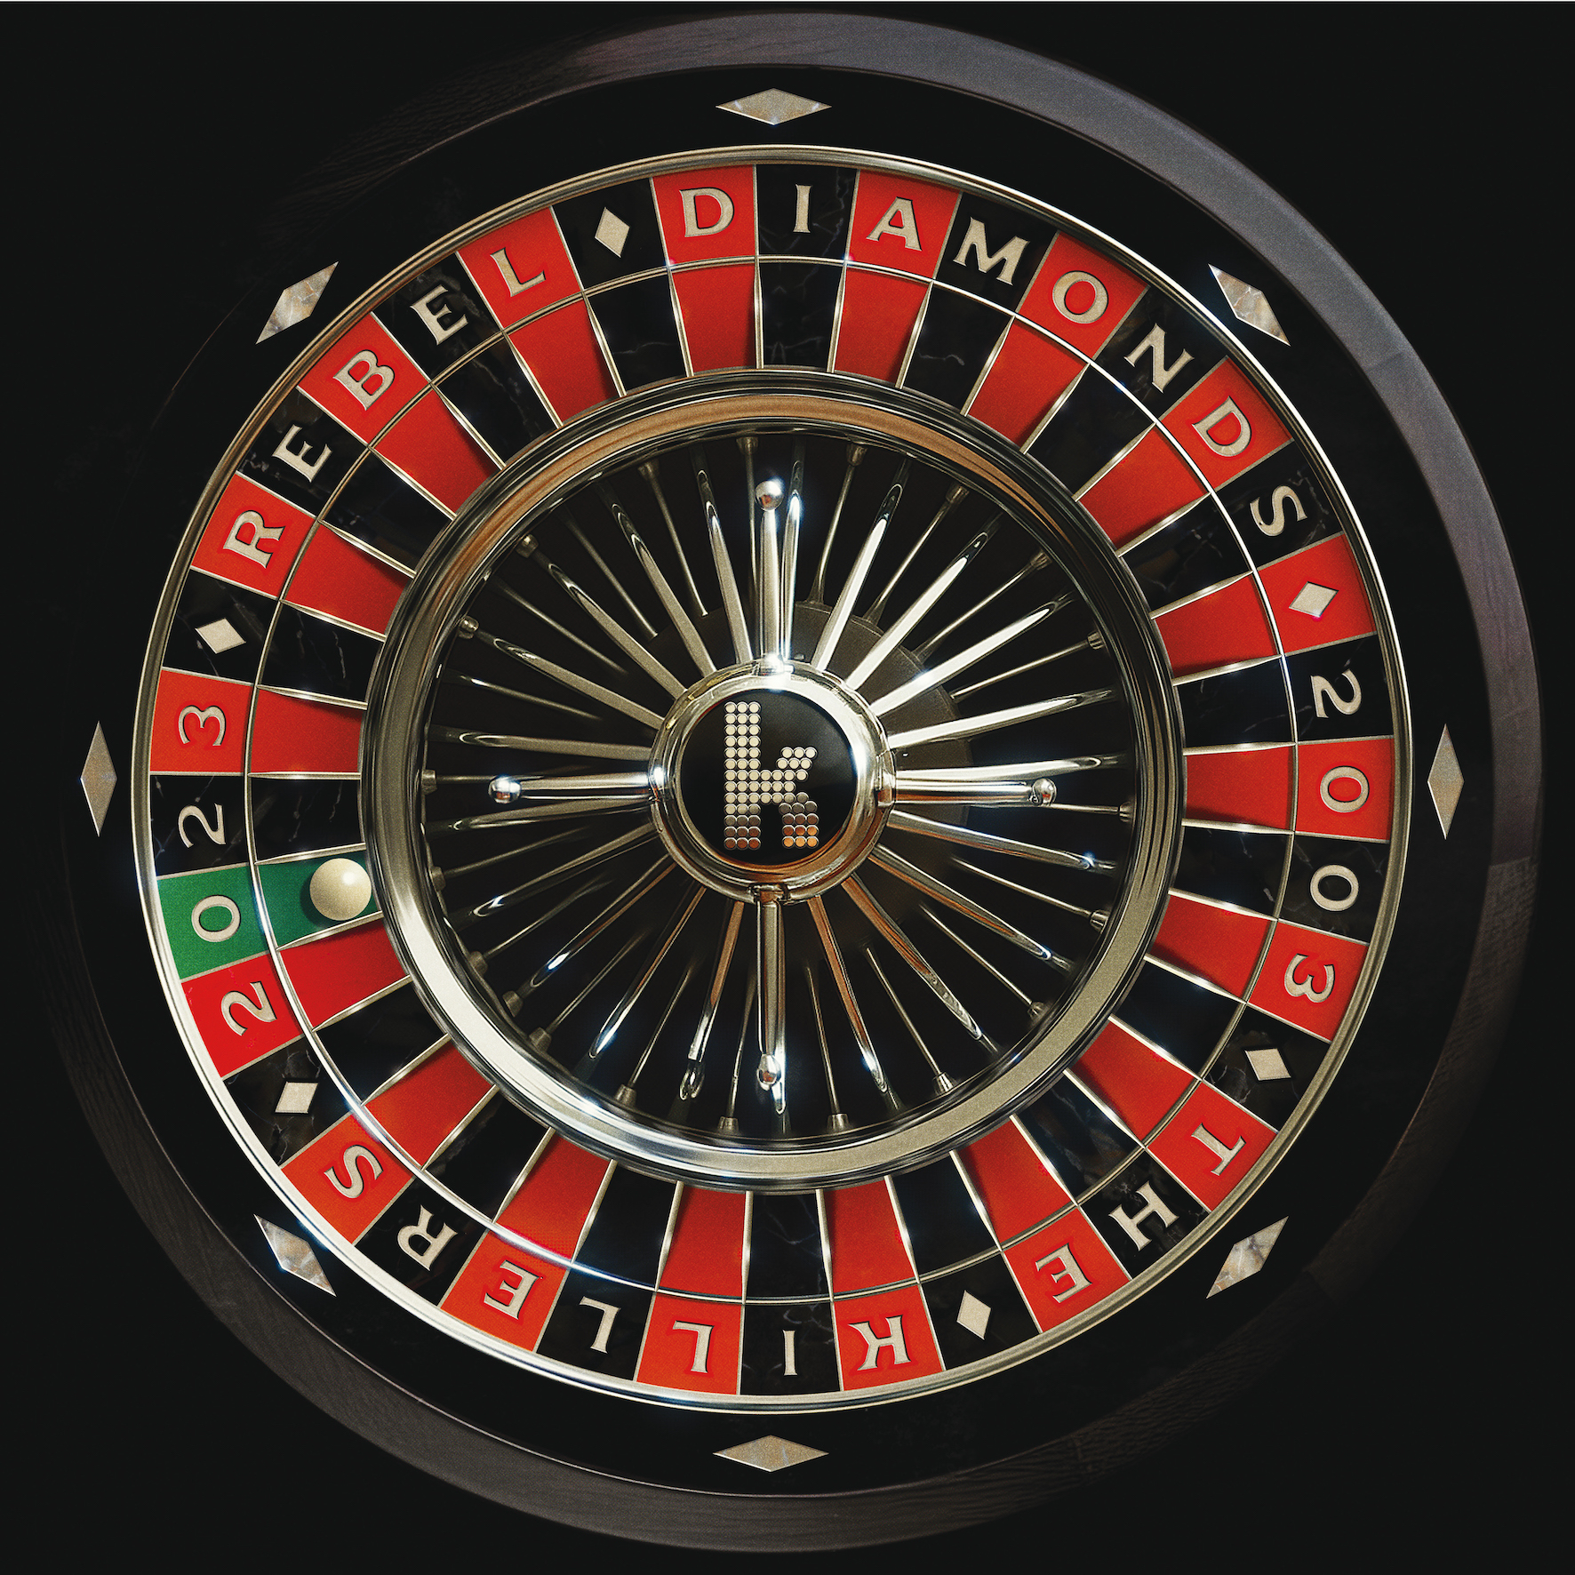(guitar), and **Mark Stoermer** (bass).

***Rebel Diamonds*** cover art. For high res, click [HERE](https://www.dropbox.com/scl/fi/ls7worqojzwptobwog4iq/Killers_RebelDiamonds_Cover.jpg?rlkey=4j92u5ci7rqquq2xactjsjjh4&dl=0)

*Rebel Diamonds* tracklisting:

1. Jenny Was a Friend of Mine

2. Mr. Brightside

3. All These Things That I’ve Done

4. Somebody Told Me

5. When You Were Young

6. Read My Mind

7. Human

8. Spaceman

9. A Dustland Fairytale

10. Be Still

11. Runaways

12. The Man

13. Caution

14. My Own Soul’s Warning

15. Dying Breed

16. Pressure Machine

17. Quiet Town

18. boy

19. Your Side of Town

20. Spirit

**KEEP UP WITH THE KILLERS:**

[WEBSITE](https://eur02.safelinks.protection.outlook.com/?url=http%253A%252F%252Fwww.thekillersmusic.com%252F&data=02%257C01%257CSteven.Rowen%2540umusic.com%257Cd8063a49022f4f9bb20b08d843a467fe%257Cbbcb6b2f8c7c4e2486e46c36fed00b78%257C1%257C0%257C637333720699965807&sdata=lEreKq6KtXkdtNFEF8myYAMEqAfAiIidt4QWFyNkoHw%253D&reserved=0)

[TWITTER](https://eur02.safelinks.protection.outlook.com/?url=http%253A%252F%252Fwww.twitter.com%252Fthekillers&data=02%257C01%257CSteven.Rowen%2540umusic.com%257Cd8063a49022f4f9bb20b08d843a467fe%257Cbbcb6b2f8c7c4e2486e46c36fed00b78%257C1%257C0%257C637333720699975802&sdata=UtjfeTZ81oxwWmpsoSAGhf5HDFnNcLMcMekMTwWBh5U%253D&reserved=0) / [INSTAGRAM](https://eur02.safelinks.protection.outlook.com/?url=http%253A%252F%252Fwww.instagram.com%252Fthekillers&data=02%257C01%257CSteven.Rowen%2540umusic.com%257Cd8063a49022f4f9bb20b08d843a467fe%257Cbbcb6b2f8c7c4e2486e46c36fed00b78%257C1%257C0%257C637333720699985798&sdata=aEgZ0lYNHZOzYgt%252BY%252FMwourQqTS8q9SVXatUP6Ga1NU%253D&reserved=0) / [FACEBOOK](https://eur02.safelinks.protection.outlook.com/?url=http%253A%252F%252Fwww.facebook.com%252Fthekillers&data=02%257C01%257CSteven.Rowen%2540umusic.com%257Cd8063a49022f4f9bb20b08d843a467fe%257Cbbcb6b2f8c7c4e2486e46c36fed00b78%257C1%257C0%257C637333720699985798&sdata=vEw47eCv8soDUc1n3JOnaCA0MEutPsZvSBUid6IzBtY%253D&reserved=0)

**For more information and press enquiries for THE KILLERS please contact**

**Jenny Entwistle**

[Jenny@chuffmedia.com](mailto:Jenny@chuffmedia.com)