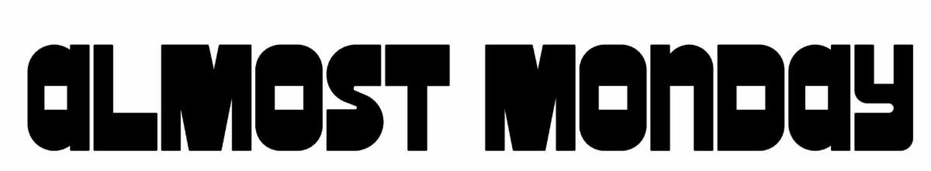

SAN DIEGO’S ALT-POP TRIO ALMOST MONDAY ARE JUMPING BACK IN WITH
THE DIVE TOUR – PART 2
UK TOUR KICKS OFF JUNE 23 IN CARDIFF
DIVE DELUXE ALBUM OUT NOW
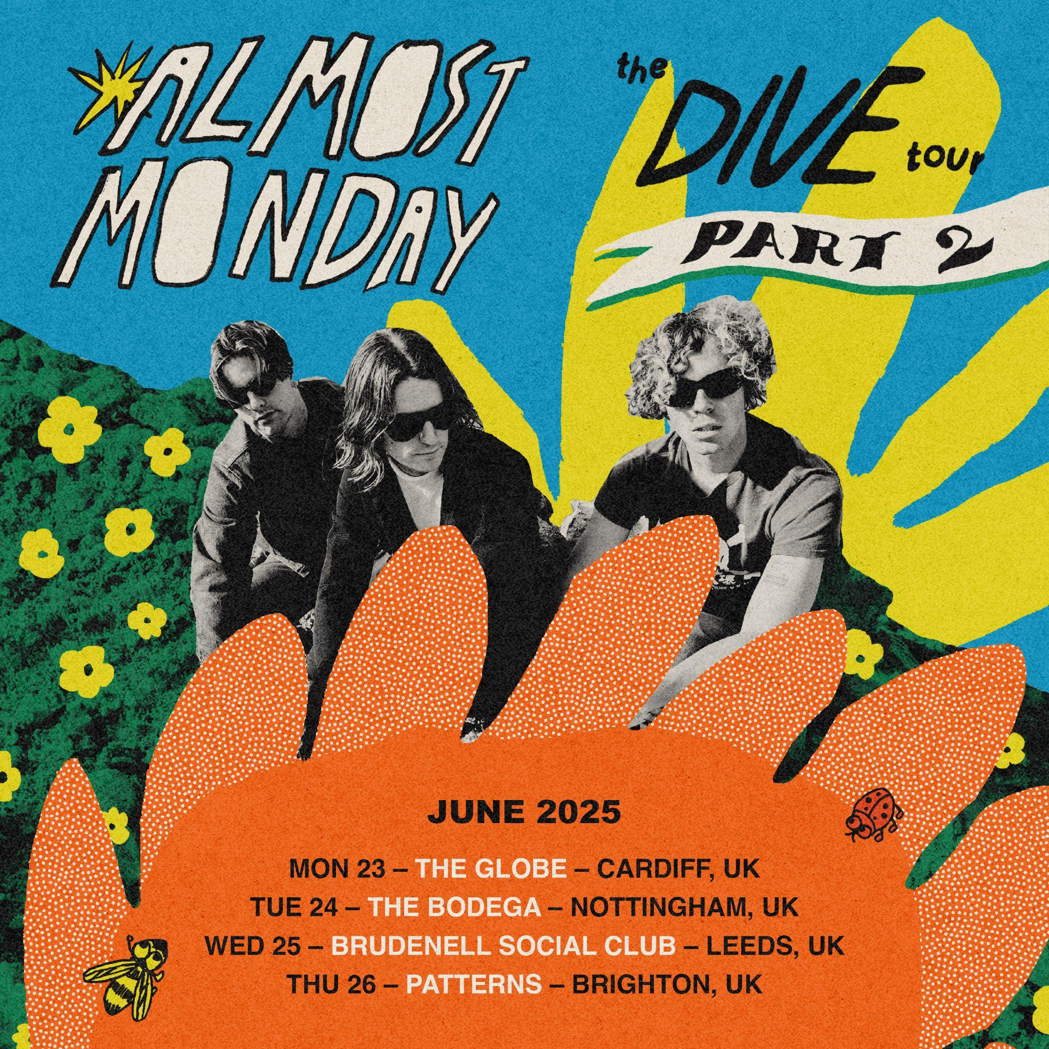

Fresh off the sold-out success of their debut headline tour across the U.S. and Europe, almost monday are hitting the road again in support of their debut album, DIVE and hit song “can’t slow down.”

THE DIVE TOUR – PART 2 launches June 11 in Mexico City before heading across the pond for a string of European headline shows beginning June 23 in Cardiff, UK. Along the way, the band will hit major festivals including Lollapalooza Berlin (July 13) and Lollapalooza Paris (July 19).
almost monday made their late-night television debut on Jimmy Kimmel Live! performing their hit single “can’t slow down”
Pre-sale tickets are available now. General on-sale starts Thursday, April 17 at 10am local time.

UK – THE DIVE TOUR PART 2
June 23 – Cardiff, UK – Globe
June 24 – Nottingham, UK – The Bodega
June 25 – Leeds, UK – Brudenell Social Club
June 26 – Brighton, UK – Patterns

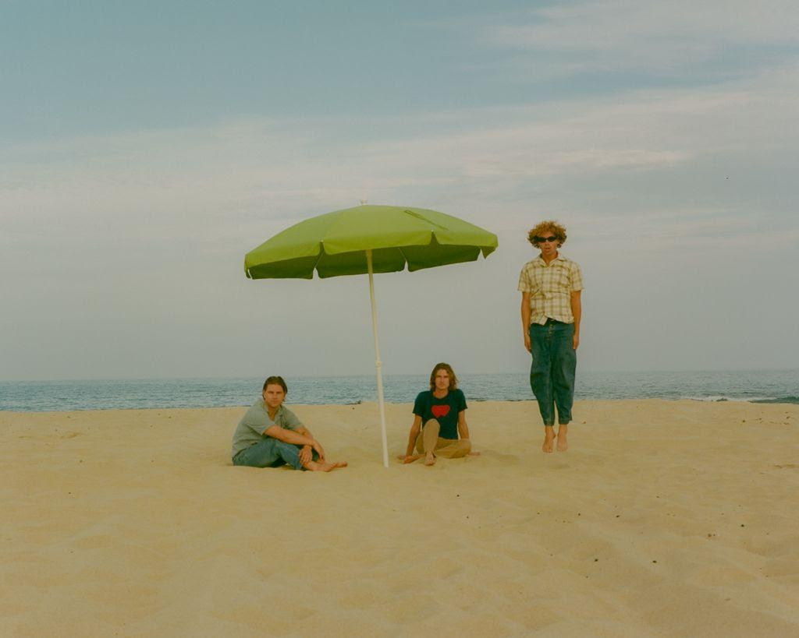

For more information and press enquiries for ALMOST MONDAY please contact

Warren Higgins
Warren@chuffmedia.com

