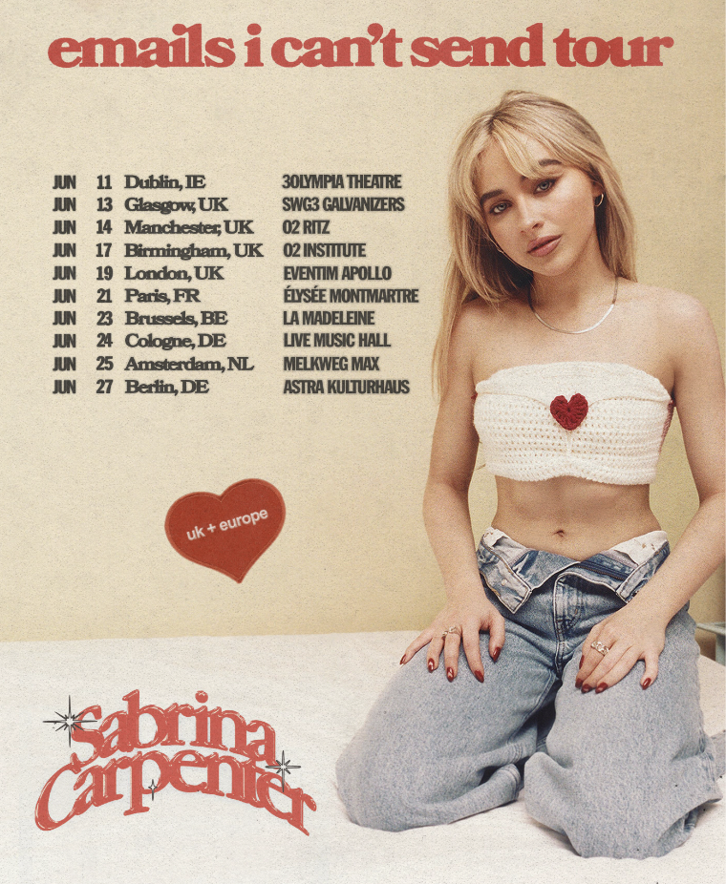

Sabrina Carpenter announces first ever UK/EU headline tour
‘Nonsense’ climbs Spotify global charts + wins spot on BBC Radio 1 playlist

Praise for emails i can’t send:
“A deeply vulnerable version of the singer confronting her feelings” - Rolling Stone, Albums of the Year
“With near stream-of-consciousness lyrics…navigating love, heartbreak and self-worth” - Billboard, Albums of the Year
“The most fully realised vision of Carpenter the musician - and the most rounded portrait of Carpenter the human being yet” - Vogue
“In this era of versatility, perhaps no one is doing it as well as Sabrina Carpenter” - Nylon
Sabrina Carpenter has today announced details of her first ever UK and European headline tour. With a 35-date run across the US and Canada set to begin in March - at over 100,000 tickets - Sabrina will hit Europe in June, including a landmark London debut at Eventim Apollo on June 19th. Artist pre-sale tickets are available tomorrow (January 31st) at 10AM local time, with general release opening on Friday (February 3rd).

This comes hot on the heels of Sabrina Carpenter’s viral hit ‘Nonsense’. With over 100 million streams, it continues to climb Spotify’s global charts as well as the OCC and Billboard Hot 100 charts, alongside winning a spot on BBC Radio 1’s playlist (Sabrina’s first ever addition at the station). ‘Nonsense’ is taken from the polymath pop sensation’s latest album emails i can’t send - a confident, exuberant record that continues to grow in impact daily, as a critics’ choice for many Best of 2022 lists, and now set to catapult Sabrina Carpenter to a new level of superstardom in 2023.

Sabrina Carpenter is a singer, songwriter, actress, designer, producer and style icon who has enchanted millions (over 28 million Instagram followers, and 13M on TikTok) in singular fashion. ‘Nonsense’ chronicles Sabrina’s transformation in her most accomplished record to date, with its mix of ultra personal songwriting and passionate, powerful performance. Aged just 23, the Pennsylvania-born artist has generated similar mega-fandom via her work in television and film: she bagged her first leading role in 2019’s film festival hit ‘The Short History of The Long Road’, before starring and exec producing in Netflix’s number 1 smash, ‘Work It’. Having made her Broadway debut starring in the iconic ‘Mean Girls’, Carpenter has already graced Forbes’ prestigious “30 Under 30” list, launched her own fragrance (‘Sweet Tooth’) and signed with Island / Polydor Records for latest album, emails i can’t send. Showcasing Sabrina Carpenter at her most raw and real, her first ever UK & European headline tour signals the long-awaited arrival of one of the most exciting voices in the world today.

UK Headline Tour Dates (for VIP packages, please see: https://bit.ly/SabrinaCarpenter2023VIPUpgrades).

13.06.23 || Glasgow || SWG3 Galvanizers
14.06.23 || Manchester || O2 Ritz
17.06.23 || Birmingham || O2 Institute
19.06.23 || London || Eventim Apollo

FOLLOW SABRINA CARPENTER:
Instagram | TikTok | Twitter | Facebook | YouTube | Website

For more information and press enquiries please contact

Jenny Entwistle
Jenny@chuffmedia.com

