ANNOUNCES O2 KENTISH TOWN FORUM HEADLINE ON 6 JUNE 2022 AND MANCHESTER ACADEMY 2

RELEASES HIGHLY ANTICIPATED ‘THE WALLS ARE WAY TOO THIN’ EP

ARTIST ON THE RISE LIVE SESSION WITH JACK STEADMAN AT O2 SHEPHERD’S BUSH EMPIRE NOW LIVE

CHOSEN AS YOUTUBE ARTIST ON THE RISE AND DEEZER’S FOCUS ARTIST

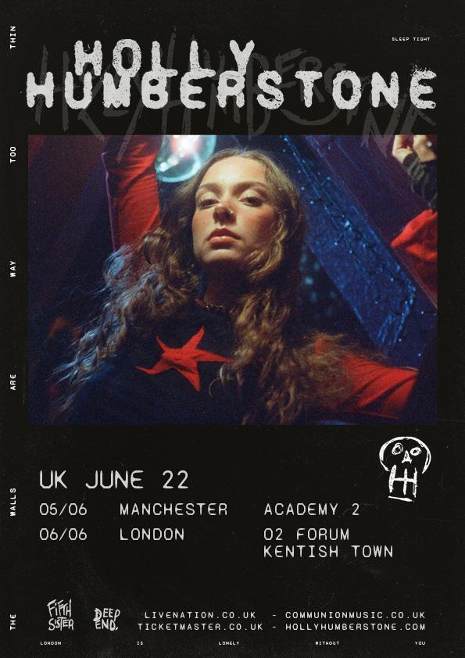

Download press photos here

Releasing her second EP The Walls Are Way Too Thin to critical acclaim and captivating thousands of fans across the UK and USA on her debut headline tour, Ivor Novello nominated breakthrough star of the year Holly Humberstone announces her biggest headline show to date at O2 Kentish Town Forum on 6 June 2022, and Manchester Academy 2 on 5 June 2022. Tickets are on sale at 10am on 3 December 2021 here. Holly has released a string of immaculate live performances called Artist On The Rise for new single ‘Friendly Fire’, first with Bombay Bicycle Club’s Jack Steadman at O2 Shepherd’s Bush Empire, followed by a beautiful version filmed at Sessions Arts Club with BRIT winner Griff.

Within the particular lives the universal, and for Holly the six-track EP represents the feeling of being lost and questioning who you are and where you belong. The EP features Holly’s “favourite” BBC A-listed ‘Scarlett’, the cinematic masterpiece title-track The Walls Are Way Too Thin, the immaculately beautiful ‘Haunted House’, 1975 collaboration ‘Please Don’t Leave Just Yet’, and two new songs ‘Thursday’ and ‘Friendly Fire’, which sit at the poignant heart of the body of work. Being the artist to watch on every festival lineup from Reading & Leeds to All Points East, with the ‘confidence and stature’ (Evening Standard) that defies her 21-years of age and only one year in the limelight, Holly has endeared fans at sold-out shows across the globe. Playing at The Roxy in LA, two-sold out Bowery Ballroom performances in NYC, with attendees included superstar Lorde. The Grantham-born artist has become the UK’s next great songwriting talent, able to articulate the “chaos in my head” (Guardian) through remarkable lyricism, and deep understanding of storytelling.

“This EP represents a feeling of being lost. It’s the kind of lost that makes you question who you are and where you belong. So lost that someone might need to find you again because you can’t find yourself. That’s how it felt to move to Liverpool, then London, and be in transit between cities and never settling”. Says Holly

LISTEN TO THE WALLS ARE WAY TOO THINK EP
WATCH FRIENDLY FIRE ROOFTOP VIDEO HERE
WATCH SCARLETT (BAD BRITISH WEATHER VERSION) WITH AMAZON PRESENTS

Recently nominated for the Ivor Novello Rising Star Award with Apple Music, and chosen as YouTube’s next Artist On The Rise and Deezer’s Focus artist, and Amazon Presents, after coming runner up in the BBC Sound of 2021, it isn’t just Holly’s acclaimed music and symbolic videos that have captured the imagination of her fans. Holly’s deep care for sustainable fashion encouraged her to launch the Fifth Sister Swap initiative, as a way for her fans to swap clothes without relying on fast fashion. At Holly’s Omeara headline this summer, she hosted the first ever IRL Swap Shop, and brought it to NYC with Rogue Garms. Launching today, Holly has partnered with TRAID, the UK charity working to tackle and solve the problems caused by making, consuming and wasting clothes, on a limited edition merch drop to encourage recycling clothes. Fans can access the sale here.

The Walls Are Way Too Thin follows Holly’s critically acclaimed debut Falling Asleep At The Wheel, which marked the first chapter in the story of a new global talent who has garnered over 190 global streams to-date. The rising pop star has achieved everything from being named VEVO DSCVR’s Artists To Watch 2021, invited to perform ‘Scarlett’ on Jimmy Fallon, and heralded by Jimmy Kimmel, James Corden, Triple J, The Sunday Times, NME (5*), The Guardian, i-D, ELLE, and Billboard. It is the honest storytelling at the heart of Holly’s craft that helped fans, and the artist has spoken of wanting all her lyrics to be ones people could tattoo on themselves, writing lines that are specific to her life, from her sister’s struggles with mental health to growing apart from her friends. “People can connect to a song more if it’s just me and my unfiltered thoughts,” she explains. “That’s what I look for in music that I listen to – a personal connection. Everything I’m going through is universal stuff. Everyone’s been through these situations, it’s not just me”.

Holly will also be joining girl in red on her extensive USA tour in Spring 2022, all live dates can be found here.

FESTIVAL DATES

05 June Manchester Academy 2 Manchester
06 June O2 Forum Kentish Town London
02 June Primavera Sound Barcelona
18 June Hurricane Festival Germany
19 June Southside Festival Germany
17 July Finsbury Park London

Holly Humberstone - ‘The Walls Are Way Too Thin’ EP Artwork

TRACKLISTING:

- Haunted House
- The Walls Are Way Too Thin
- Please Don’t Leave Just Yet
- Thursday
- Scarlett
- Friendly Fire

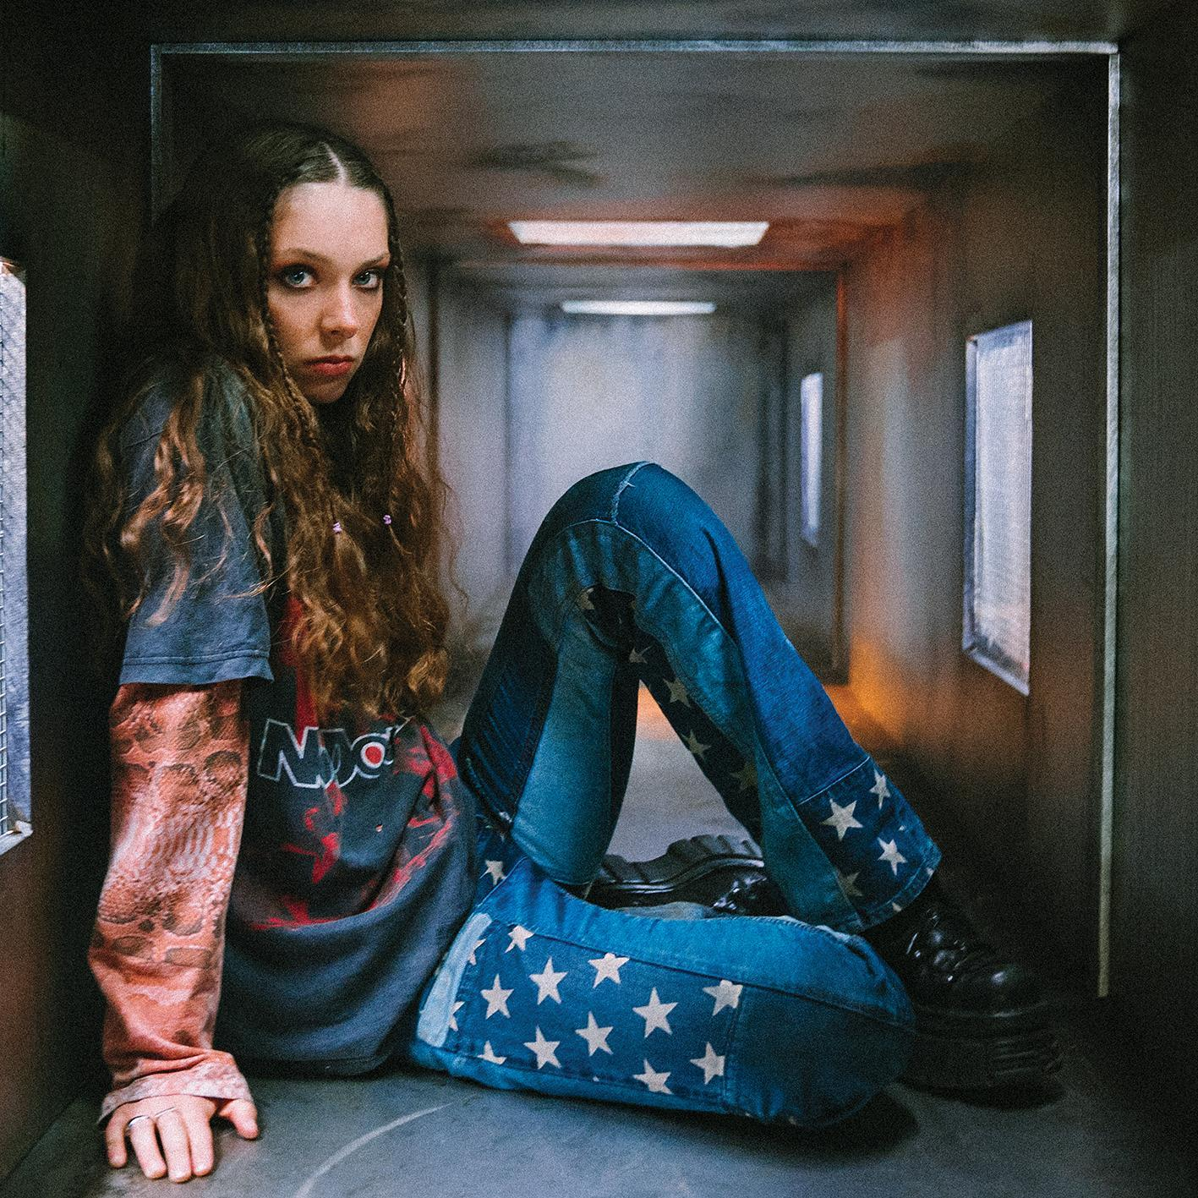

Follow Holly Humberstone:
YouTube/ Instagram / Twitter / Facebook / Spotify /
Apple/ / TikTok

For more information and press enquiries please contact

Jenny Entwistle
Jenny@chuffmedia.com

