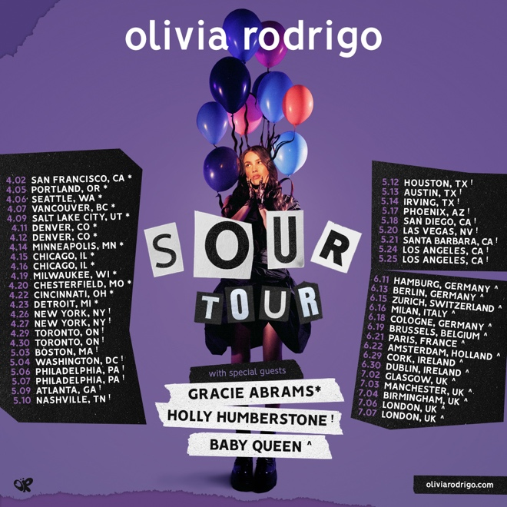

OLIVIA RODRIGO ANNOUNCES 2022 NORTH AMERICA, UK AND European TOUR IN SUPPORT OF HER GRAMMY-NOMINATED DEBUT ALBUM SOUR

RODRIGO’S “SOUR TOUR” KICKS OFF APRIL 2 IN SAN FRANCISCO
AND WILL STOP AT MORE THAN 40 MAJOR CITIES ACROSS
NORTH AMERICA AND EUROPE
INCLUDING TWO-NIGHT-RUNS AT RADIO CITY MUSIC HALL IN NEW YORK,
THE GREEK THEATRE IN LOS ANGELES, AND EVENTIM APOLLO IN LONDON

Tour Announce Caps off Rodrigo’s Incredible Year, which Saw Her Win
“New Artist of the Year” at the 2021 American Music Awards and
Earn Seven Nominations for the 2022 Grammy Awards Including “Record Of The Year,” “Album Of The Year,” “Song Of The Year,” and “Best New Artist”

Special guests Gracie Abrams, Holly Humberstone and Baby Queen will join the Tour

Verified Fan Sale for the SOUR Tour Begins Today
Tickets Go On-Sale To The Public On December 10

December 6, 2021 – New York, NY – Grammy-nominated, critically acclaimed singer/songwriter, Olivia Rodrigo, today announced her 2022 SOUR Tour in support of her Grammy-nominated record-breaking, RIAA Double Platinum Certified debut album, SOUR – out now on Geffen Records. Kicking off April 2nd at the Bill Graham Civic Auditorium in San Francisco, CA, the tour will visit more than 40 major cities across North America and Europe including two-night runs at Radio City Music Hall in New York, and the Greek Theatre in Los Angeles, CA, before wrapping with two nights at Eventim Apollo in London, UK on July 6th and 7th. Special guests Gracie Abrams (April 2 – 23), Holly Humberstone (April 26 – May 25) and Baby Queen (June 11 – July 7) will join the Tour. The Verified Fan sale is open now through December 7 at 11:59pm PT, visit HERE. Public ticket on-sale begins on December 10, visit HERE.

Fresh off her win as “New Artist of the Year” at the American Music Awards, the tour announcement caps off Rodrigo’s banner year, which, most recently saw her earn her seven nominations for the 2022 Grammy Awards including “Record Of The Year,” “Album Of The Year,” “Song Of The Year,” “Best New Artist,” “Best Pop Solo Performance,” “Best Pop Vocal Album,” and “Best Music Video,” making her the second youngest artist in Grammy history to score nods in each of the Big Four categories in the same year.

Named the #1 Album of 2021 by Rolling Stone and called one of the Best Albums of 2021 by the New York Times, SOUR recently landed at the top of several Billboard year-end lists including the top Global 200 Artist, top Overall New Artist, top Hot 100 Artist, top Hot 100 Female Artist, and top Hot 100 Songwriter, among others. SOUR also landed at the top of Spotify’s recently unveiled annual 2021 “Wrapped” campaign, which highlights the platform’s most streamed artists, songs, albums and podcasts. With over 1.1 billion streams, “driver’s license” was the top streamed song of 2021 on Spotify (both in the U.S. and worldwide), while Rodrigo’s “good 4 u” also landed in the top five most streamed songs list on Spotify, with SOUR earning the number one spot as the most globally streamed album. Rodrigo also was named Variety’s “Songwriter of the Year” and earned Apple Music Awards for Breakthrough Artist of the Year, Album of the Year and Song of the Year.

With the release of SOUR, the highly anticipated LP debuted at No. 1 on the Billboard 200 with 295,000 equivalent album units earned in the U.S., quickly achieving RIAA Gold certification in its first week. Upon its release, SOUR scored the most U.S. audio streams from a female debut album ever and broke the record for the most-streamed album in a week by a female artist in Spotify history with over 385M global steams. The stunning album from the 18-year-old multi-platinum artist produced two #1 songs “drivers license” (4x Platinum) and “good 4 u” (3x Platinum), the top 5 song “deja vu” (2x Platinum) and not to mention entered the charts at No. 1 in the U.K., Canada, Ireland, Norway, Holland, Sweden, Australia, and New Zealand. All 11 tracks from the album have landed in the top 30 of Billboard’s Hot 100, making Rodrigo the first female artist, and the fourth act overall, to simultaneously chart 11 or more songs in the top 30.

For a full list of SOUR Tour dates and cities, see below: 2022 SOUR TOUR DATES:
Date | City | Venue
April 2, 2022 | San Francisco, CA | Bill Graham Civic Auditorium
April 5, 2022 | Portland, OR | Theater of the Clouds
April 6, 2022 | Seattle, WA | WAMU Theater
April 7, 2022 | Vancouver, BC | Doug Mitchell Thunderbird Sports Centre
April 9, 2022 | Salt Lake City, UT | UCCU Center
April 11, 2022 | Denver, CO | Mission Ballroom
April 12, 2022 | Denver, CO | Mission Ballroom
April 14, 2022 | Minneapolis, MN | Armory
April 15, 2022 | Chicago, IL | Aragon Ballroom
April 16, 2022 | Chicago, IL | Aragon Ballroom
April 19, 2022 | Milwaukee, WI | Eagles Ballroom
April 20, 2022 | Chesterfield, MO | The Factory
April 22, 2022 | Cincinnati, OH | The Andrew J Brady ICON Music Center
April 23, 2022 | Detroit, MI | Masonic Temple Theatre
April 26, 2022 | New York, NY | Radio City Music Hall
April 27, 2022 | New York, NY | Radio City Music Hall
April 29, 2022 | Toronto, ON | Massey Hall
April 30, 2022 | Toronto, ON | Massey Hall
May 3, 2022 | Boston, MA | Roadrunner
May 4, 2022 | Washington, DC | Anthem
May 6, 2022 | Philadelphia, PA | The Met Philadelphia
May 7, 2022 | Philadelphia, PA | The Met Philadelphia
May 9, 2022 | Atlanta, GA | Coca-Cola Roxy
May 10, 2022 | Nashville, TN | Grand Ole Opry House
May 12, 2022 | Houston, TX | 713 Music Hall
May 13, 2022 | Austin, TX | Moody Amphitheater
May 14, 2022 | Irving, TX | Pavilion at Toyota Music Factory
May 17, 2022 | Phoenix, AZ | Arizona Federal Theatre
May 18, 2022 | San Diego, CA | The Rady Shell at Jacobs Park
May 20, 2022 | Las Vegas, NV | The Chelsea
May 21, 2022 | Santa Barbara, CA | Santa Barbara Bowl
May 24, 2022 | Los Angeles, CA | Greek Theatre
May 25, 2022 | Los Angeles, CA | Greek Theatre
June 11, 2022 | Hamburg, Germany | Stadtpark
June 13, 2022 | Berlin, Germany | Verti Music Hall
June 15, 2022 | Zurich, Switzerland | Halle 622
June 16, 2022 | Milan, Italy | Fabrique
June 18, 2022 | Cologne, Germany | Palladium
June 19, 2022 | Brussels, Belgium | Forest National
June 21, 2022 | Paris, France | Zénith
June 22, 2022 | Amsterdam, Holland | AFAS Live
June 29, 2022 | Cork, Ireland | Live At The Marquee
June 30, 2022 | Dublin, Ireland | Fairview Park
July 2, 2022 | Glasgow, UK | O2 Academy Glasgow
July 3, 2022 | Manchester, UK | O2 Apollo Manchester
July 4, 2022 | Birmingham, UK | O2 Academy Birmingham
July 6, 2022 | London, UK | Eventim Apollo
July 7, 2022 | London, UK | Eventim Apollo

SOUR Tour Artwork HERE
SOUR Tour Press Photo HERE

For more information and press enquiries please contact

Jenny Entwistle
Jenny@chuffmedia.com

