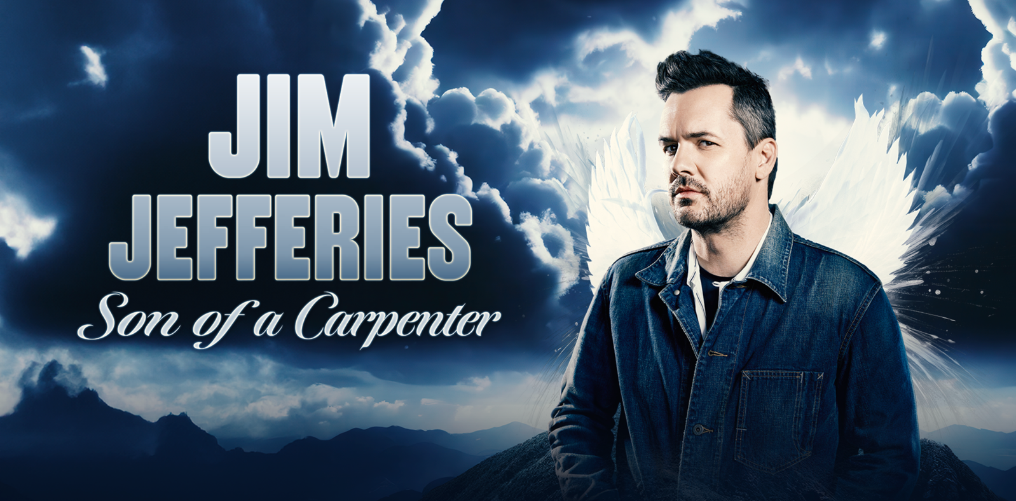
JIM JEFFERIES TOURS THE UK THROUGHOUT NOVEMBER
INCLUDING TWO SEPTEMBER SHOWS AT LONDON’S EVENTIM APOLLO
One of the most influential and provocative voices in global comedy returns to the UK for a major nationwide tour

Acclaimed comedian, actor, and writer Jim Jefferies has officially announced the UK leg of his brand-new stand-up tour, Son of a Carpenter. Already on sale and in high demand, this long-awaited run will see Jefferies bring his sharp, belief-challenging, and deeply personal brand of comedy to audiences across the UK in September and November 2025.

Born in Australia but forged in the UK’s vibrant comedy scene, Jefferies' return feels like a homecoming. Now an international comedy titan, he has earned a reputation for entertaining audiences across the globe with his provocative and thought-provoking comedy.

Jefferies has released ten stand-up specials, including five Netflix hits. His latest, High & Dry (2023), finds him reflecting on newly married life, the laziness of koala bears, the injustices of male pattern baldness and the reason why he’ll never drink again, all delivered with the brutal honesty and brilliant wit fans have come to love.

He has also starred in the FX series Legit, which he co-created and produced, and hosted Comedy Central’s The Jim Jefferies Show (2017–2019), known for its bold takes on politics and culture. In 2019, he was named Stand-Up Comedian of the Year at the Just for Laughs Festival, further cementing his status as one of comedy’s most respected voices.

Currently, he can be seen hosting FOX’s reality show, The Snake, where contestants must use their training, charm, and powers of persuasion as they face fear-inducing challenges designed to showcase their true colors. He will also be starring in Jordan Peele’s newest production, Him, alongside Tyriq Withers, Marlon Wayans, and Julia Fox which releases in September 2025. Up next, his new Netflix special, Jim Jefferies: Town Limb Policy will premiere worldwide on August 12th.

SON OF A CARPENTER UK TOUR DATES

6 Sep London, Eventim Apollo
8 Sep London, Eventim Apollo
2 Nov Manchester, O2 Apollo
3 Nov Sheffield, City Hall
4 Nov Liverpool, Empire Theatre
6 Nov Newcastle, O2 City Hall
7 Nov Glasgow, SEC Armadillo
8 Nov Edinburgh, Playhouse
11 Nov Cambridge, Corn Exchange
13 Nov Oxford, New Theatre
14 Nov Nottingham, Royal Concert Hall
15 Nov Leeds, First Direct Arena
17 Nov Bristol, Beacon
18 Nov Bath, The Forum
21 Nov Leicester, De Montfort Hall
22 Nov Birmingham, BP Pulse Live
23 Nov Cardiff, Utilita Arena
27 Nov Portsmouth, Guildhall
28 Nov Plymouth, Pavilions
29 Nov Brighton, Centre
30 Nov Southend, Cliffs Pavilion

Tickets are on sale now via https://myticket.co.uk/artists/jim-jefferies

Don’t miss your chance to see one of the most electrifying comedians of our time, live on stage.

For all media enquiries contact Warren@chuffmedia.com on 07762 130510

