Jeff Goldblum & The Mildred Snitzer Orchestra

Announce Additional UK Shows
As Part Of The Night Blooms World Tour

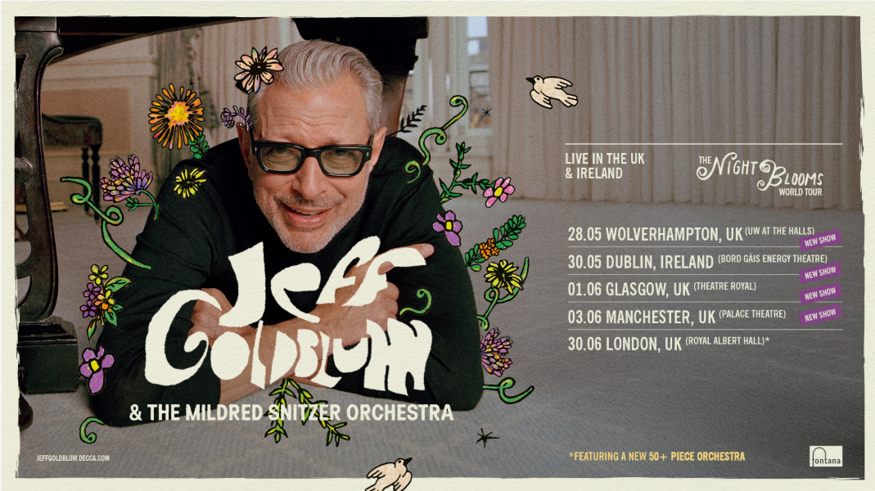

Jeff Goldblum & The Mildred Snitzer Orchestra are delighted to announce additional UK dates as part of The Night Blooms World Tour. Showcasing Goldblum’s forthcoming album, Night Blooms, the tour will now call at Wolverhampton, Glasgow and Manchester alongside the 50+ piece orchestra extravaganza planned for London’s Royal Albert Hall.

Following the success of its companion album Still Blooming, which debuted at #1 on the Official Jazz & Blues Albums Chart and #10 on the UK Official Albums Chart in 2025, Night Blooms marks a rich new chapter in his ever-evolving musical journey. Set to be released on 5th June 2026 on Universal’s recently relaunched Fontana label, Night Blooms marks an electrifying continuation of Goldblum’s successful musical odyssey alongside his longtime ensemble, The Mildred Snitzer Orchestra. Piano playing Goldblum also adds his unique vocals on a few tracks on this forthcoming album, alongside a dazzling lineup of collaborators whom he has mobilized as a result of his illustrious decades-long career across film, television, stage, fashion, and music including Cynthia Erivo, Melody Gardot, Ariana Grande, Scarlett Johansson, Charlie Puth, dodie, Haley Reinhart, Maiya Sykes and more.

Arriving hot on the heels of Goldblum’s portrayal as 'The Wizard' in Wicked and Wicked: For Good, Night Blooms reflects his deepening commitment to the 88 keys, song, and performance, transforming a 30-year passion for music into a thriving parallel career. The Night Blooms World Tour will bring these recordings to life on stage, serving audiences an intimate yet exuberant evening of jazz and storytelling with a delicious dollop of Hollywood vibes.

The World Tour Dates
- 24 April — Melbourne, AUS — Palais Theatre
- 28 April — Perth, AUS — Riverside Theatre
- 30 April — Brisbane, AUS — Brisbane Convention and Exhibition Centre
- 2 May — Adelaide, AUS — Festival Theatre
- 5 May — Sydney, AUS — Sydney Opera House
- 28 May – Wolverhampton, UK – UW At The Halls
- 30 May – Dublin, IRE – Bord Gáis Energy Theatre
- 1 June – Glasgow, UK – Theatre Royal
- 3 June – Manchester, UK – Palace Theatre
- 30 June — London, UK — Royal Albert Hall
- 2 July — Madrid, ES — Venue TBA
- 5 July — Barcelona, ES — Auditori Fòrum CCIB
- 7 July — Antwerp, BE — Queen Elizabeth Hall
- 9 July — Paris, FR — Salle Pleyel

The Night Blooms World Tour promises to be a sparkling celebration of Night Blooms — featuring Jeff Goldblum & The Mildred Snitzer Orchestra at their most playful and creatively adventurous yet.

Tickets will go on sale to the general public on Friday 13 February. For more information, please visit https://jeffgoldblum.decca.com.

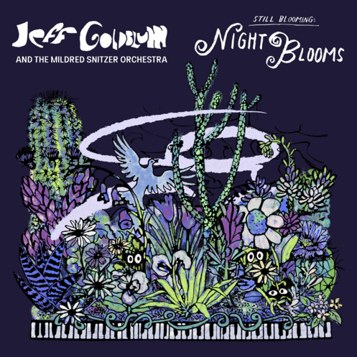

DOWNLOAD HIGH-RES ALBUM/SINGLE COVER & PRESS SHOT HERE

For more information contact warren@chuffmedia.com

