
Announce I quit UK Arena Tour
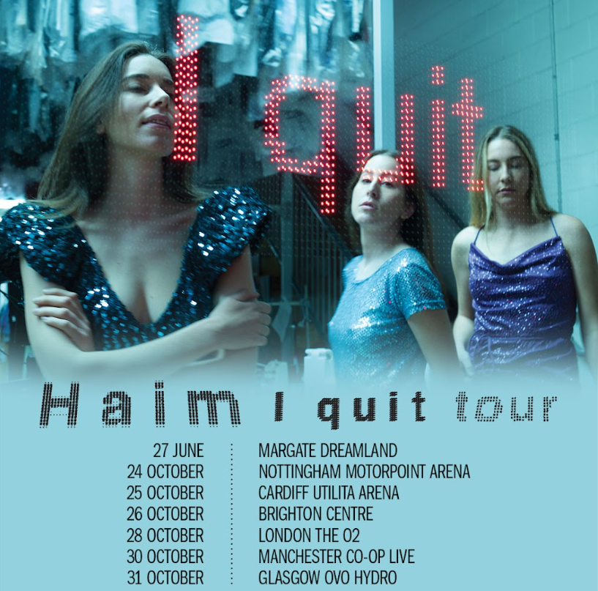
HAIM have announced details of a UK arena tour in October. The rock trio will play six dates in support of their upcoming fourth album I quit, which was announced last week and will be released on June 20th via Polydor Records. The I quit UK tour kicks off in Nottingham on October 24th and includes a show at London’s O2 Arena on October 28th. In addition, following their return to the stage at Primavera Sound, the band will play a special one-off headline show at Margate’s Dreamland on June 27th, marking their first UK show since their triumphant headline at All Points East in 2023.
Fans who pre-order the album HERE by Tuesday 29th April at 12PM BST will get access to an exclusive pre-sale at 10am local time on Wednesday 30th April. Tickets for the tour go on general sale at 10am local time on Friday May 2 HERE
I quit UK tour dates are:
June 27 - Margate - Dreamland Summer Series
Oct 24 - Nottingham - Motorpoint Arena
Oct 25 – Cardiff - Utilita Arena
Oct 26 – Brighton - Brighton Centre
Oct 28 – London - The O2
Oct 30 – Manchester - Co-Op Live
Oct 31 – Glasgow - OVO Hydro

HAIM confirmed the release of their highly anticipated fourth studio album on stage last week at a set of surprise shows in Los Angeles at The Bellwether. The 15-track album was produced by Rostam Batmanglij and Danielle Haim and radiates the raw energy of seasoned performers whose deep reverence for classic rock shapes songs that are built for live performance. Pre-save I quit here.
The official announcement coincided with the arrival of new single “Down to be wrong” alongside a video directed by Bradley and Pablo (Harry Styles, Charli XCX, Rosalia ) and featuring heartthrob Logan Lerman.
“Down to be wrong” follows previously released album tracks “Relationships” and “Everybody’s trying to figure me out,” which have been met with critical praise across the board.
I quit is the first new album since the band’s 2020 album Women In Music, Pt. III, which earned them a Brit Award for International Group. Women In Music, Pt. III received two GRAMMY Award nominations, including the prestigious “Album of the Year” recognition. With this nomination, HAIM became the first all-female rock group to be included in the GRAMMY’s top category. Women In Music, Pt. III debuted #1 on the U.S. Album Sales chart, as well as the Rock and Alternative charts and entered at #1 on the UK Album chart.

DOWNLOAD PRESS PHOTO (credit: Terrence O’Connor)

