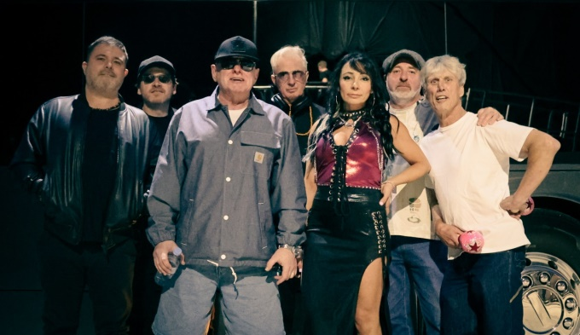

Happy Mondays Announce UK Tour for Spring 2026

Ahead of the 35th anniversary of their classic album ‘Pills ‘n’ Thrills And Bellyaches’, the Happy Mondays have confirmed a 22-date tour for March and April 2026.

Happy Mondays frontman Shaun Ryder, Bez (freaky dancing and percussion), Mark Day (guitar), Gary Whelan (drums), Dan Broad (MD/guitar/keys) and Firouzeh Berry (backing vocals) will perform the album’s highlights, including the massive hit singles, ‘Step On’, ‘Kinky Afro’ and ‘Loose Fit’, in addition to other hits and fan favourites, such as ‘24 Hour Party People’, ‘Hallelujah’, ‘Judge Fudge’ and ‘W.F.L.’.

The tour begins in Newcastle on 13th March and ends in Belfast on 24th April, and includes dates along the way at The Roundhouse in London (27th March) and a hometown show at Manchester’s O2 Victoria Warehouse (11th April).

Joining the tour as very special guests at all dates are The Farm and Northside, who were both on the bill for the Happy Mondays’ legendary 1991 concert at Elland Road in Leeds.

A venue pre-sale will take place from 9.00am on Wednesday 17th September, before going on general sale at 9.00am on Friday 19th September, available from www.alttickets.com and www.happymondaysofficial.co.uk.

Shaun Ryder said, “I’m really looking forward to getting back on tour with the Mondays in 2026, especially with our old mates The Farm who are touring with us.”

Bez added, “Really excited to be going back on tour again in the UK next year! I love being on the road with the Mondays, there is no better feeling than playing to the fans of live music. I'll see you all next year.”

Happy Mondays became the pioneers of the Madchester sound after signing to Tony Wilson’s Factory Records in the late ‘80s, blending their love of funk, rock, psychedelia and house with the sounds of the UK’s emerging rave scene.

The band became icons of Britain’s biggest cultural phenomenon for a generation when they crossed over into the mainstream with ‘Pills 'n' Thrills And Bellyaches’, which reached #4 in the UK Albums Chart following its release on 27th November 1990. It remained on the albums chart until the end of May 1991, establishing itself as one of the decade’s defining albums.

The Happy Mondays’ reputation as one of Britain’s most influential and loved bands was recognised in 2016 when they won the Ivor Novello Inspiration Award.

Very special guests The Farm made their breakthrough in 1990, with the first of their nine Top 40 singles being the huge hits ‘Groovy Train’ (#6) and the evergreen ‘All Together Now’ (#4), both of which featured on debut album ‘Spartacus’, which topped the Official UK Albums Chart following its release in March 1991.

The Farm’s lead singer Peter Hooton said, “We are absolutely delighted to be joining the Happy Mondays as special guests on their forthcoming tour. We go back a long way, having first met them at one of our gigs at the Boardwalk Manchester in 1986, when their style and attitude struck a chord. We also played with them at the legendary Elland Road gig in 1991 and toured with them in 2005, so we can’t wait for these gigs. It will be like a meeting of the tribes once again!”

Completing the bill will be the Happy Mondays’ fellow Mancunians and former Factory Records labelmates Northside, whose association with the burgeoning Madchester scene was cemented when their singles ‘Shall We Take A Trip’ (which was banned by the BBC for its references to LSD), ‘My Rising Star’ and ‘Take 5’ all made the UK Top 50 Singles Chart in 1990. The following year, Northside’s debut album ‘Chicken Rhythms’ reached #19 in the UK Albums Chart.

Northside’s lead singer Dermo said, “It's like Elland Road all over again, bit this time we're all on tour together. Bring it on!”

The full list of tour dates is as follows:

13 March - Newcastle, O2 City Hall
14 March - Leeds, O2 Academy
15 March - Nottingham, Rock City
20 March - Cardiff, DEPOT
21 March - Liverpool, Mountford Hall
22 March - Sheffield, The Octagon
26 March - Cambridge, Corn Exchange
27 March - London, Roundhouse
28 March - Southend, Cliffs Pavilion
29 March - Norwich, The LCR
02 April - Brighton, Dome
03 April - Bristol, Beacon Hall
04 April - Birmingham, O2 Academy
05 April - Bournemouth, O2 Academy
09 April - Margate, Dreamland
10 April - Guildford, G Live
11 April - Manchester, O2 Victoria Warehouse
16 April - Glasgow, Barrowland
17 April - Glasgow, Barrowland
18 April - Glasgow, Barrowland
22 April - Dublin, Vicar Street
24 April - Belfast, Mandela Hall

For more information contact warren@chuffmedia.com

