EMBARGO: 10AM FRIDAY 21ST MARCH

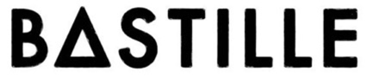
ANNOUNCE HUGE UK ARENA TOUR NOVEMBER 2025
“FROM ALL SIDES” – SONGS FROM THE FIRST FIFTEEN YEARS
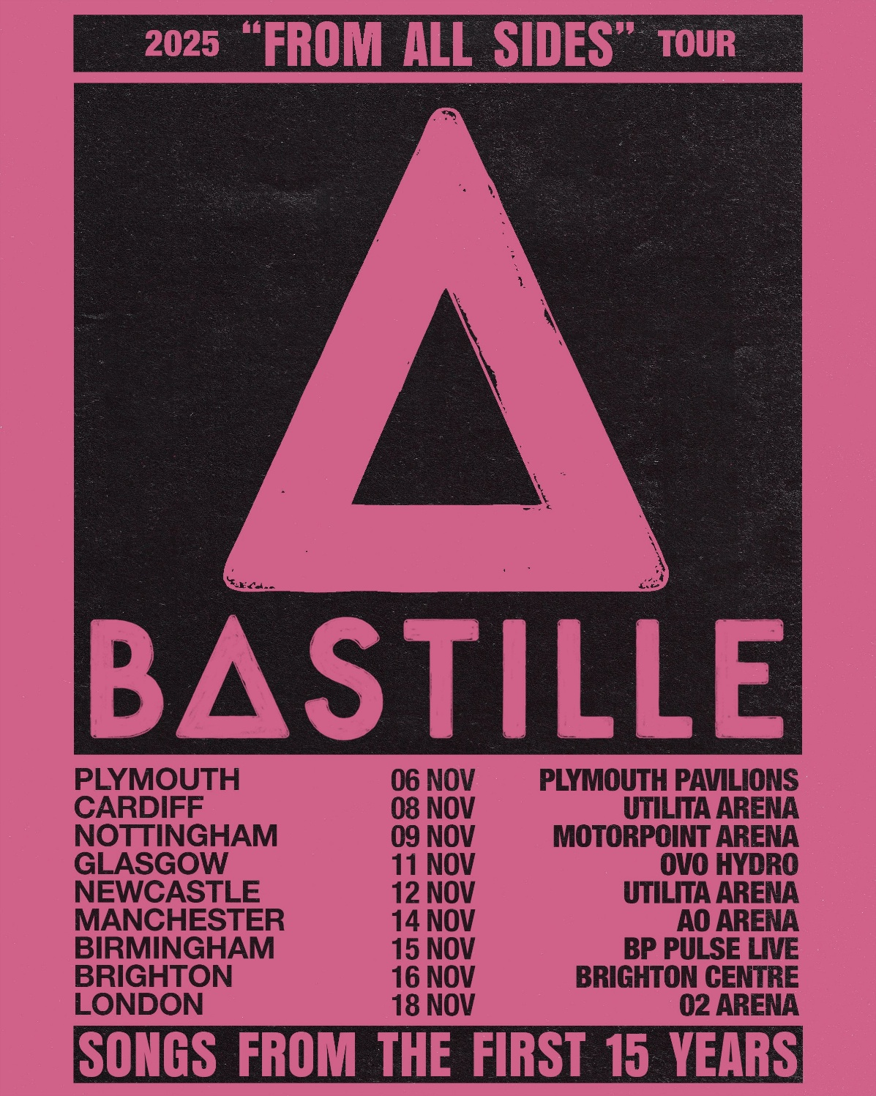
BASTILLE TO SUPPORT YOUTH MUSIC’S ‘RESCUE THE ROOTS’ CAMPAIGN

Ticket pre- sale Wednesday 25th March
General on-sale date Friday 28th March
Ticket link here

Friday 21st November – Today, one of the UK’s biggest and best live acts, multi – platinum selling band, Bastille announce a huge UK arena tour in November 2025. “From All Sides” – Songs from the first 15 years is a celebration of the band’s career-spanning, multi-billion streaming records so far.

Performing in nine cities across the UK, opening in Plymouth on the 6th November at the Plymouth Pavilions, continuing on to Cardiff, Nottingham, Glasgow, Newcastle, Manchester, Birmingham, Brighton, and finally culminating with a date at London’s O2 Arena on 18th November; the “From All Sides” shows will be the only opportunity to see the four piece – Dan Smith, Will Farquarson, Chris ‘Woody’ Wood and Kyle Simmons, perform live globally in 2025.

The band’s first UK arena shows in over three years, each show will feature songs from across Bastille’s entire discography - everything from fan favourites to deep cuts and intimate unplugged moments, rarities from the Other Peoples’s Heartache mixtapes, alongside seminal moments from across the band’s four top five charting albums, which includes three UK No 1’s - Bad Blood (2013), Wild World (2016), Give Me The Future (2022), and Doom Days, No.4 (2019).

On playing the tour, Bastille say, “We’re really excited to announce that we’re going on tour for the first time in a while to play the songs we all love from our first 15 years and beyond. Hope to see a load of you in November.”

Bastille are showing their support for grassroots youth music spaces by giving a tour donation to Youth Music's 'Rescue the Roots' campaign.

Youth Music, the UK’s leading charity helping marginalised young people make and monetise music, announced its urgent £1 million ‘Rescue the Roots’ fundraising campaign earlier this month to address the funding crisis threatening grassroots youth music projects across the country. The sector is currently at breaking point and without action, the future of young people’s lives in music will be even more bleak - a recent survey found that 41% of grassroots youth music projects are at risk of closure - an increase of 17% from last year.

Youth Music will match every pound raised up to £1 million to create a total of £2 million to quickly distribute to youth organisations and emerging young creatives who are in urgent need of support. Bastille's tour donation will therefore be match funded by Youth Music, doubling its impact.
In addition to the donation, Bastille will help support Youth Music's NextGen Community throughout the tour with mentoring sessions, giving young people wanting to get into the music industry insight and understanding on the live sector and arena tours.

Matt Griffiths, Youth Music CEO, says, “The crisis facing grassroots youth music projects is at breaking point. The lack of funding available is at critically low levels and the threat of closure for many is more imminent than ever. We're delighted to further develop our relationship with Bastille, who have also supported us previously, to help raise awareness and funds for our Rescue the Roots campaign while in addition to this, giving our NextGen Community vital insight and knowledge on how the live sector of the music industry works."

With over 13 million records sold, 3 No.1 albums, 6 UK top 40 singles and 2 billion video views, Bastille continue to be one of the world’s most streamed bands.

As the festival headliners bring their one-off celebratory shows to UK arena’s this autumn, “From All Sides” – Songs from the first 15 years will see fans experience a Bastille show like no other, one they’ll not want to miss.

“From All Sides” – Songs from the first 15 years – Full dates below.

Thu 6th November Plymouth, Pavilions
Sat 8th November Cardiff, Utilita Arena
Sun 9th November Nottingham, Motorpoint Arena
Tuesday 11th November Glasgow, OVO Hydro
Wed 12th November Newcastle, Utilita Arena
Friday 14th November Manchester, AO Arena
Saturday 15th November Birmingham, BP Pulse Live
Sunday 16th November Brighton, Centre
Tuesday 18th November London O2 Arena

BASTILLE: INSTAGRAM | TWITTER | FACEBOOK | TIKTOK | WEBSITE

About Bastille
Over the course of over a decade together, Bastille’s unique sound has connected with audiences across the globe like no other British band in recent memory.

The band’s chart-conquering twice No.1 debut album ‘Bad Blood’, which featured the international hit ‘Pompeii’, was the biggest-selling digital album of 2013. They became that year’s biggest-selling global breakthrough act, with over a billion Spotify streams earning them the British Breakthrough Act award at the 2014 Brits, along with two Grammy nominations. Since then, ‘Bad Blood’ has gone on to become triple platinum and sold over 1 million copies in the UK alone.

Fast forward to 2020 with two further album releases, Wild World (No.1 UK, 2016) and Doom Days No.4 UK 2019) and the release of their acclaimed documentary, Bastille Re-Orchestrated, Bastille were nominated for Best Group at the BRITs.
In 2022 Bastille released their fourth studio album, Give Me The Future, which was acclaimed by critics across the board, and shot straight to the top of the UK charts, earning the band their third No.1 album.

2023 was a year of celebration for the four-piece as they marked the 10-year anniversary of the release of their breakthrough debut album Bad Blood. The band released ‘Bad Blood X’, an extended edition of Bad Blood and have played a special series of sold-out Bad Blood X shows and festivals across the UK, Europe and the US. They also joined forces with multiple Academy Award® and Grammy®-winning composer Hans Zimmer to record Pompeii MMXXIII, a stunning rework of their era-defining international hit single. The track featured on the end credits of BBC’s Planet Earth III, with Bastille frontman, Dan Smith working on the music across every episode alongside Hans Zimmer and Bleeding Fingers. In 2024 the band took a year’s hiatus with a break from touring.

With over 13 million records sold, 3 No.1 albums, 6 UK top 40 singles and 2 billion video views, Bastille continue to be one of the world’s most streamed bands.

About Youth Music - Equalising access to music.
We’re a national charity. We help marginalised young people to make and monetise music. Every year, we raise £10 million to fund inspirational grassroots music projects and support aspiring young creatives up and down the UK. We’re campaigning to break down barriers for young people facing inequity, exclusion and discrimination. Together with our partners, we’re helping the next generation to transform their lives through music. Join Us. For more information on Rescue the Roots, please visit: https://www.youthmusic.org.uk/rescue-the-roots

For more information and press enquiries please contact
Jenny Entwistle
Jenny@chuffmedia.com

