GOOD NEIGHBOURS
Return with new single ‘People Need People’
LISTEN/WATCH

- UK and Ireland Tour Announced for February 2026

Debut album Blue Sky Mentality - due for release on September 26th, 2025
PRE-ORDER


Good Neighbours return this week with stirring new single ‘People Need People’ – the final preview of their debut album Blue Sky Mentality, out September 26th via Polydor Records.
Premiering on Wednesday night as BBC Radio 1’s Hottest Record, ‘People Need People’ is a widescreen anthem centered on friendship, solidarity and the moments we lean on each other most. With luminous synths, pulsing percussion and a soaring chorus made to be sung shoulder-to-shoulder, it’s a rousing reminder that no one has to go it alone.
Speaking about the track, the band share: “The title is everything the track is about. When we started this band, we were in and out of jobs and struggling with staying afloat. Luckily, we had an amazing group of mates around us who we’ve seen laugh and cry when the going gets tough. The song should be an arm around the ones you love.”
‘People Need People’ follows the euphoric rush of recent singles ‘found u/me’ and ‘Suburbs’, as well as the duo’s radiant cover of The La’s ‘There She Goes’ for Amazon Music. Together, the tracks showcase the depth and range of Blue Sky Mentality – a debut album that smuggles big feelings into even bigger choruses, uniting listeners in moments of catharsis, joy and release.
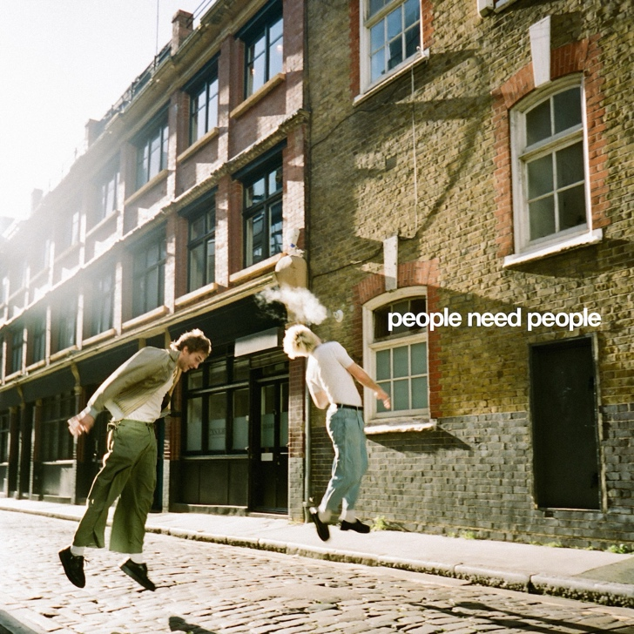
‘People Need People’ Artwork
The announcement comes alongside exciting news of the duo’s biggest UK & Ireland tour to date, set for February 2026, with shows across the UK and Ireland. Full itinerary below, tickets available HERE.
Over the bank holiday weekend Good Neighbours took to the Main Stage at Reading & Leeds Festival, bringing their anthems to huge crowds - a landmark moment that further cemented them as one of the UK’s most exciting new live acts. Watch them perform ‘Suburbs’ HERE and see clips from ‘Home’ HERE.
It followed the real sense of homecoming that was the announcement of Blue Sky Mentality, where Scott and Oli marked the moment with a sweat-soaked, sold-out show at London’s Sebright Arms – the very venue where they played their first ever gig just 18 months ago, in November 2023.
Written across a whirlwind year of long-haul flights, tour buses, hotel rooms and emotional highs and lows, the album captures the tension between distance and belonging – the pull of community, the need for connection, and the journey back to yourself. It’s a record that wears its heart loudly and proudly: a 14-track burst of euphoric indie-pop that smuggles big feelings – grief, love, hope, resilience – into massive choruses and sun-streaked synths. From their viral debut ‘Home’ to fan favourites ‘Keep It Up’, ‘Ripple’ and ‘Starry Eyed’, Blue Sky Mentality is both a document of their meteoric rise and a rallying cry for openness, optimism and togetherness.
Speaking on the album, the band share:“Blue Sky Mentality has been our motto since day one. Our band began as a kind of light relief - a creative outlet to break from jobs that we couldn’t stand and some tough personal times. Over the last year, we ran with that feeling, writing our debut album on the road - in the back of tour buses, hotel rooms, and scattered corners of the world. That’s what Blue Sky Mentality means to us - finding light, friendship and a sense of escapism wherever you are.”

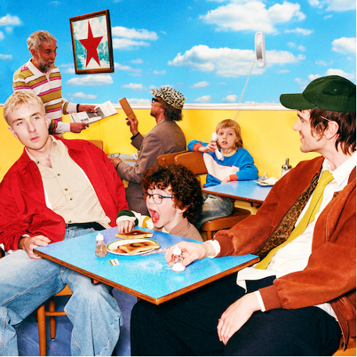
(LP Artwork)

Blue Sky Mentality tracklist:
1. Keep It Up
2. Skipping Stones
3. Ripple
4. found u/me*
5. Walk Walk Walk
6. Kids Can’t Sleep
7. Home
8. Small Town
9. Starry Eyed
10. People Need People
11. Left Hand Man
12. Suburbs
13. Wonderful Life
14. The Buzz
*Vinyl edition includes ‘Somebody’ instead of ‘found u/me’
UK Indie Store tour dates:
22-Sep Bristol Rough Trade
23-Sep Birmingham HMV, The Vault
25-Sep London Kingston Circuit with Banquet Records
26-Sep Liverpool Jacaranda Baltic
27-Sep Leeds Wardrobe with Crash Records
29-Sep Edinburgh Caves with Assai
30-Sep Nottingham The Saltbox with Rough Trade
UK Tour Dates 2026:
12-Feb Glasgow SWG3
13-Feb Manchester New Century Hall
14-Feb Sheffield Foundry
16-Feb Birmingham O2 Institute
17-Feb London O2 Forum Kentish Town
18-Feb Brighton Chalk
20-Feb Bristol The Electric
21-Feb Oxford O2 Academy 1

Follow Good Neighbours:
TIKTOK | INSTAGRAM | TWITTER/X | FACEBOOK | YOUTUBE

For more information and press enquiries please contact

Jenny Entwistle
Jenny@chuffmedia.com

