
FLORENCE + THE MACHINE
ANNOUNCES UK & EU TOUR
TICKETS
NEW ALBUM
EVERYBODY SCREAM
OUT ON HALLOWEEN
PRE-ORDER
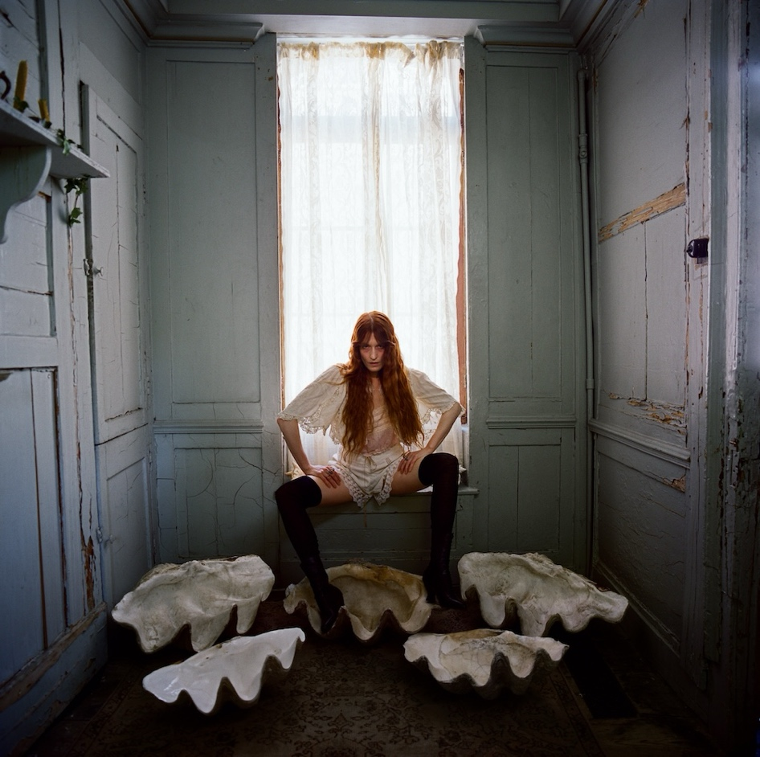
Today, Florence Welch - also known as Florence + The Machine - announces her UK & EU tour to celebrate the release of her sixth studio album Everybody Scream, set for release on October 31. She will be bringing the magic to life across major strongholds including two nights at London’s O2 Arena, the Accor Arena in Paris and the Tauron Arena in Krakow. Florence will be joined by Paris Paloma who will be opening the shows across the eighteen dates for the Everybody Scream tour.
The album’s title track was released last week with an accompanying video directed by Autumn de Wilde. Everybody Scream was written and produced by Florence Welch over the past two years with a close-knit circle of collaborators including Mark Bowen of IDLES, who appears in the video for the single, Aaron Dessner and Mitski.
After needing lifesaving surgery on the Dance Fever Tour, Florence’s recovery took her down the path of spiritual mysticism, witchcraft and folk horror as she felt the limits of her body and explored what it means to be “healed”. The album treads through womanhood, partnership, aging and dying; exposing the murky in the mundane.
Across five albums - 2009’s Lungs, 2011’s Ceremonials, 2015’s How Big, How Blue, How Beautiful, 2018’s High As Hope and 2022’s Dance Fever - Florence has become one of the most monumental artists of a generation, with multiple US and UK #1 albums and countless awards. Known for her earth-shattering live show and singular, iconic voice, Florence has sold out shows and headlined festivals the entire world over. She has collaborated and shared stages with icons - The Rolling Stones, Lady Gaga and Taylor Swift among them - and published a book of lyrics, poetry and drawings, Useless Magic.


(Album cover, credit Autumn de Wilde)

EVERYBODY SCREAM UK + EU TOUR 2026
6 February - Belfast - SSE Arena
8 February - Birmingham - bp pulse Live
9 February - Glasgow - OVO Hydro
11 February - Newcastle - Utilita Arena
13 February - Liverpool - M&S Bank Arena
14 February - Sheffield - Utilita Arena
16 February - London - The O2
17 February - London - The O2
20 February - Manchester - Co-op Live
22 February - Paris - Accor Arena
23 February - Antwerp - Sportpaleis
25 February - Amsterdam - Ziggo Dome
26 February - Cologne - Lanxess Arena
2 March - Vienna - Stadthalle
4 March - Munich - Olympiahalle
5 March - Prague - 02 Arena
7 March - Krakow - Tauron Arena
9 March - Berlin - Uber Arena
Follow Florence HERE

For more information, please contact jenny@chuffmedia.com

