FC BULLARD LIVE!
THE CHAOS HITS THE ROAD IN 2026!
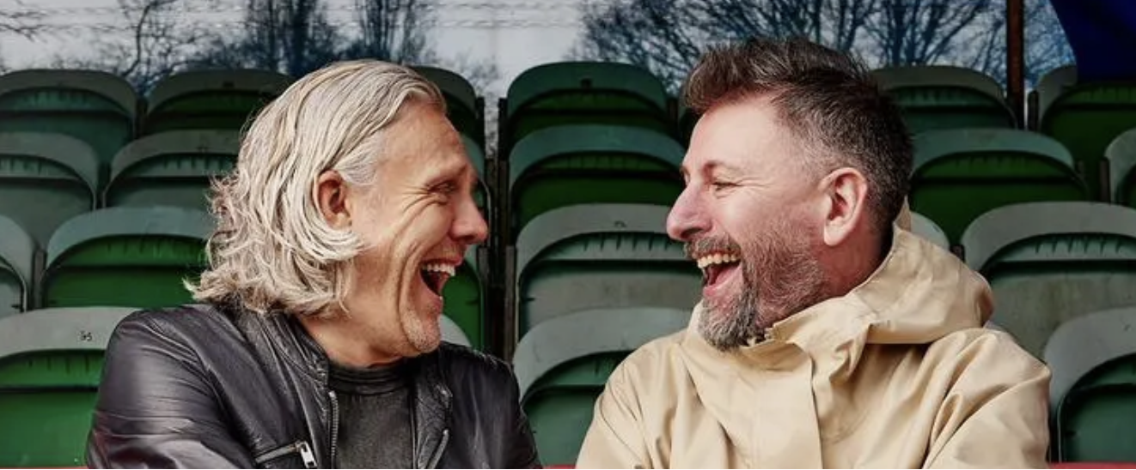

Jimmy Bullard & Fenners take their hit podcast from the studio to the stage in a brand-new UK tour

VENUE PRESALES - Wednesday 6th August @ 10am
GENERAL SALE - Friday 8th August @ 10am

Prices from £27.50 @ www.seetickets.com/tour/fc-bullard
Football fans, brace yourselves, Jimmy Bullard and John “Fenners” Fendley are hitting the road in 2026 with their laugh-a-minute live show FC Bullard Live!, bringing their chaotic, comedy-fuelled podcast to venues across the UK and it promises to be as unpredictable and entertaining as a last-minute winner in the pouring rain.

The duo behind the smash-hit podcast FC Bullard are heading out on a nationwide tour that promises stories, shambles, games, guests and gallons of laughter. If you’ve ever wondered what it takes to build a football club from scratch, this isn’t the night for you. But if you want an evening of absolute mayhem with two of football’s best-loved personalities, then welcome to the club.
FC Bullard is the brainchild of Jimmy Bullard, former Premier League cult hero turned broadcaster and Fenners, long-time producer and presenter of the iconic Sky Sports show Soccer AM. In the podcast, they attempt to build a football club from the ground up: no kit, no badge, no players, and absolutely no idea what they’re doing. Each episode they welcome footballing legends, celebrities and grassroots heroes as they figure it out in real-time, one disaster at a time.
And now they’re bringing that chaos to a stage near you.
Expect behind-the-scenes stories from their wild careers, live games, utter nonsense, and a few surprises along the way. Whether you’re a hardcore footy fan or just in it for the laughs, this will be a night to remember.
Tour dates:

15-Feb-26 Manchester The Hall at Aviva Studios
16-Feb-26 Hull Connexin Live
18-Feb-26 Cardiff Depot
20-Feb-26 Birmingham Town Hall
21-Feb-26 Wolverhampton Wulfrun Hall
22-Feb-26 Nottingham Theatre Royal
23-Feb-26 Sheffield City Hall
1-Apr Newcastle Tyne Theatre & Opera House
3-Apr Stoke Victoria Hall
4-Apr London Shepherds Bush Empire

Jimmy Bullard is a former professional footballer who lit up the Premier League with his sharp wit and sharp elbows. Known for his time at clubs like Wigan Athletic, Fulham, Hull City, and Ipswich Town, he became a fan favourite for his technical flair, fearless style of play, and offbeat humour. His infamous goal celebration at Hull — recreating Phil Brown’s team talk — is the stuff of football folklore.
Since retiring from the game, Jimmy has carved out a successful media career, appearing on shows like I’m A Celebrity… Get Me Out of Here! and co-hosting Soccer AM for six seasons, where he brought his trademark mischief to Saturday mornings.
John “Fenners” Fendley started out behind the camera, producing TV classics including Soccer AM, before stepping in front of it to become the show’s full-time host in 2015. A genuine fan of the game with a deep love for grassroots football and a knack for quick-witted banter, Fenners has spent two decades shaping the tone of football entertainment in the UK.
Together, Jimmy and Fenners are the ultimate double act — a blend of professional footballing chaos and top-tier media chops. FC Bullard is their joint creation: part football podcast, part comedy sketch, part total shambles – and fans can’t get enough of it.
UP THE PIRATES! 🏴‍☠️
FC Bullard. Welcome to the club.

For all interview & media enquiries contact warren@chuffmedia.com on 07762 130510

