EMPIRE OF THE SUN

ANNOUNCES RUN OF UK SHOWS THIS SUMMER

TICKETS ON SALE NOW
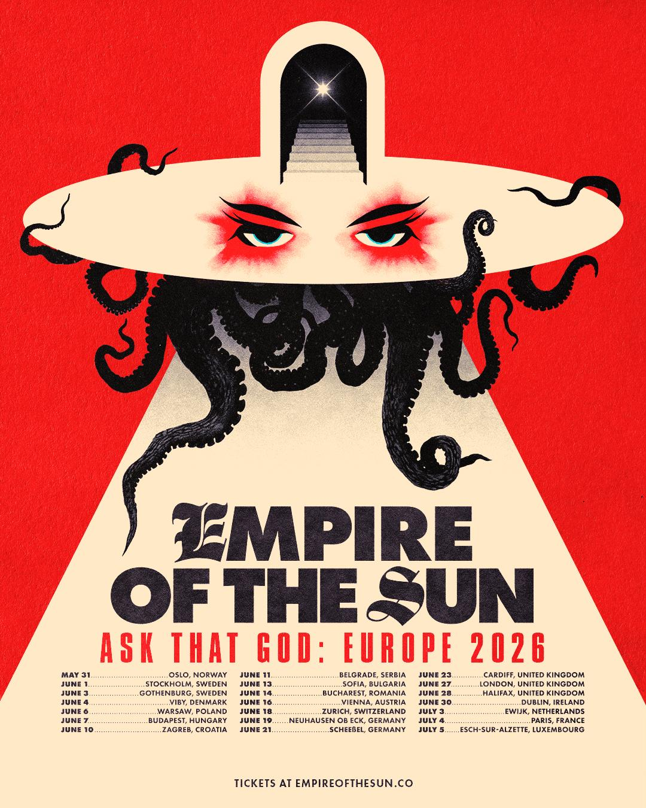

Visionary electronic luminaries Empire of the Sun will illuminate the UK this summer. Delivering a spellbinding evening of anthemic soundscapes, ethereal storytelling and extraordinary visual artistry, expect to be immersed into a world of pure imagination, perfectly suited to their larger-than-life performances.

Empire of The Sun’s upcoming run will see them revisit countries from their hotly anticipated 2025 European tour - their first shows in the region in six years - and bring the show for the first time to Ireland, Norway, Sweden, Austria, Denmark and more.

With a discography spanning four critically acclaimed studio albums, billions of streams, and major remixes and reimaginings - including their recent Alive (Reimagined) EP - Luke Steele and Nick Littlemore consistently push sonic boundaries and have built a world around the project that is all their own.

Their highly anticipated 2024 album Ask That God signalled a new era for the duo, arriving as their first album in eight years and blending existential themes with their quintessential imaginative and nostalgia-tinged synth-pop sound. Featuring fan favourites Changes, Cherry Blossom, and Music On The Radio, Ask That God has garnered more than 500million global streams and enchanted listeners and live audiences around the world.

Empire of the Sun’s ever-captivating live shows rest on the fringe of fantasy and reality, shepherding audiences into a kaleidoscopic world of spectacular visuals, theatrical performance, and larger-than-life production. The band’s Ask That God Tour 2025 became a landmark global run, selling out headline shows across North America and Europe while showcasing the band’s most ambitious live production to date. In North America, the tour drew crowds in major cities including Los Angeles, New York, Chicago, Toronto, Denver and Berkeley, highlighted by a sold-out Red Rocks Amphitheatre performance and festivals including Austin City Limits, CRSSD, and Just Like Heaven.

Across Europe, Empire of the Sun continued the momentum with sold-out dates in London, Paris, Berlin, Amsterdam, Milan, Barcelona and Lisbon, including an instantly sold-out show at Alexandra Palace in London and major summer festival stages. The tour also extended to South America, where the band appeared at flagship festivals including Lollapalooza Brasil (São Paulo) and Estéreo Picnic (Bogotá), reaffirming Empire of the Sun’s enduring global appeal and their status as one of the most visually and sonically distinctive live acts in the world.

Playing beloved classics like Walking On A Dream, We Are The People, Alive, and High and Low, as well as tracks from Ask That God, Empire of the Sun’s upcoming European tour promises fans an immersive and unforgettable live experience.

Tickets are on sale now.

EMPIRE OF THE SUN
ASK THAT GOD UK 2026

June 23 - TK Maxx Presents Depot Live at Cardiff Castle- Cardiff, United Kingdom
June 26 - Alexandra Palace - London, United Kingdom
June 27 - Alexandra Palace - London, United Kingdom
June 28 - TK Maxx presents Live at The Piece Hall - Halifax, United Kingdom

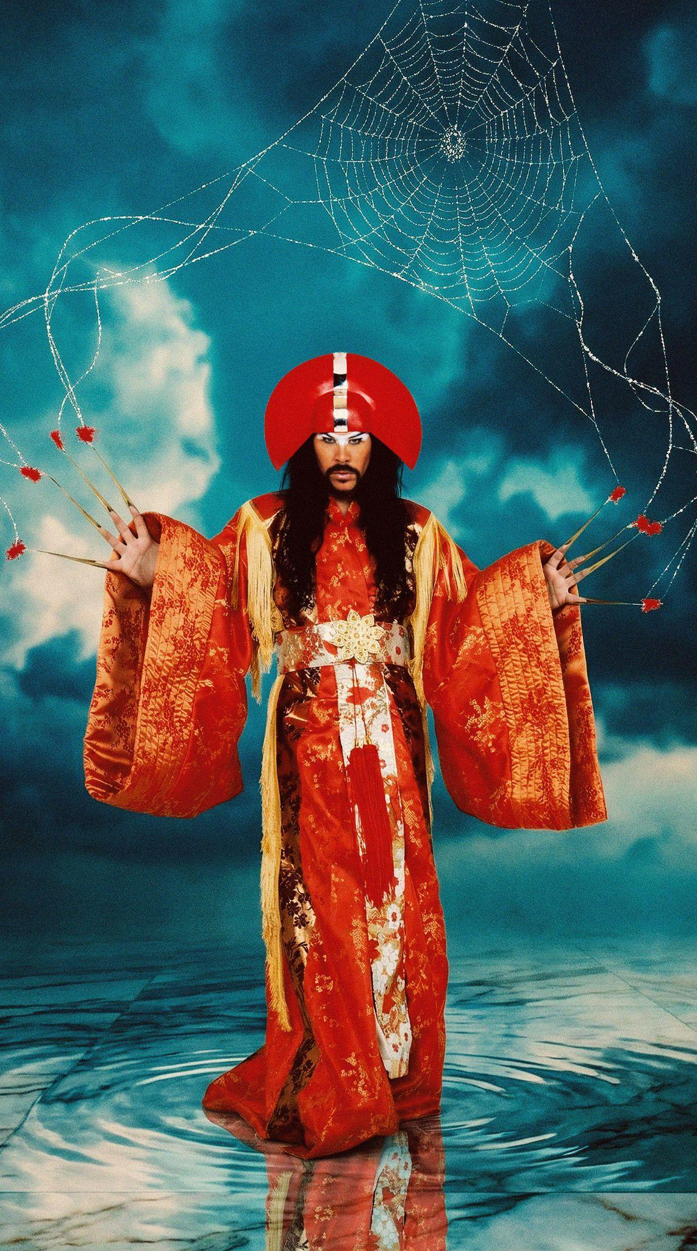
DOWNLOAD HIGH-RES PRESS PHOTO HERE

ABOUT EMPIRE OF THE SUN
Empire of the Sun are the architects of one of music’s most visionary universes — a world where sound, art, and myth converge in radiant color. The Australian duo Luke Steele and Nick Littlemore create not merely albums, but entire worlds: portals of imagination where pop becomes celestial and the ordinary dissolves into the extraordinary. Their debut album, Walking On A Dream, launched a global phenomenon. Its title track became a generational anthem, now enshrined in Spotify’s Billions Club, and continues to inspire millions with its ethereal optimism and timeless spirit. Empire of the Sun’s melody, surrealism, and emotional gravity set a new bar for conceptual pop, earning multi-platinum certifications across the US, UK, and Australia and introducing the band’s unmistakable visual language to the world. From the cosmic adventures of Ice on the Dune to the lush futurism of Two Vines and the transcendental explorations of Ask That God, Empire of the Sun have consistently expanded the boundaries of what a music project can be. Their body of work — spanning 5 million albums sold, over 6 billion global streams, and a mantle of eight ARIA Awards and two APRA Awards — has cemented them as one of the most innovative and influential creative forces of the 21st century.

DISCOVER EMPIRE OF THE SUN
OFFICIAL WEBSITE | INSTAGRAM | YOUTUBE | SPOTIFY | APPLE MUSIC

For more information and press enquiries please contact

Warren & Harry
@chuffmedia.com

