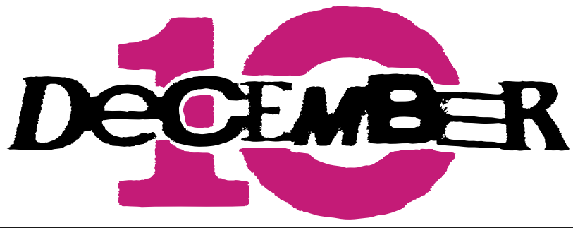

DECEMBER 10 ANNOUNCE DECEMBER 10: THE NEXT STEP

Britain’s breakthrough new boyband set for a headline UK & Ireland tour

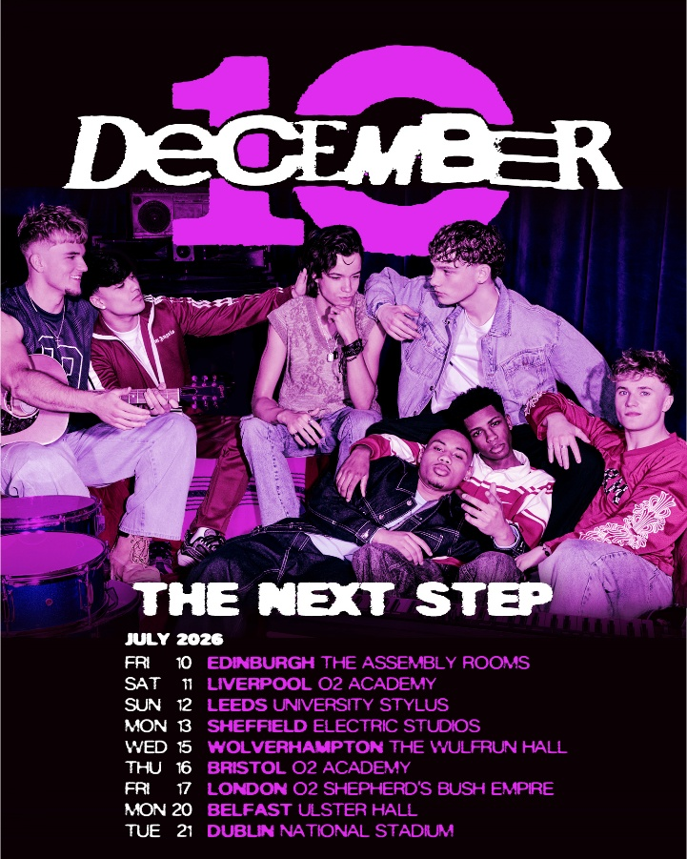

DOWNLOAD IMAGERY:
December 10 Hi-Res Press Shots HERE
Tour Artwork HERE

London, UK, 2 April 2026 - Britain’s brand-new boyband December 10 today announce December 10: The Next Step – kicking off in Edinburgh on Friday 10 July and wrapping in Dublin on Tuesday 21 July (see below for full list of dates and details).

"We loved our Introducing! run of shows - as in LOVED - that was collectively the favourite week of our lives… so it was time to take the next step and go on the road again. Hendrik came up with the name when we were at dinner yesterday in Tokyo, as this tour really feels like us taking the next step... We are buzzing to add new music to the set list and get back on the tour bus and on the road." - December 10

General tickets for the December 10: The Next Step UK shows will be available to purchase from 10am BST on Friday 10 April HERE (UK) and HERE (Ireland). For details of a very special fan presale (from 10am BST on Thursday 2 April), head to www.december10.com.

The announcement of December 10: The Next Step arrives ahead of December 10’s upcoming O2 Priority headline show at O2 Shepherd’s Bush Empire on 8 April, where demand has already exceeded capacity fourfold. It follows their first-ever festival appearance at Ultra Teen Fest in Japan and their Introducing! run in February, which saw them perform 13 sold-out shows across the UK and Ireland to more than 6,500 fans, with additional dates added twice in response to overwhelming demand.

Less than four months on from their reveal on Netflix’s global series Simon Cowell: The Next Act, and newly signed to EMI Records, December 10 are moving at a relentless pace. They have already amassed millions of followers across social platforms, over 600,000 monthly listeners on Spotify and over 6 million organic YouTube views across the official music video and stripped-back performance for their debut single “Run My Way”; the official music video and stripped-back performance for recently released “Angel”; and their stripped-back take on NSYNC’s “Bye, Bye, Bye”.

Formed on camera during Netflix’s docuseries Simon Cowell: The Next Act, (released worldwide on 10 December 2025), December 10 have quickly built a devoted fanbase through their live shows and online following. The hugely fun, charismatic and high-energy septet consists of Cruz (19), Danny (17), Hendrik (19), John (17), Josh (17), Nicolas (17) and Seán (19).

They’re not just brilliant singers, but accomplished musicians too, playing 14 instruments between them: Nicolas plays guitar and harmonica; Danny plays guitar; Josh plays guitar, cajón and drums; Hendrik plays guitar, bass and piano; Seán plays guitar, piano and harmonica; while John was due to take Grade 8 clarinet and piano this year — until life got a bit busy.

December 10 are very much a boyband for our times: a truly inclusive group representing Chorley, Rochester, Dublin, London, Lisbon and Walsall, with Irish, Brazilian, Indian, Nigerian and Jamaican heritage between them. Their musical influences are just as expansive - from Fela Kuti, Daft Punk, Brent Faiyaz and Steve Lacy to Pearl Jam, Freddie Mercury, The Notorious B.I.G., Catfish and the Bottlemen, Sabrina Carpenter and Usher, alongside Brazilian icons like Legião Urbana and Cazuza.

Fun, high-energy and utterly endearing, December 10 are rapidly carving out their place among Britain’s most talked-about new pop bands.

DECEMBER 10: THE NEXT STEP

Fri 10 July - Assembly Rooms, Edinburgh
Sat 11 July - O2 Academy Liverpool, Liverpool
Sun 12 July - Styles, Leeds
Mon 13 July - Electric, Sheffield
Wed 15 July - Wulfrun Hall, Wolverhampton
Thu 16 July - O2 Academy, Bristol
Fri 17 July - O2 Shepherd’s Bush Empire, London
Mon 20 July - Ulster Hall, Belfast
Tue 21 July - National Stadium, Dublin

Follow December 10 here: WEBSITE INSTAGRAM TIKTOK

For more information and press enquiries please contact warren@chuffmedia.com

