CREEPING JEAN
NEW SINGLE DESERT SAUCE
UK HEADLINE TOUR SEPT & OCT
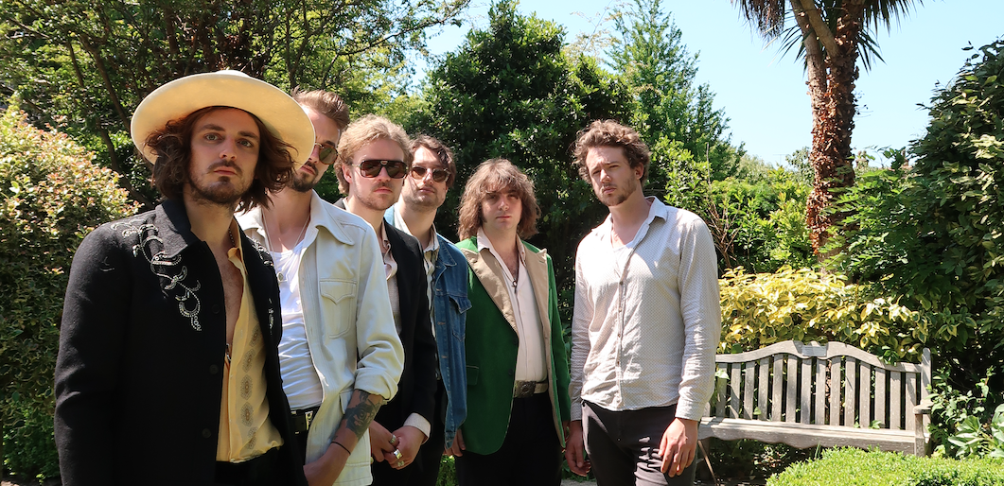

Putting a modern twist on the vintage 60s & 70s sound, Creeping Jean are a Brighton six piece offering up huge Indie-Rock tunes to cut through the haze. Having picked up ongoing support from BBC Radio 6 Music, Radio X, BBC Radio 2 and BBC Introducing among others, the band are now back with new single 'Desert Sauce' ahead of their upcoming UK tour.
Taking a full throttle approach on the opening of ‘Desert Sauce’, Creeping Jean quickly build momentum with a wall of biting guitars, warm keys and tight, punching drums. Olly’s incisive vocal take demonstrates his effortless ability to bring a charismatic energy to the track as he delivers tongue in cheek, dessert laden innuendos one by one. Bringing together influences such as Jack White and The Doors, ‘Desert Sauce’ truly captures the tight yet electrifying and explosive nature of their live shows, showcasing them as one of the UK’s most exciting up and coming Indie Rock outfits.
Speaking on the new single, Lead singer Olly said: “Having a real sweet tooth and a love for desserts, we word played innuendos as we carved a desert rock sounding record with a title switch from ‘dessert sauce’ into one that would be a no.1 hit for any cake maker. Savoy truffle by the Beatles was a little inspiration as well.”
Having sold 5 thousand pairs of converse via their Brighton based shop ‘Waiste Vintage’ and at Carboot sales, Creeping Jean are a homegrown band with a stadium sound thundering their way towards success in 2021. With previous appearances at festivals including Isle Of White, The Great Escape and Truck Festival, Rave reviews from the likes of Gigslutz and a previous tour with Temples under their belt, the band are set to double down on their successes with a full UK tour booked for the autumn:
25 Sept Southampton, Joiners
29 Sept liverpool, EBGBs
30 Sept Manchester, Gullivers
1 Oct Brighton, Patterns
8 Oct Sheffield, Record Junkie
9 Oct London, Shacklewell Arms
22 Oct Birmingham, The Dark Horse
For more information please contact warren@chuffmedia.com on 07762 130510

