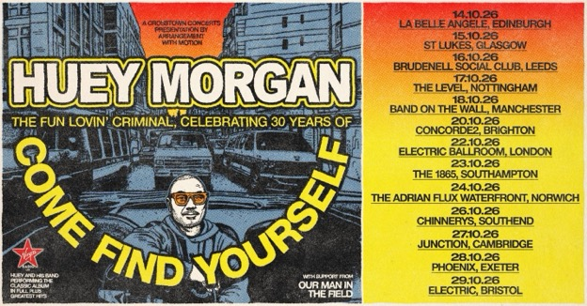

13-DATE UK TOUR – OCTOBER 2026
Ticket presale 9am, 3rd March / General onsale 9am, 5th March
Tickets available via Hueymorgan.com

After founding Fun Lovin' Criminals and writing and producing their seminal hits, Huey Morgan marks 30 years since the release of Come Find Yourself with a brand-new band and a 13-date UK tour this October. Three decades on from the era-defining debut that gate crashed the Britpop party with unmistakable New York swagger, Morgan is reclaiming the songs that changed his life and soundtracked a generation.

When Come Find Yourself landed in 1996, it didn’t simply arrive, it exploded. Amid Britpop’s euphoric blur, Fun Lovin’ Criminals carved their own lane with a cinematic, genre-hopping sound that fused rock ’n’ roll, funk, blues, soul, hip hop, jazz and Latin rhythms into something effortlessly cool and completely original. Streetwise yet sophisticated, it was a Lower East Side state of mind delivered with groove-heavy basslines and razor-sharp storytelling.

“After 30 years, this record seems as fresh as it did when I first released it. I am so happy to be playing this again. Please come and check it out. It's gonna be awesome.” Huey Morgan

Breakout single Scooby Snacks famed for sampling dialogue from Reservoir Dogs and Pulp Fiction became an instant cult classic, propelling the album into the UK charts for nearly two years. From collecting glasses at Manhattan’s legendary Limelight nightclub to world tours and a raucous Pyramid Stage appearance at Glastonbury Festival in 1999, the Criminals quickly became one of the era’s most charismatic live acts, touring with U2 and collaborating with the late great B.B. King.

Morgan’s voice remains unmistakable. A respected broadcaster and cultural commentator, he now hosts weekends on Virgin Radio and has built a parallel career as an author and television presenter renowned for his encyclopaedic knowledge of music and film.

This October 2026 tour brings it full circle. Across 13 UK dates, Huey Morgan revisits the swagger, groove and storytelling brilliance of Come Find Yourself, performing the songs he wrote and produced with the fire and finesse that made them classics. Thirty years on, the stories still cut, the grooves still swing, and the cool remains undeniable.

The Fun Lovin’ Criminal wasn’t just the name of his platinum ’90s anthem, it’s who he is. Accept no imitations. The King of New York is back.

UK TOUR DATES:

14-Oct-26 Edinburgh La Belle Angele
15-Oct-26 Glasgow St Lukes
16-Oct-26 Leeds Brudenell Social Club
17-Oct-26 Nottingham The Level
18-Oct-26 Manchester Band On The Wall
20-Oct-26 Brighton Concorde 2
22-Oct-26 London Electric Ballroom
23-Oct-26 Southampton The 1865
24-Oct-26 Norwich Waterfront
26-Oct-26 Southend Chinnerys
27-Oct-26 Cambridge Junction
28-Oct-26 Exeter Phoenix
29-Oct-26 Bristol Electric

All media assets here.

For more information contact Warren@chuffmedia.com on 07762 130510



