Presents

CATALOGUE:
THE HITS TOUR

15th November to
18th December
PRE-SALES - Wednesday 20th March, 10am
GENERAL SALES - Friday 22nd March, 10am

Via Midgeure.co.uk/shows

Media assets here
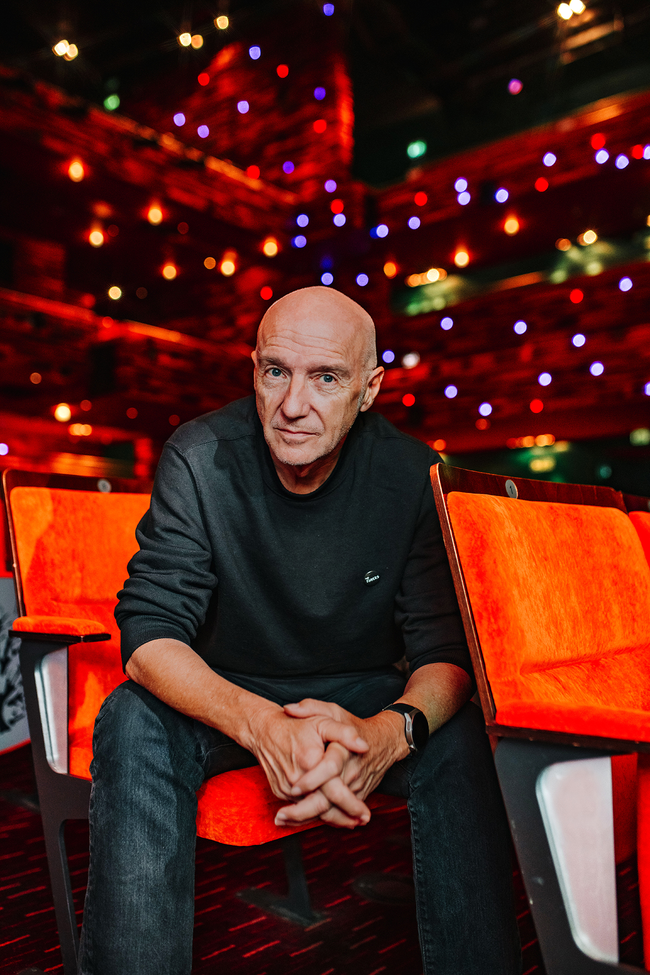

Having celebrated his 70th birthday with a sold out show at the historic Royal Albert Hall in October 2023, Midge is keen to continue the celebration of his life in music by announcing a new 23 date UK tour for November and December 2024.

The tour will give Midge the opportunity to showcase the musical breadth and versatility of his extensive song catalogue written during the past 50 years; giving old and new fans alike a truly remarkable night of hits and rarely heard gems.

Midge says “I performed live long before I was ever allowed anywhere near a recording studio and as much as I love spending time writing and recording, live music remains my first love. This ‘Catalogue’ tour will allow me to not only play a wide selection of hits from my past but perform some of the most requested favourites. Revisiting these moments from my musical life is something I am really looking forward to sharing”.

Midge Ure has had an unrivalled career earning him Ivor Novello, Grammy and BASCAP awards along with a flotilla of gold and platinum records during the past five decades. His story includes the early teen glam rock of Slik, his foray with The Sex Pistols Glen Matlock for The Rich Kids into the 80’s which saw him secure his place in musical history not just as part of Ultravox and Visage who helped shape the new romantic and electro-pop era, but as producer and co-writer of Band Aid’s ‘Do They Know It’s Christmas?’ which led to Live Aid, the summer 1985 global concert that, all exaggeration aside, spoke for a generation.

15-Nov-24 Bournemouth Pavilion
17-Nov-24 Truro Hall For Cornwall
18-Nov-24 Torquay Princess Theatre
19-Nov-24 London Palladium
22-Nov-24 Portsmouth Guildhall
23-Nov-24 Oxford New Theatre
24-Nov-24 Cardiff New Theatre
25-Nov-24 Leicester De Montfort Hall
27-Nov-24 Ipswich Regent Theatre
29-Nov-24 Guildford G-Live
30-Nov-24 Sheffield City Hall
1-Dec-24 Birmingham Symphony Hall
3-Dec-24 Hull City Hall
4-Dec-24 Gateshead Glasshouse
5-Dec-24 Scarborough Spa Theatre
7-Dec-24 Liverpool M&S Bank Arena Auditorium
8-Dec-24 Leeds Grand Theatre
9-Dec-24 Manchester Bridgewater Hall
12-Dec-24 Aberdeen Music Hall
13-Dec-24 Perth Concert Hall
14-Dec-24 Edinburgh Usher Hall
18-Dec-24 Glasgow Royal Concert Hall

For all media enquiries please contact
Warren@chuffmedia.com on 07762 130510

