BREE RUNWAY ANNOUNCES DEBUT UK HEADLINE TOUR
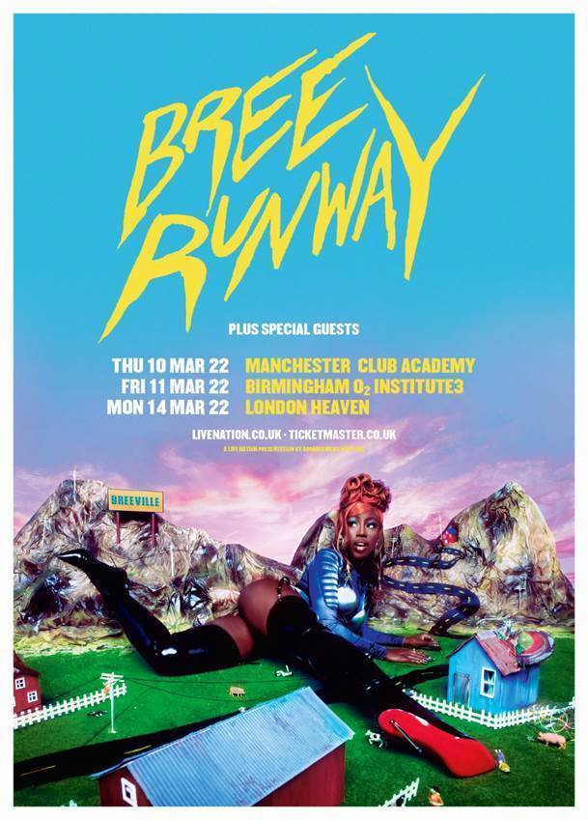

“STATEMENT OF INTENT FROM A SUPERSTAR IN WAITING” NME *****

“EXPECT TO SEE HER PLAYING ARENA’S SOON” EVENING STANDARD ****

PRE SALE WEDNESDAY 17TH
GENERAL ONSALE THURSDAY 18TH
^{(LINKS BELOW )}

Fast-rising, pop phenomenon Bree Runway, has announced her highly anticipated debut tour, set to take place in March 2022. Taking in Manchester and Birmingham before ending in her hometown of London at Charing Cross’s Heaven.

Cementing herself as one of the breakout stars of 2021, Bree kicked off the year shortlisted for BBC Sound of 2021. Single releases from her widely acclaimed 2000AND4EVA Mixtape including, ATM, Gucci and HOT HOT have garnered huge global acclaim with Bree scoring a BET Award for Best New International Act (viewer’s choice) and co-signs from the likes of Doja Cat, Chloe Bailey — whom she cameoed for on “Have Mercy” — Khalid, as well as rap behemoth Cardi B. The Hackney-born singer also featured on Lady Gaga’s Dawn Of Chromatica Remix album released in September, securing what she calls the “feature of a lifetime”. Last week Bree also received two MOBO nominations for Best Female and Video of the Year for HOT HOT.

Embracing a DIY approach to her ascent to super-stardom, Bree Runway has quickly amassed a fervent grassroots loyal following. Sonically, Bree is an enigma, forever evolving global pop into her own contortions, and never one to shy-away from fashion, she’s become a muse for some of the world’s biggest labels - Gucci — synced the star’s song of the same name just days ago. As she mentions in her 2021 PAPER cover story “It’s beyond the music, it’s a lifestyle.”

The tour announcement comes weeks after Bree’s sold-out inaugural, back-to-back headline performances at Colours in London which saw the emerging super-star’s flair for live performances. Packed with showmanship and an undeniable, instantaneous star-appeal, Bree Runway is destined to lead by example on her 2022 live shows. Scoring a flawless 5 stars from NME and with the Evening Standard declaring Bree as a “super-star in waiting” her biggest UK shows to date promise to be the live launch of Bree’s impending pop domination for the year ahead.

BREE RUNWAY - ‘BREEVILLE’ – 2022 Tour Dates:
Thu, 10 Mar - Manchester, Club Academy
Fri, 11 Mar - Birmingham, O2 Institute3
Mon, 14 Mar - London, Heaven

PRESALE LINKS
Manchester
Birmingham
London
General Sale

For more information & media enquiries contact warren@chuffmedia.com

