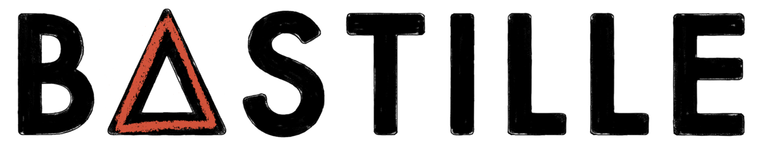
ANNOUNCE SERIES OF SPECIAL ‘BAD BLOOD X’ SHOWS 2023

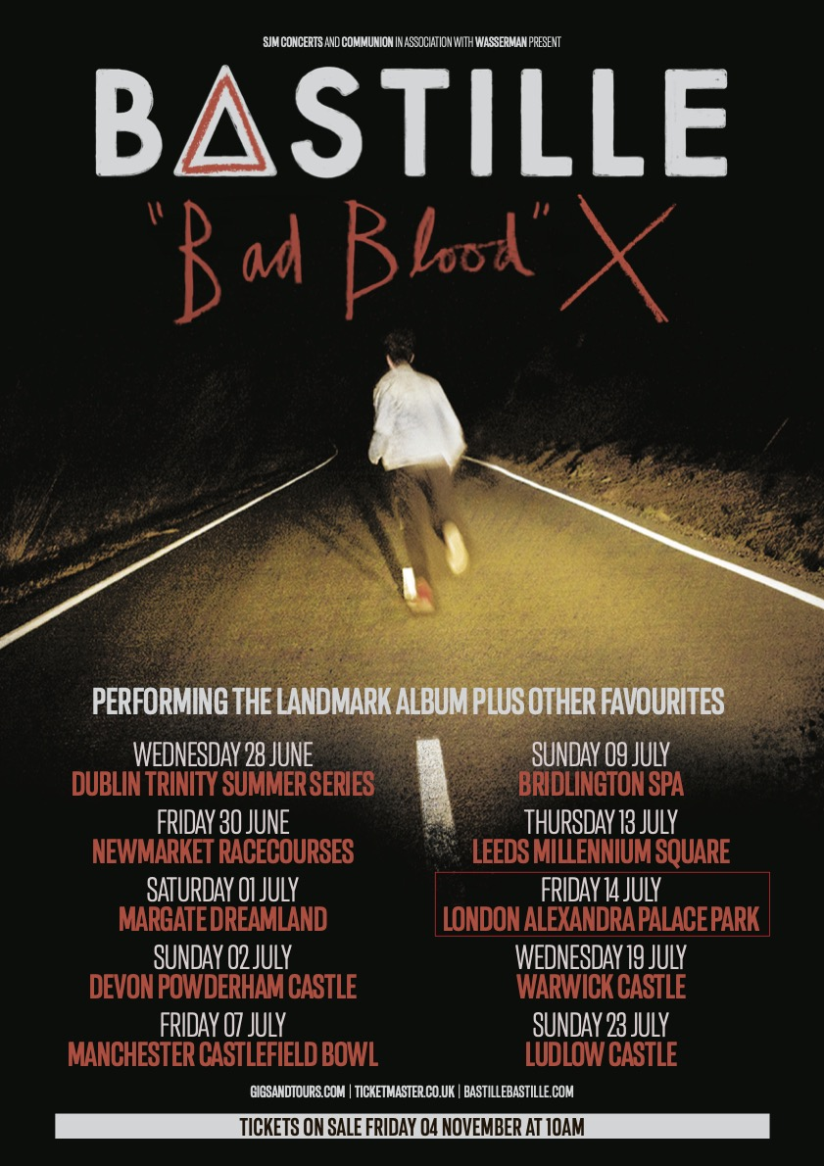

TICKETS ON SALE FRIDAY NOVEMBER 4TH HERE

2023 marks the 10th Anniversary of Bastille’s chart-conquering, twice No.1 debut album, ‘Bad Blood’. In celebration of its release the band announce a series of very special one-off shows next summer, giving fans the opportunity to hear the album played live in its entirety alongside other fan favourites.

Hailed as a trailblazing album, ‘Bad Blood’ featured the international hit, ‘Pompeii’ and became the biggest-selling digital album of 2013. Bastille became that year’s biggest-selling global breakthrough act, with over 1 billion Spotify streams earning them the British Breakthrough Act award at the 2014 Brits, along with two Grammy nominations. Since then, ‘Bad Blood’ has gone on to achieve triple platinum status with over 1 million copies sold in the UK alone.

In 2022, Bastille released their fourth album, the No.1, critically acclaimed record, ‘Give Me The Future’. Called, “Their best album” by both Rolling Stone and Clash and, “the most expansive, yet cohesive record Bastille have put their name to” by NME, ‘Give Me The Future’ explores a futuristic wonderland free from restrictions. Brimming with literary, cinematic, and cultural references to films like Thelma & Louise, the artist Keith Haring and musicians like Phil Collins and The Police, the album is filled with danceable dreamscapes, providing an escapist universe where you can travel back and forward in time to be anyone, do anything, and embrace a new wave of technology, which enables us to get lost inside our imagination.

Earlier this year the band completed an extensive sold-out UK arena tour, followed by sold-out shows in both the US and South America. Next up they take the ‘Give Me The Future’ tour to Europe playing thirteen shows across 10 countries.

Catch them in 2023 on the following dates!

Friday 30th June – Newmarket Racecourses
Saturday 1st July - Margate Dreamland
Sunday 2nd July - Devon Powderham Castle
Friday 7th July - Manchester Castlefield Bowl
Sunday 9th July - Bridlington Spa
Thursday 13th July - Leeds Millennium Square
Friday 14th July - London Alexandra Palace Park
Wednesday 19th July - Warwick Castle
Sunday 23rd July - Ludlow Castle

BASTILLE: INSTAGRAM | TWITTER | FACEBOOK | TIKTOK | WEBSITE

For more information and press enquiries please contact

Jenny Entwistle
Jenny@chuffmedia.com

