Jax Jones announces UK club tour, debut Essential Mix and search for new talent
The ‘Deep Joy Club Tour’, set up to highlight UK grassroots venues such as Moles in Bath and Liquid Room in Edinburgh, will also provide a platform for up-and-coming DJs via a competition to win paid support slots alongside the Ivor Novello, Brit and Grammy-nominated artist and DJ.
Budding DJs are invited to send mixes to Jones, fresh from dropping his own debut Essential Mix, who will choose an artist for each date on the tour. The mix, which aired on Saturday, features a host of exclusives alongside current and iconic productions, with material from Chaya & Kungs, Dance System, Ewan McVicar, and WUGD signings System.Inc and Forever.
LISTEN TO JAX JONES’ ESSENTIAL MIX
A passionate advocate for UK nightlife and music culture, Jones’ recent interviews with the BBC as well as his newly minted WUGD label and its plans to provide bursaries and support to up and coming artists, show an artist who believes in the power of breaking down barriers.
“Since I started DJing, I have spent almost every weekend in clubs. Playing my own tunes and seeing and feeling the instant reaction from the dance floor is a massive part of my creative process that I’ve missed so much this last year. It’s something I want to share with new artists starting out, giving them that opportunity by joining me on tour. And I just know it will be such an incredible feeling being all back in a room together. See you down front!” - Jax Jones
DJ mix submissions for the tour can be submitted via demos@wugd.co.uk. Entries must include a name, a short introduction, the date they’re local to, social media links and a streaming link to the mix (no download links).
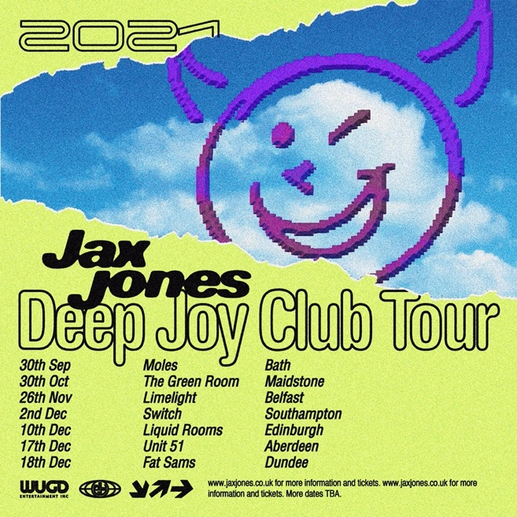
Deep Joy Club Tour Dates:
30.09 - Moles, Bath
30.10 - The Green Room, Maidstone
26.11 - Limelight, Belfast
27.11 - Switch, Southampton
10.12 - Liquid Room, Edinburgh
17.12 - Unit 51, Aberdeen
18.12 - Fat Sams, Dundee
BBC Radio 1 Essential Mix: Tracklist
Superflat - You Ain't Got The Funk
ID - ID
Jax Jones - Feels
Carlos Bendekos & Chinco Franco - Dropping Science (edit) Robin Breaks - I Get Dubbed
Forever - ID
System Inc - ID
ID - ID
ID - ID
Ewan Mcvicar - Tell Me Something Good
Dean Lindsey - Music Baby
Pangaea - Like This
Busy Twist - Tropic
Jax Jones - House Work (Carnival VIP)
Dance System - All I Wanna Do
Jax Jones - Paris
Jackmaster & Jasper James - For Ya
X Presidents - Diamond Rings
T2 - Heartbroken feat. Jodie (Salute Edit)
Kamikaze - Ghetto Kyote
Chaya x Kungs - Sickness
MC Fioti - Bum Bum Tam Tam (Jax Jones Remix) ID - ID
Jax Jones - You Don't Know Me (Edit)
Unknown Artist - Untitled
ID - ID
Gehts Noch / Ciara (Edit)
Jax Jones - Cruel (Festival Edit)
Gat Decor - Passion W/ Brandy - I Wanna Be Down Jax Jones - Crystalise
Oklou - Level 5
Notorious BIG - Juicy
WATCH: BBC NEWSBEAT’S ‘CLUBBING... WE’VE LOST DANCING’ W/ JAX JONES
About Jax Jones
Ivor Novello, Grammy and BRIT nominated DJ, producer and multi-instrumentalist Jax Jones has amassed over 11 million monthly Spotify listeners as well as surpassing three million single sales and 4 billion streams. Working with the likes of Mabel, Years and Years, Martin Solveig, RAYE, Stefflon Don, MNEK and Madison Beer, his last record ‘Snacks’ was named the best-selling dance album of 2019. Jax has become a mainstay in modern British music and continues to create genre defying music for both the charts and specialist dance scene.

For more information and press enquiries please contact

Jenny Entwistle
jenny@chuffmedia.com

