MACHINE GUN KELLY ANNOUNCES
MASSIVE GLOBAL ARENA OUTING
‘MAINSTREAM SELLOUT TOUR’

Special Guests on UK dates will be iann dior and 44phantom
Tickets On Sale Starting Friday, March 25th at 10AM Local Time at Ticketmaster.com

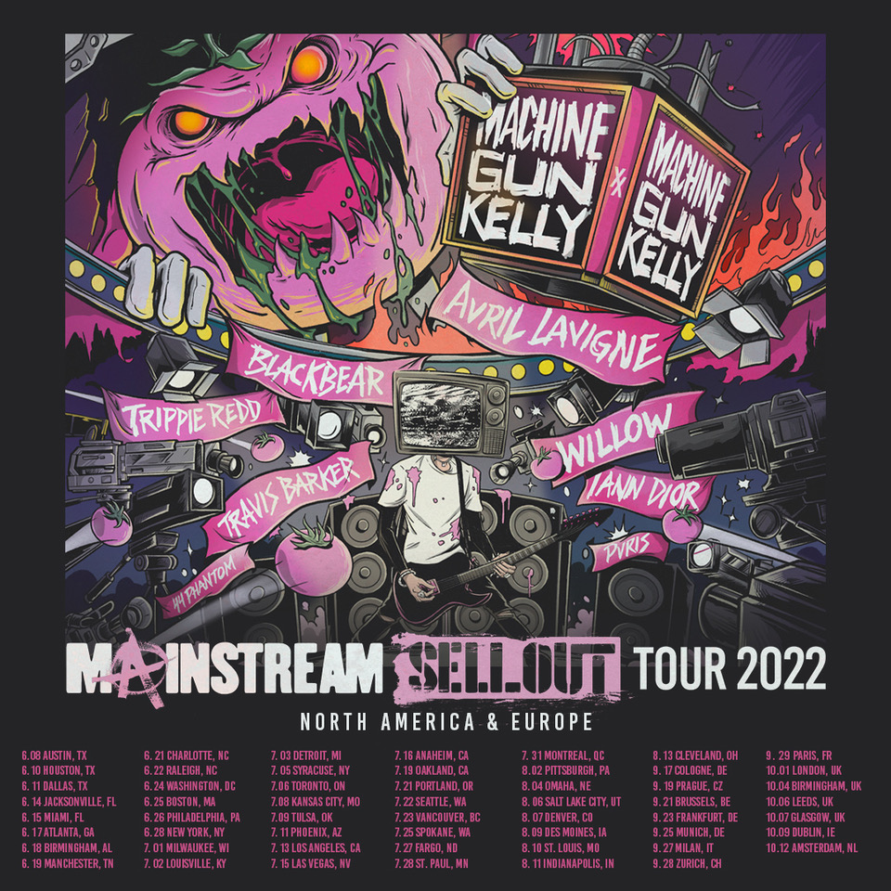

Today, Machine Gun Kelly has announced his international Mainstream Sellout Tour -- a colossal 52 arena run across North America and Europe featuring an incredible roster of special guests including Avril Lavigne, Travis Barker, blackbear, Trippie Redd, WILLOW, iann dior, PVRIS and 44phantom on select dates. The multi-platinum selling artist’s first ever arena tour will also feature a special hometown stadium performance in Cleveland, OH at FirstEnergy Stadium, the largest venue in the city. The genre-bending performer has amassed over 15.5 billion streams online and sold over 10 million album units. Full routing and details on special guests by city below.

Produced by Live Nation, the North American leg of the tour kicks off this June at Moody Center in Austin, making stops in Miami, Boston, Phoenix, Los Angeles and more before wrapping up in Cleveland at FirstEnergy Stadium on August 13th. The 15-stop European leg kicks off on September 17th at the Lanxess Arena in Cologne, making stops in Prague, Paris, London and more before wrapping up in Amsterdam at AFAS Live on October 12th.

TICKETS: Tickets go on sale starting Friday, March 25th at 10am local time at Ticketmaster.com.

NORTH AMERICAN TOUR DATES:
Wed Jun 8 – Austin, TX – Moody Center***^
Fri Jun 10 – Houston, TX – Toyota Center***^
Sat Jun 11 – Dallas, TX – American Airlines Center***^
Tue Jun 14 – Jacksonville, FL – VyStar Veterans Memorial Arena***^
Wed Jun 15 – Miami, FL – FTX Arena***^
Fri Jun 17 – Atlanta, GA – State Farm Arena*^
Sat Jun 18 – Birmingham, AL – The Legacy Arena At BJCC*^
Sun Jun 19 – Manchester, TN – Bonnaroo Music & Arts Festival
Tue Jun 21 – Charlotte, NC – Spectrum Center*^
Wed Jun 22 – Raleigh, NC – PNC Arena*^
Fri Jun 24 – Washington, DC – Capital One Arena*^
Sat Jun 25 – Boston, MA – TD Garden+$
Sun Jun 26 – Philadelphia, PA – Waterfront Music Pavilion+$
Tue Jun 28 – New York, NY – Madison Square Garden*^ – (on sale starting 12pm local time)
Fri Jul 1 – Milwaukee, WI – Summerfest*
Sat Jul 2 – Louisville, KY – KFC Yum! Center*^
Sun Jul 3 – Detroit, MI – Little Caesars Arena*^
Tue Jul 5 – Syracuse, NY – St. Joseph's Health Amphitheater*^
Wed Jul 6 – Toronto, ON – Scotiabank Arena*^
Fri Jul 8 – Kansas City, MO – T-Mobile Center*^
Sat Jul 9 – Tulsa, OK – BOK Center*#
Mon Jul 11 – Phoenix, AZ – Footprint Center*#
Wed Jul 13 – Los Angeles, CA – The Forum*#
Fri Jul 15 – Las Vegas, NV – T-Mobile Arena*#
Sat Jul 16 – Anaheim, CA – Honda Center*#
Tue Jul 19 – Oakland, CA – Oakland Arena*#
Thu Jul 21 – Portland, OR – Moda Center*#
Fri Jul 22 – Seattle, WA – Climate Pledge Arena*#
Sat Jul 23 – Vancouver, BC – Pepsi Live at Rogers Arena*#
Mon Jul 25 – Spokane, WA – Spokane Arena*#
Wed Jul 27 – Fargo, ND – FargoDome*#
Thu Jul 28 – St. Paul, MN – Xcel Energy Center*#
Sun Jul 31 – Montreal, QC – Osheaga
Tue Aug 2 – Pittsburgh, PA – PPG Paints Arena”#
Thu Aug 4 – Omaha, NE – CHI Health Center”#
Sat Aug 6 – Salt Lake City, UT – USANA Amphitheatre”#
Sun Aug 7 – Denver, CO – Ball Arena”#
Tue Aug 9 – Des Moines, IA – Wells Fargo Arena”#
Wed Aug 10 – St. Louis, MO – Enterprise Center”#
Thu Aug 11 – Indianapolis, IN – Ruoff Music Center”#
Sat Aug 13 – Cleveland, OH – FirstEnergy Stadium*”$#’
*With support from Avril Lavigne
***With support from Blackbear
^With support from iann dior
+With support from PVRIS
”With support from Travis Barker
$With support from Trippie Redd
#With support from WILLOW
’With support from 44phantom

EUROPEAN TOUR DATES:
Sat Sep 17 – Cologne, DE – Lanxess Arena’^
Mon Sep 19 – Prague, CZ – Sportovní Hala V Holešovicích’^
Wed Sep 21 – Brussels, BE – Palais 12’^
Fri Sep 23 – Frankfurt, DE – Festhalle’^
Sun Sep 25 – Munich, DE – Olympiahalle’^
Tue Sep 27 – Milan, IT – Mediolanum Forum’^
Wed Sep 28 – Zurich, CH –Hallenstadion’^
Thu Sep 29 – Paris, FR – Zenith’^
Sat Oct 1 – London, UK – OVO Arena Wembley’^
Tue Oct 4 – Birmingham, UK – Utilita Arena’^
Thu Oct 6 – Leeds, UK – First Direct Arena’^
Fri Oct 7 – Glasgow, UK – OVO Hydro’^
Sun Oct 9 – Dublin, IE – 3Arena’^
Wed Oct 12 – Amsterdam, NL – AFAS Live’^
^With support from iann dior
‘With support from 44phantom

For more information and press enquiries please contact

Jenny Entwistle
Jenny@chuffmedia.com

