THE CADILLAC THREE
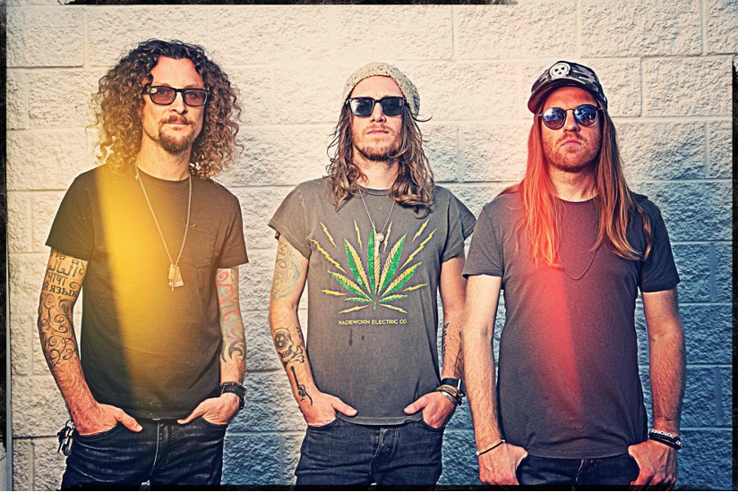
ANNOUNCE LINDSAY ELL
AS SPECIAL GUEST ON THEIR
HILLBILLY HYPNOTIZED TOUR
UK SUMMER 2022
TICKETS AVAILABLE NOW HERE

Country Fuzz heroes The Cadillac Three return to the UK this summer with their brand-new Hillbilly Hypnotized Tour and are delighted to announce that country sensation Lindsay Ell will be joining them as Special Guest on all dates.

Lead singer Jaren Johnston comments, “We are thrilled to be adding our good friend Lindsay Ell to the Hillbilly Hypnotized Tour in the UK! Lindsay is an incredible musician & will make this tour really special. We cannot wait to get back & see our friends in the UK, we are counting down the days”.

The Cadillac Three, who were recently nominated for their second consecutive Group of the Year at the ACM Awards, released their fifth studio album Tabasco and Sweet Tea in 2020 which saw the trio inject some funk into their trademark southern rock sound. And the Hillbilly Hypnotized Tour will be the first chance for their legions of UK fans to experience tracks from both that album and its predecessor, the critically acclaimed Country Fuzz, alongside hits from the band’s decade-long career.

One of the most spontaneous and exciting live bands on the planet, The Cadillac Three will be playing eight shows across the UK, including a headline performance at The Long Road Festival and a celebratory show at London’s legendary Roundhouse.

Lauded as “one of the most exciting and talented young artists in country music” by Forbes, Lindsay Ell is a triple threat: accomplished musician, unique vocalist and awe-inspiring songwriter. With more than 200M global career streams, Ell is an award-winning multi-instrumentalist who has toured alongside the likes of Luke Bryan, Buddy Guy, Brantley Gilbert, Brad Paisley, Blake Shelton, Dierks Bentley and Keith Urban. With three #1 singles under her belt, Ell’s debut album was named Billboard’s Country Album of the Year (2017) with its follow up (heart theory) earning multiple Canadian Album of the Year nominations. 2022 will see Ell continue to host Canada’s smash-hit television program Canada’s Got Talent (Citytv) and appear as direct support for Shania Twain just before landing in the UK with The Cadillac Three.

HILLBILLY HYPNOTIZED TOUR DATES
SUMMER 2021

AUGUST
Fri 26th – O2 Academy, Glasgow
Sat 27th – O2 Academy, Manchester
Sun 27th – The Long Road Festival, Leicestershire
Tues 30th – O2 City Hall, Newcastle

SEPTEMBER
Fri 2nd – Great Hall, Cardiff
Sat 3rd – Institute, Birmingham
Mon 5th – Rock City, Nottingham
Tues 6th – The Roundhouse, London

Tickets are available now from https://www.livenation.co.uk/

thecadillacthree.com

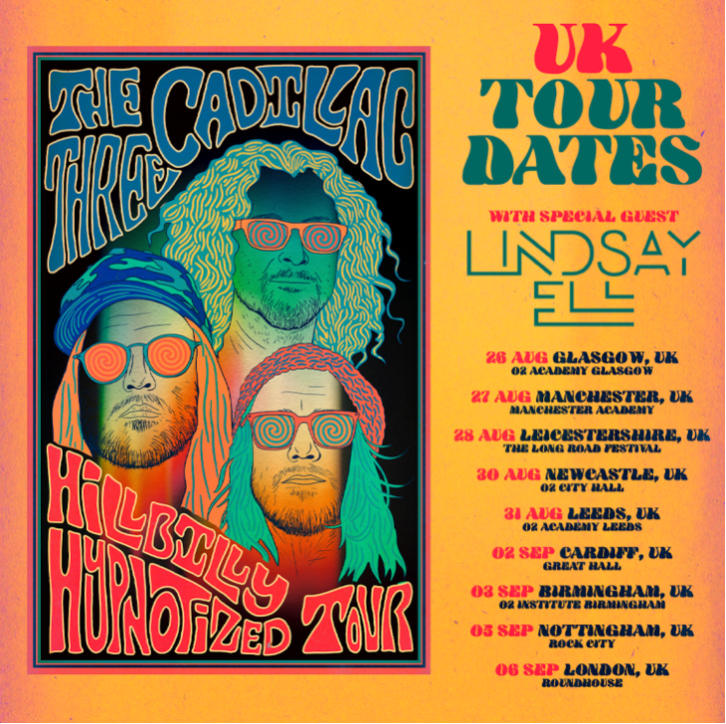

For more information and press enquiries please contact
Jenny Entwistle
Jenny@chuffmedia.com

