DRUG STORE ROMEOS

DEBUT ALBUM THE WORLD WITHIN OUR BEDROOMS OUT TODAY ON FICTION

ANNOUNCE HEADLINE & IN-STORE TOUR - BIGGEST HEADLINE SHOW TO DATE @ LONDON’S SCALA 17 NOV
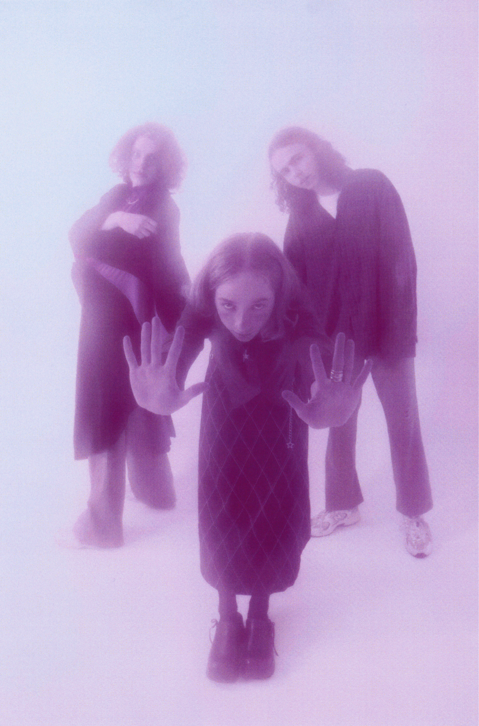

Photo credit: Neelam Khan Vela

Listen to The world within our bedrooms HERE

Hampshire trio Drug Store Romeos have today released their critically acclaimed debut album The world within our bedrooms via Fiction Records. The world within our bedrooms has already been the subject of glowing praise from the likes of NME (4*) The Line Of Best Fit (8/10), Dork (4*), and more. Drug Store Romeos will embark on an in-store and headline tour, will play their biggest headline show to date at London’s Scala on 17 November – tickets are available HERE - and will support Black Country, New Road across Europe later this year.

Recorded at London’s Eastcote Studios with regular producer George Murphy, The world within our bedrooms is a testament to youth and adventure; an escape from mundanity and proof that art will always open a door for those looking to escape. The band explain: “The album is a journey of emotions and colour schemes. A lot of bands have a consistent emotion across their whole album but we wanted to reflect the ever changing nature of someone’s mental state over a period of time. We always wanted to create our own world, and as a three we have this force field around us.”

With their beloved Stereolab, Broadcast, and Mild High Club acting as guiding lights, the band sought to shake things up and push beyond the walls of their bedroom. Vocalist Sarah scoured vintage magazines for lyrical inspiration - inspired by Dadaist poet Hugo Ball - and hung a print of transcendentalist artist Agnes Pelton’s 1934 piece ‘Orbits’ in the vocal booth. “When I look at that painting it’s where I want my voice to exist,” she says of the work by an artist renowned for her abstract approach to depicting stillness, “I would sing and try to immerse myself in that.”

Across the album’s singles ‘What’s On Your Mind’ and ‘Secret Plan’, Drug Store Romeos have been continuously lauded by the likes of The Line Of Best Fit (where ‘What’s On Your Mind’ was crowned Song Of The Day), So Young, Dork, and Gigwise as well as being playlisted at the Independent, Notion, NME, and Coup de Main. Drug Store Romeos were also recently tipped in The FADER’s longstanding tastemaker series GEN F and by blog icons Pigeons & Planes as one of their 15 New and Rising Bands You Should Listen to in 2021. Drug Store Romeos have also been consistently celebrated across national radio by Jack Saunders, Huw Stephens, Phil Taggart, and Sian Eleri at BBC Radio 1, Lauren Laverne and Shaun Keaveny at 6 Music, John Kennedy at Radio X, Apple Music’s Matt Wilkinson and more.

***
Drug Store Romeos formed at college in nearby Farnborough when childhood friends Jonny and Charlie pinned an ad about finding a bassist for their new band to the school’s notice board - Sarah replied and quickly proved herself a better vocalist than either of them. Sharing affections for Suburban Lawns and Tom Tom Club, Drug Store Romeos cut their teeth playing live at college, Guildford Boiler Room and Aldershot West End Centre, rather than the familiarly trodden paths in London - although they did frequent the city as often as three times a week at one point; carrying all of their equipment back to Fleet by train as none of the band were old enough to drive.

While the band have since moved to London, by the time they came to record The world within our bedrooms, all three members were keen to hold onto that wide-eyed energy for as long as possible. Those 3am walks home from Fleet station, with amps and flight cases slung over their shoulders, would become a rite of passage; the quiet countryside influencing their hushed atmospheric sound and nocturnal leanings, the tight bonds formed back home buoying their hypnotic and delicate blend of dream pop and synth-led explorations.

Having built an identity away from the London music scene in the otherworldly and isolated suburbs of Hampshire, Drug Store Romeos are emerging from their cocoon with a purpose, a direction and a fresh lease of life.

***

Praise for Drug Store Romeos’ The world within our bedrooms

“The most ethereal debut album of the year... a hazy anthology of dozing micro-pop ditties, there's a wealth of sublimity to be found. Had this album been released 30 years ago, it might be a cult classic by today”
NME 4*

“contains so much beauty and subtle colour that it demands a return trip to ensure every inch of it is explored thoroughly”
Dork 4*

“A cosmic odyssey...The world within our bedrooms is one to lose yourself in…”
The Line Of Best Fit 8/10

“They appear to interact and create on a different plain, a level most haven’t discovered yet, and maybe never will.”
God Is In The TV 8/10

“if the goal of a debut album is to introduce yourself to the world with a sound and style that's purely your own, the Romeos have done a pretty stellar job”
DIY 3.5*

“Drug Store Romeos have amassed a cult-like reputation for their timeless take on moon-kissed and instrumentally transcending star-gazing”
So Young

“It's surreal and silly but also deeply sentimental, a transportative pop song that doesn't take itself too seriously”
The FADER (‘Secret Plan’)

“Simultaneously serene and curious - patience and details are what set Drug Store Romeos apart”
Complex

“Exquisite and comforting... one of Britain's most exciting bands”
The i newspaper

***

See Drug Store Romeos live in 2021:

*supporting Black Country, New Road
29 July | SET, London (SOLD OUT)
9 Aug (afternoon) | Vinilo, Southampton
9 Aug (evening) | Vinilo, Bournemouth
10 Aug (afternoon) | Pie and Vinyl, Southsea
10 Aug (evening) | Resident, Brighton
11 Aug | Rough Trade, Nottingham
12 Aug | Rough Trade, Bristol

2-5 Sep | End Of The Road Festival
25-26 Sep | Dot to Dot Festival
9 Oct | Are You Listening? Festival

23 Oct | Bumann & Sohn, Cologne, Germany*
24 Oct | Orangerie, Brussels, Belgium*
25 Oct | Le Trabendo, Paris, France*
27 Oct | Le Grance Mix, Tourcoing, France*
28 Oct | Le Lieu Unique, Bordeaux, France*
30 Oct | Dabadaba, Donostia, Spain*
1 Nov | ZBD, Lisbon, Portugal*
2 Nov | El Sol, Madrid, Spain*
3 Nov | Laut, Barcelona, Spain*

12 Nov | Cobalt, Newcastle
13 Nov | Stag & Dagger Festival, Glasgow
14 Nov | Stag & Dagger Festival, Edinburgh
15 Nov | Deaf Institute, Manchester
17 Nov | Scala, London
19 Nov | Music Hall, Ramsgate
20 Nov | Blue Moon, Cambridge
21 Nov | Waterfront, Norwich
23 Nov | Heartbreakers, Southampton
24 Nov | Clwb Ifor Bach, Cardiff

Drug Store Romeos - The world within our bedrooms - out 09/07/2021 via Fiction

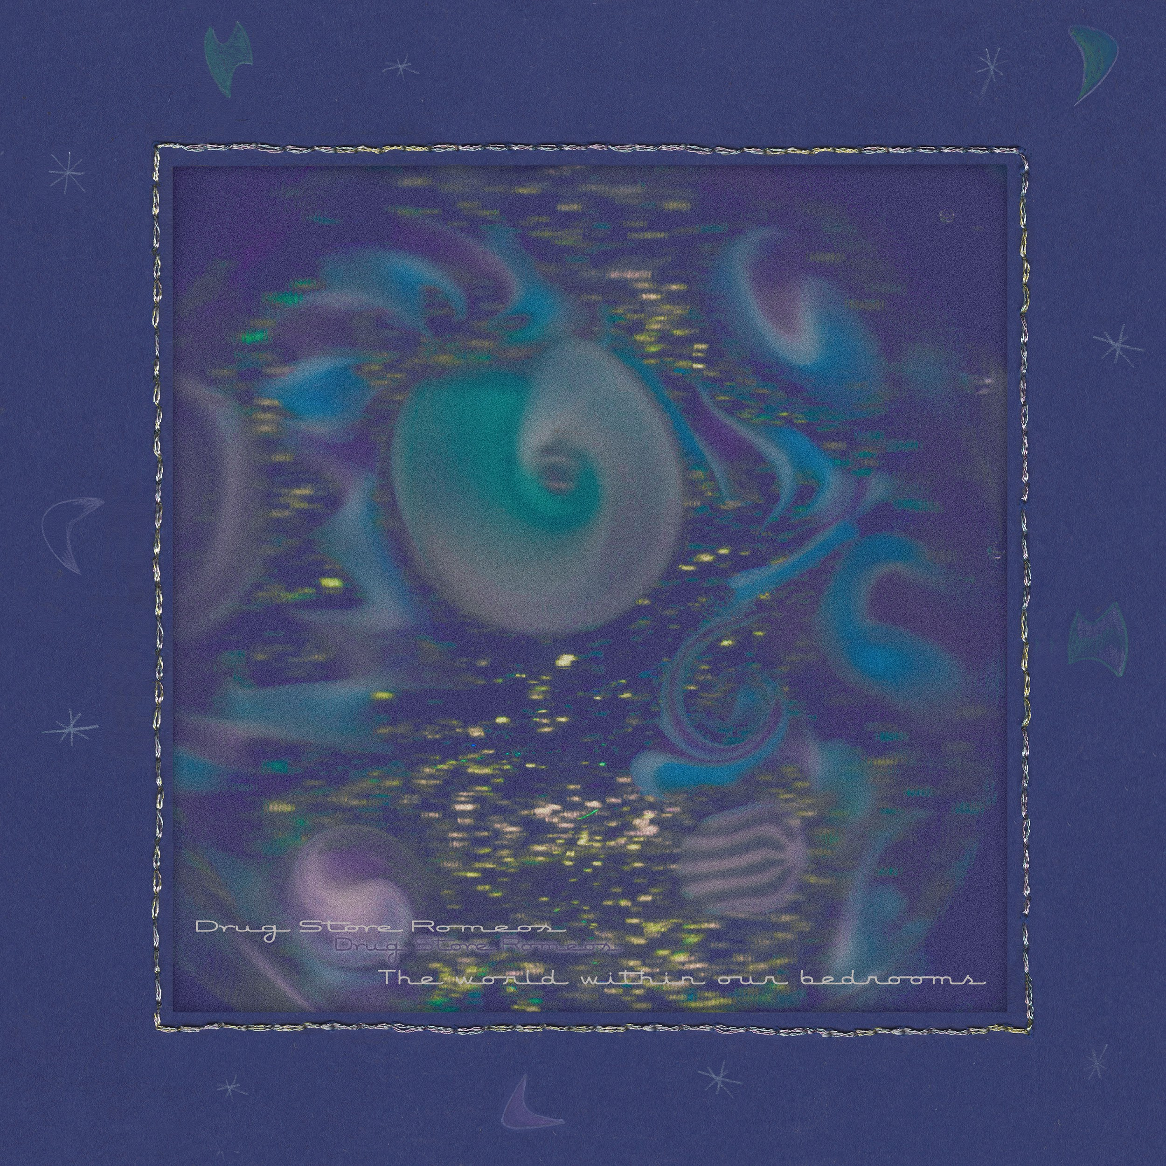

1. Building Song
2. Secret Plan
3. Bow Wow
4. Elevator
5. Walking Talking Marathon
6. Frame Of Reference
7. Feedback Loop
8. What’s On Your Mind
9. No Placing
10. Vibrate
11. Electric Silence
12. Kites
13. Put Me On The Finish Line
14. Cycle Of Life
15. Adult Glamour

For more information and press enquiries please contact

Jenny Entwistle
Jenny@chuffmedia.com

