MR JUKES & BARNEY ARTIST

ANNOUNCE LIVE DATES FOR AUGUST 2021

NEW JOINT ALBUM ‘THE LOCKET’ DUE OUT 02 JULY 2021

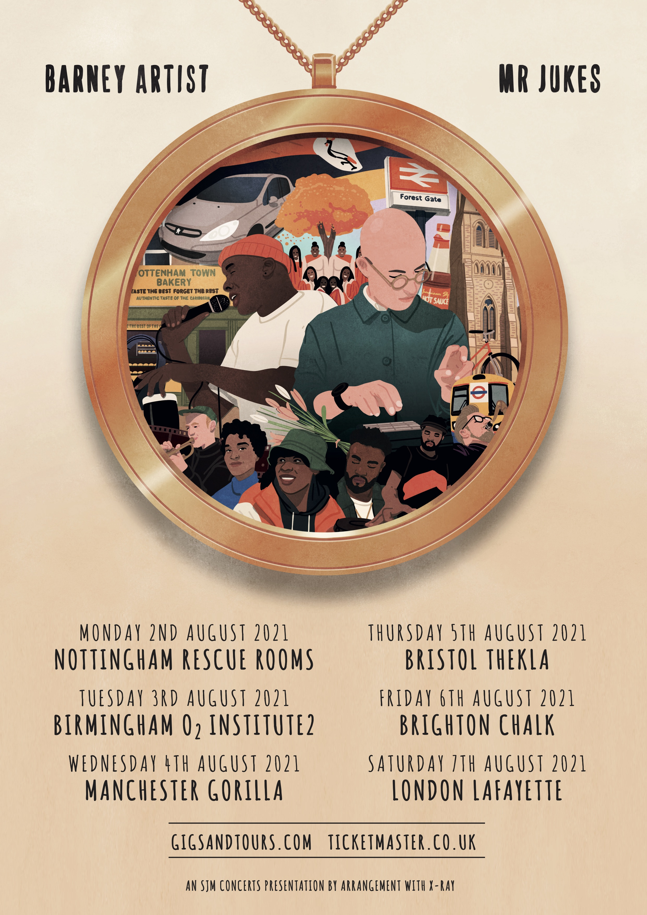

To celebrate the release of their new collaborative album ‘The Locket’, which is due out on 2nd July via their own label The Locket Records / Virgin Music, Mr Jukes & Barney Artist have announced six very special live dates for August 2021.

‘The Locket’ is the coming together of two masters of their craft to create something hopeful in a time of unrest. It features ten tracks cut from sessions that span over eighteen months. It’s sunshine-dappled, psych-tinged, hip-hop flavoured, leftfield pop. Beats, bars and a unique sort of retro futurism that zips from sepia-tinged to full technicolour almost as fast as Barney’s flow. The pair have also recently shared their new single ‘Vibrate’, stream the track HERE and watch the brilliant video HERE.
During a period of prolonged inactivity, Jack Steadman scratched an itch to do something new. He went by the moniker of Mr Jukes and released an album, God First, in 2017. We say ‘by himself’ but it was very much an open-door policy, resulting in a collaborative record that brought contributions by legends such as Charles Bradley, De La Soul, Horace Andy, Lianne La Havas, BJ The Chicago Kid and Lalah Hathaway. The project also features a contribution from Barney Artist, who Jack had quite simply stumbled upon on a Spotify playlist and never forgotten.
Barney’s music takes the vibrance of jazz infused hip-hop but with a London feel. Growing up in Forest Gate, East London, Barney touches on conscious themes by way of lively, dynamic delivery to create something instantly likeable, like the artist. He’s a larger than life presence, fun to be around and a searing, peerless talent too. A collaborator by nature, Barney grew up around Tiana Major9 and Jay Prince and has made music with Tom Misch, Alfa Mist and Jordan Rakei.
Barney’s contribution to God First, “From Golden Stars Comes Silver Dew” (also featuring Lalah Hathaway) proved to be a standout. Bonded by a mutual love of the ever-changing landscape of modern hip-hop, the two artists instantly fell into step with one another. There was no clear plan or brief to fulfil for a full-length Jukes X Barney project, but both artists instinctively knew that it would be a waste not to explore the potential they’d uncovered. They were right, clearly.
Jukes and Barney are excited to be performing together this year to showcase their new album and summery songs that pull from their love of hip-hop.
LIVE DATES 2021
Mon 02 August Nottingham Rescue Rooms
Tue 03 August Birmingham O2 Institute 2
Wed 04 August Manchester Gorilla
Thu 05 August Bristol Thekla
Fri 06 August Brighton CHALK
Sat 07 August London Lafayette

Tickets go on general sale at 9:00am on Friday 28th May and will be available from www.gigsandtours.com
‘The Locket’ is due out on 2nd July, you can pre-order the album here: https://mrjukesandbarneyartist.lnk.to/TheLocketSo
For more information visit: www.thelocket.co.uk

For all media enquiries contact warren@chuffmedia.com on 07762 130510

