BECKY HILL ANNOUNCES BIGGEST HEADLINE SHOWS TO DATE WITH UK ARENA TOUR FOR OCTOBER 2024
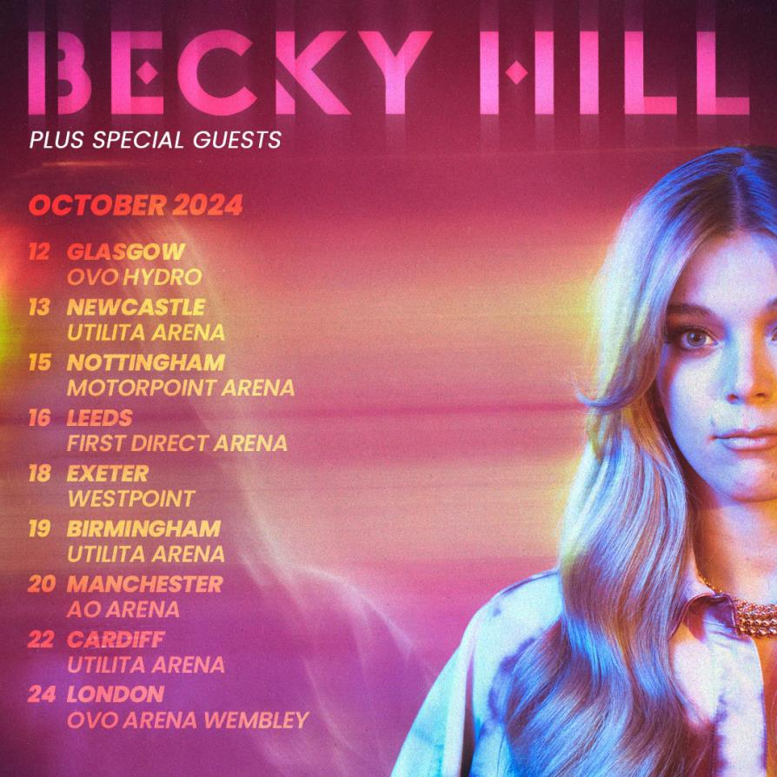
London UK — British singer and songwriter, Becky Hill, is set to grace stages across the UK in October 2024 as she embarks on her biggest headline shows to date with a nationwide arena tour in support of her highly anticipated upcoming second album. With an irrefutable aptitude for writing chart-smashing dance-pop songs and a reputation as a leading force in the UK music scene, Becky Hill is without a doubt one of the UK's most exceptional talents, having secured two BRIT Awards, eighteen Top 40 singles (including the current hit ‘Disconnect’) and billions of streams.
Playing arena shows across the country, this tour will mark an incredible milestone in Becky’s career. The sensational live shows will once again showcase her incredible vocal prowess, captivating stage presence, and her ability to connect with fans in an unparalleled way.
Becky says, “This is my biggest tour yet! ARENAS HERE I COME!! I can’t wait to play all my hits for you as well as tracks from my new album. see you there for a party!”
Becky Hill’s chart-topping journey has seen collaborations with some of the world's most renowned artists and producers and has ignited dancefloors and huge audiences this summer at festivals such as Glastonbury, Reading & Leeds, Radio 1's Big Weekend, Parklife, and TRNSMT. This tour announcement will certainly build excitement for fans towards the release of her highly anticipated second album slated for release in 2024.
Tickets go on sale 10am on Friday 27th October 2023 at livenation.co.uk.
- TOUR DATES OCTOBER 2024:
- Saturday, October 12th: Glasgow - OVO Hydro
- Sunday, October 13th: Newcastle - Utilita Arena
- Tuesday, October 15th: Nottingham - Motorpoint Arena
- Wednesday, October 16th: Leeds - First Direct Arena
- Friday, October 18th: Exeter – Westpoint
- Saturday, October 19th: Birmingham - Utilita Arena
- Sunday, October 20th: Manchester - AO Arena
- Tuesday, October 22nd: Cardiff - Utilita Arena
- Thursday, October 24th: London - OVO Arena Wembley
About Becky Hill
With an irrefutable aptitude for writing chart-smashing pop songs and a reputation as a leading force in the electronic music scene, Becky Hill has gone from strength-to-strength since first coming to attention as the voice of Wilkinson’s ‘Afterglow’. She has consistently returned to the Top 10 with hits including ‘Gecko (Overdrive)’ with Oliver Heldens (#1), ‘Wish You Well’ with Sigala (#8), ‘Remember’ with David Guetta (#3) and ‘Crazy What Love Can Do’ with David Guetta and Ella Henderson (#5) and now, ‘Disconnect’ (#8) – plus a total of 18 Top 40 singles. She has collaborated with a who’s who of global talent, with other big names such as Joel Corry, Galantis, Sigala, MK, Jonas Blue and Tiesto.
Her 2021 debut album ‘Only Honest On The Weekend’ debuted at #7 and was certified Gold, adding to a career which has already achieved four double-platinum singles. In addition to her two BRIT Awards, Becky has also won two ASCAP London Music Awards for ‘False Alarm’ and ‘Lose Control’, plus Best Female Artist at the 2022 O2 Silver Clef Awards. Her international success reached new heights in 2022 with four #1 hits at US dance radio in the shape of ‘Run’ with Galantis’, ‘Crazy What Love Can Do’ with David Guetta and Ella Henderson, ‘History’ with Joel Corry’, and ‘Words’.

Follow Becky Hill:
Spotify | Apple Music | YouTube | TikTok | Instagram | Facebook | Twitter | Website
For more information & media enquiries, please contact Warren
warren@chuffmedia.com

