**CAITY BASER ANNOUNCES ‘*WATCH THAT GIRL (SHE’S GONNA SING IT)’* SHOWS**

**EXCLUSIVE AND INTIMATE FIRST LISTEN SHOWS OF HER BRAND NEW MUSIC**

**TEN DATES ANNOUNCED ACROSS THE UK AND EUROPE THROUGHOUT APRIL**

*Poster for Caity Baser’s ‘Watch That Girl (She’s Gonna Sing It) live shows. All press assets available* [*here*](https://drive.google.com/open?id=1465OdVOS_-RUBFReow_pZpu0sTAbQeIB&usp=drive_fs)*.*

Fresh off the back of the release of her bold, new comeback single ‘Watch That Girl (She’s Gonna Say It), BRIT-nominated artist Caity Baser has announced a run of exclusive, intimate live shows across the UK and Europe..

Billed as ‘intimate piano shows’, the ten-date run will take place in April and be an opportunity for fans to experience Caity’s new, unreleased music for the first time. Tickets are on sale now.

Caity Baser’s ‘Watch That Girl (She’s Gonna Sing It) dates are as follows:

9th April - The Joiners Live!, Southampton

10th April - Mama Roux’s, Birmingham

11th April - The Dome, London

13th April - The Globe, Cardiff

14th April - The Fleece, Bristol

17th April - King Tut’s Wah Wah Hut, Glasgow

18th April - Factory 251, Manchester

20th April - Dublin, Ireland

22nd April - Prachtwerk, Berlin, Germany

24th April - Amsterdam, Netherlands

This tour announcement follows Caity’s recent return, having unveiled new single ‘Watch That Girl (She’s Gonna Say It) earlier this month. The song, out now via Capitol Records UK, signals a bold & fearless new direction for the 22-year-old BRIT Award-nominated singer, both in terms of sound and lyric.

Co-written and performed by Caity with acclaimed duo Oh Wonder, the single’s fresh, more sophisticated sonic direction for Caity includes a lush, all-live instrumentation—a first in her career. Featuring vibrant arrangements of live guitars, piano, drums, horns, strings, organ, and a chanting choir, the song’s production and Caity’s vocal performance include nods to many of Caity’s favourite inspirations such as the timeless sounds of Motown, writers of the great American songbook, theatrical classics and many of legendary divas who have shaped music history.

This new sound is matched by a deeper lyrical maturity. Where Caity’s past hits often explored themes of boys and relationship struggles, this single signals a shift in tone. ‘Watch That Girl (She’s Gonna Say It)’ finds Caity confronting her past head-on, weaving themes of growth, self-reflection, and empowerment into her songwriting and combining recollections of her real-life experiences with imagery and symbolism previously unexplored by Baser. Despite this evolution, Caity’s trademark honesty and vulnerability remain central, continuing the candid storytelling her fans have come to love.

**About Caity Baser:**

Her mixtape ‘Still Learning’, released last year, earned UK breakthrough pop star and songwriter Caity Baser a top 10 in the UK album charts and followed her nomination for the BRITs Rising Star Award. She hit the road for her UK tour which saw her perform at sold-out venues across the country, totalling over 30,000 tickets sold - including London’s Hammersmith Apollo. She performed twice at last year’s Glastonbury Festival and capped off the year with a one-off, special Christmas show just for her fans, to give back to them after supporting her so much throughout her career. The theme of accessibility and unity with her fanbase has been an ongoing one for Caity, including when she announced her tour ticket prices would be capped to help her young fans during the cost of living crisis.

Caity Baser’s critical acclaim has also been widespread for such a young star. She has been the cover star of esteemed music and culture publications such as NME, Dork Magazine, Notion Magazine and was praised by The Guardian for her live show and its “*chatty, bratty, cartwheeling celebration of girlhood”*. Rolling Stone UK chose Caity as their Future Of Music artist and she has been similarly championed by The BBC, The Independent, DIY, CLASH, Hunger, Daily Star, The Sun, The Mirror as well as Capital Radio, BBC Radio 1’s Mollie King, Greg James, Jack Saunders and more.

For more on Caity Baser:

[Instagram](https://www.instagram.com/caitybaser/) | [Twitter](https://twitter.com/BaserCaity) | [TikTok](https://vm.tiktok.com/ZMeWEqbX9/) | [Website](https://caitybaser.com/) | [Facebook](https://www.facebook.com/CaityBaserOfficial) | [Spotify](https://open.spotify.com/artist/7dJCdUO0l0K2WXzrzjYpmC?si=hejaYPcQQQSjwXQz1ntW-Q) | [Apple Music](https://music.apple.com/gb/artist/caity-baser/1555239928) | [Amazon](https://music.amazon.co.uk/artists/B08XLQ2RQY/caity-baser?)

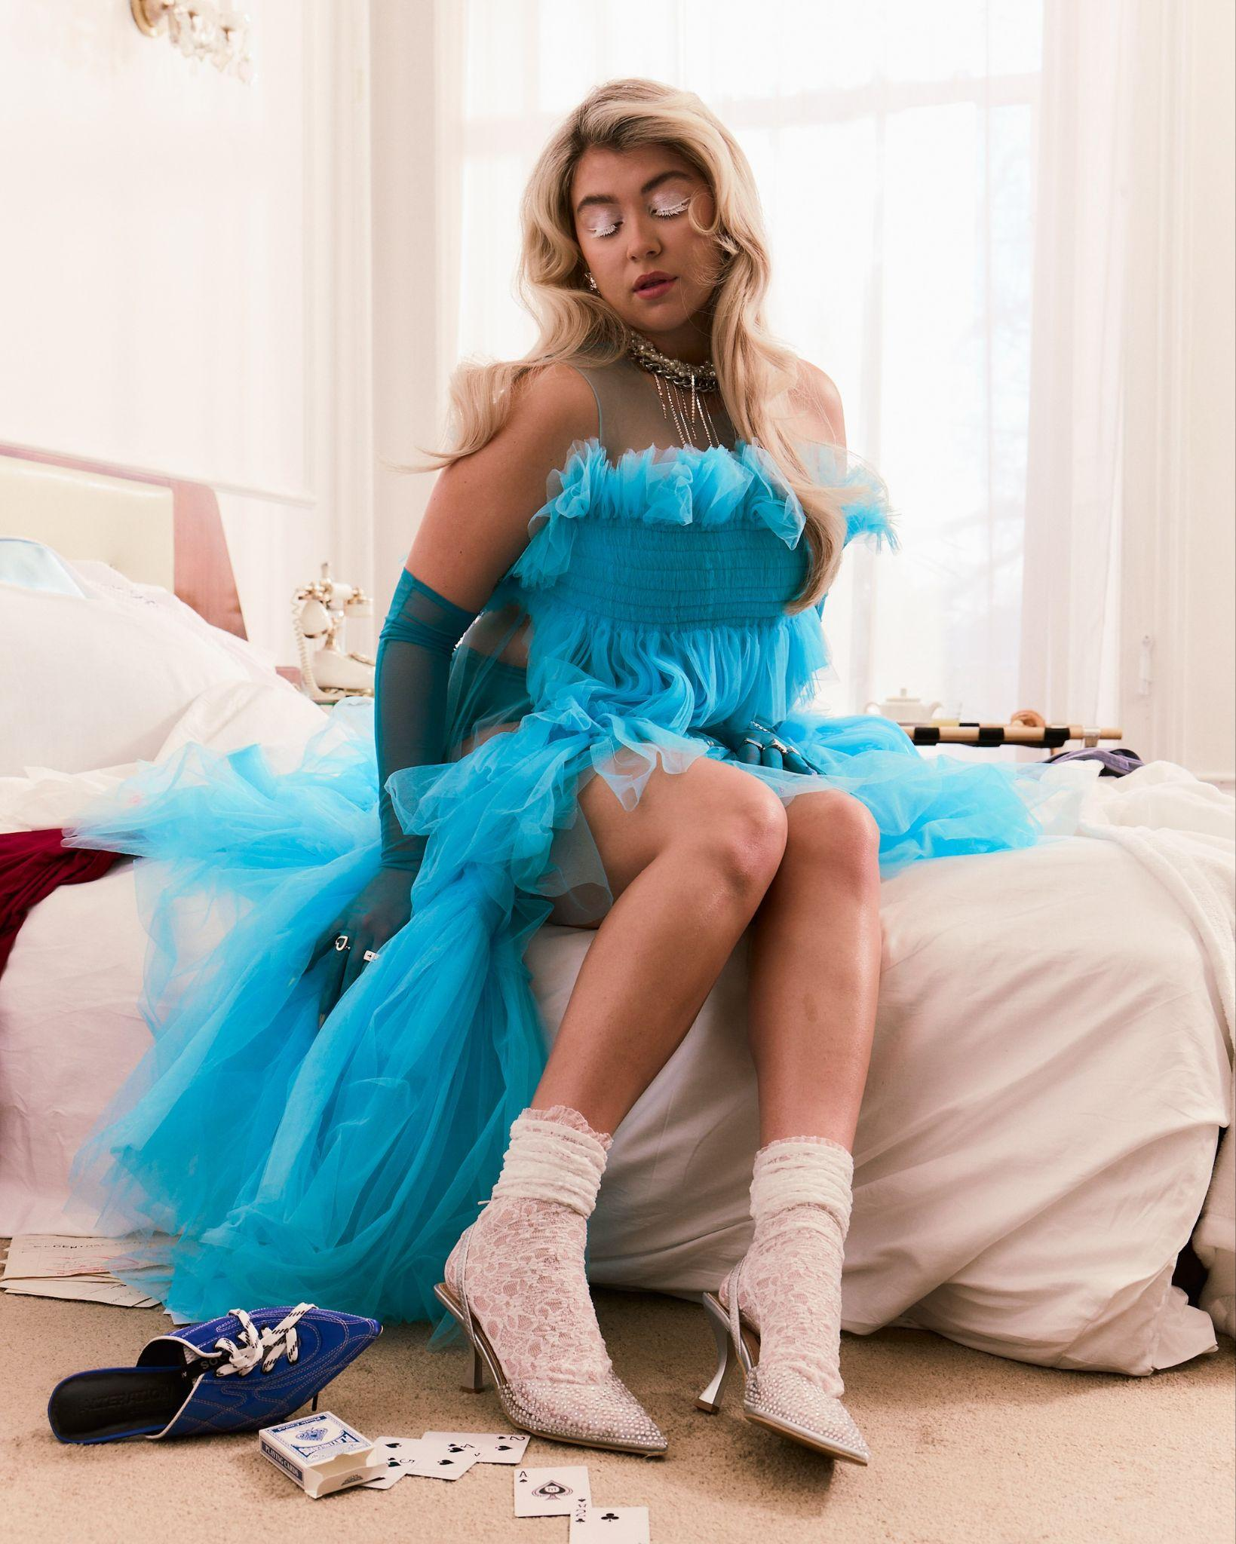

*Caity Baser press shot, credit Finn Waring. All press assets available* [*here*](https://drive.google.com/open?id=1465OdVOS_-RUBFReow_pZpu0sTAbQeIB&usp=drive_fs)*.*

***For more info contact:***[***warren@chuffmedia.com***](mailto:warren@chuffmedia.com)