RG LIVE and AGN Concerts LTD presents by arrangement with Mission Control

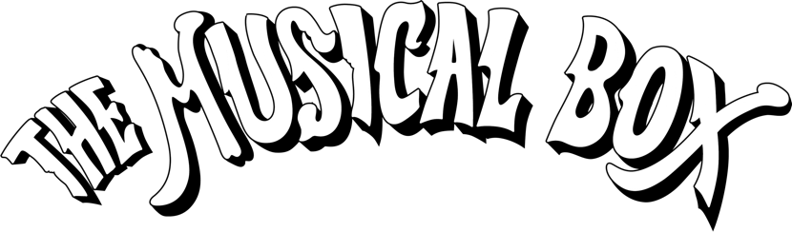
Performs

AND THEN THERE WAS… PHIL
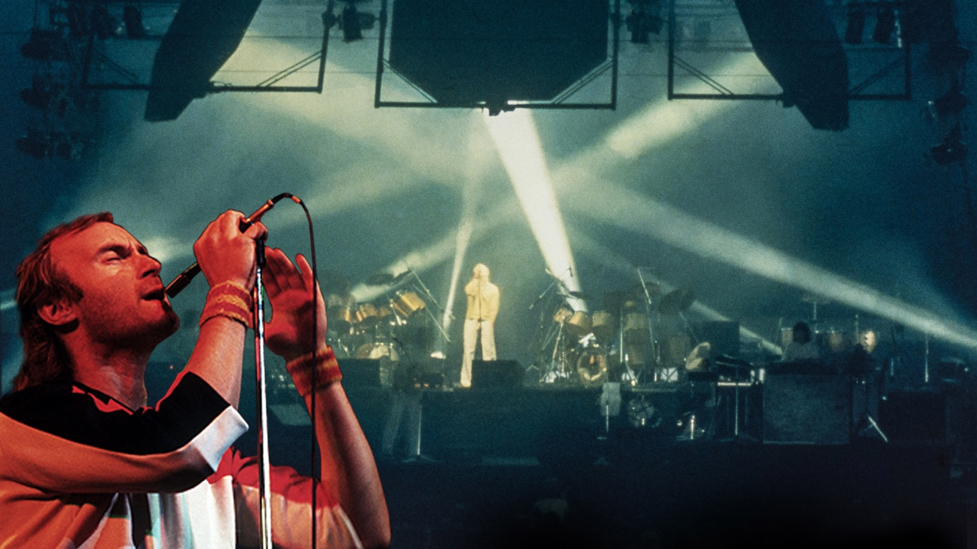

Celebrating the early years of Phil Collins at the helm of Genesis (1976-80)

For more than three decades, Canada’s The Musical Box have done something few others dare attempt; not simply perform Genesis songs, but a painstakingly researched theatrical reconstruction of Genesis in their prime. Endorsed by the original band members themselves, they now move for the first time into the Phil Collins-fronted years, revisiting the pivotal period from 1976 to 1980.

Renowned for their attention to detail, with And Then There Was… Phil, The Musical Box are constructing a faithful recreation of the original 1978 Mirrors tour stage set, complete with period costumes and the tour’s revolutionary mirrored lighting design. Alongside using vintage instruments and equipment, the result is more than a concert it is a time machine.

Showcasing Genesis’ incredible prog rock repertoire, including some of the band’s early hits such as Follow You, Follow Me and classic tracks from four crucial albums: A Trick of the Tail (1976), Wind & Wuthering (1976), …And Then There Were Three…(1978), and Duke (1980); records that capture Genesis in transition from cult prog auteurs to mainstream contenders.

Over the years, members of Genesis themselves have recognised the band’s extraordinary work. Steve Hackett has performed live with them; Peter Gabriel has attended performances and Phil Collins himself joined The Musical Box on stage in Geneva in 2005. Collins’ verdict remains definitive:

“They’re not a tribute band, they have taken a period and are faithfully reproducing it in the same way that someone would do a theatrical production.”

For over three decades, The Musical Box have set the gold standard in musical theatre homage, faithfully recreating Genesis’ formative years with meticulous detail. Since first touring the UK in 2003, they have built a devoted following for their acclaimed productions focusing on the Peter Gabriel era. Now, for the first time, the band moves into the Phil Collins era, revisiting the ground breaking 1976–1980 period that reshaped Genesis and propelled them toward global superstardom.

“What we love about this era is that it bridges two worlds. You still have the big prog pieces, but you can hear the songwriting tightening up, becoming more direct. Phil stepping forward was the spark that allowed that shift to happen. It’s Genesis on the edge of becoming the band that would dominate the ’80s. We can’t wait to share the authentic sound of this time and perform for UK audiences” The Musical Box team

And Then There Was… Phil UK TOUR 2026

10-Jun-26 Guildford G Live
11-Jun-26 High Wycombe Wycombe Swan
13-Jun-26 Leicester De Montford Hall
14-Jun-26 York Barbican
16-Jun-26 Glasgow Pavilion Theatre
17-Jun-26 Edinburgh Usher Hall
19-Jun-26 Manchester The Bridgewater Theatre
21-Jun-26 Birmingham Alexandra Theatre
26-Jun-26 London Cadogan Hall
27-Jun-26 London Cadogan Hall
28-Jun-26 Brighton Theatre Royal
30-Jun-26 Truro Hall for Cornwall
1-Jul-26 Cambridge Corn Exchange
2-Jul-26 Bath The Forum

Tickets available from venue box office, themusicalbox.net &
https://www.rg.live/events/the-musical-box-and-then-there-was-phil

All media assets available here.
For more on info contact warren@chuffmedia.com / 07762 130510

