NEW ALBUM
CALL THIS A REALITY?
OUT 27TH JAN 2023

FEBRUARY UK HEADLINE TOUR ANNOUNCED
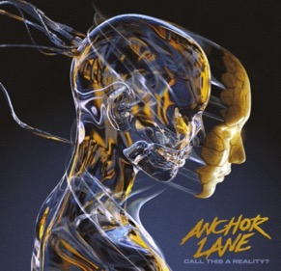

“Innovative & profoundly enjoyable with melodies that seep into your brain” – NME
“A band that could get a funeral service up and moving” – The Bristol Gig Guide
“bags of confidence and some impressive, intelligent song writing” - BBC Radio Scotland

Glasgow rock band Anchor Lane have announced a massive new UK headline tour for February 2023 in support of their forthcoming album release ‘Call This A Reality?’ including a previously announced headline show at Glasgow’s Garage 2 on the 28th January 2023, giving fans the opportunity to celebrate the album’s release with the band.

Conor, Lawrence and Graeme spent the past couple of years writing and recording the new material in Glasgow with producer Bruce Rintoul (Twin Atlantic, Fatherson, Vukovi). The resulting sound of the band’s sophomore album can only be described as ROCK, with an underlying groove and is a sum of the bands influences including the likes of Nothing But Thieves, Royal Blood, Bring Me The Horizon and Green Day.

“We’re so excited to bring our brand new album Call This A Reality? out on the road! Expect fun, high energy performances every night along with some old favourites too. Don’t forget your dancing shoes!”

The February UK headline tour will finally give fans the chance to hear the album live and cement the band as ones to watch within the UK rock scene after a successful run of supporting and smaller headline shows over 2022 garnered great reviews.

Prior to the release of their debut album ‘Casino’ in 2020, Anchor Lane had been building a following with to their relentless gigging schedule. The album garnered rave reviews across the board and went straight into the Official UK Rock Albums Chart at Number 9, scoring the band their first Top 10. It was also Top 20 in the Official Scottish Albums Chart and Top 50 in the Official UK Independent Albums Chart. Appearing at festivals such as Download, Isle of Wight, Stone Free and Belladrum etc. (along with notable guest spots with acts like Eagles of Death Metal, Tremonti and Cheap Trick) Anchor Lane were denied the opportunity to tour the release of ‘Casino’ due to the global pandemic. The band turned this into a positive when, amongst several live streams for their fans, they used the time to dig deeper into the song writing process, which has resulted in the brand new collection of songs to be found on ‘Call This A Reality?’.

TOUR DATES 2023:
28 January Glasgow - Garage G2
02 February Bradford - Nightrain
04 February Newcastle - St. Doms
05 February Manchester - Retro
07 February Grimsby - Yardbirds
09 February Plymouth - The Junction
10 February Bridgewater - Cobblestones
11 February Birmingham - Asylum 2
12 February Stoke-on-Trent - Eleven
14 February Chester - Live Rooms L2
15 February Milton Keynes - Craufurd Arms
16 February Nottingham - Rescue Rooms
24 February Aberdeen - Krakatoa
25 February Edinburgh - The Mash House

Tickets for all of the above dates are available on: https://anchorlanemusic.com/upcominggigs/

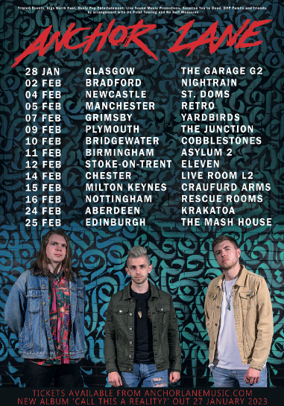

‘Call This a Reality?’ the brand new album from Anchor Lane, is available to pre-order from the band’s D2C Townsend Music store here > https://anchor-lane.tmstor.es/

Listen to Anchor Lane and follow the band on: https://linktr.ee/anchorlane

For more on info contact warren@chuffmedia.com

