CARL PALMER AND AN EVENING WITH EMERSON, LAKE & PALMER
The music. The spectacle. The reunion you never thought possible.

COMES TO THE UK FOR THE FIRST TIME FOR 3 SHOWS, FEBRUARY 2027

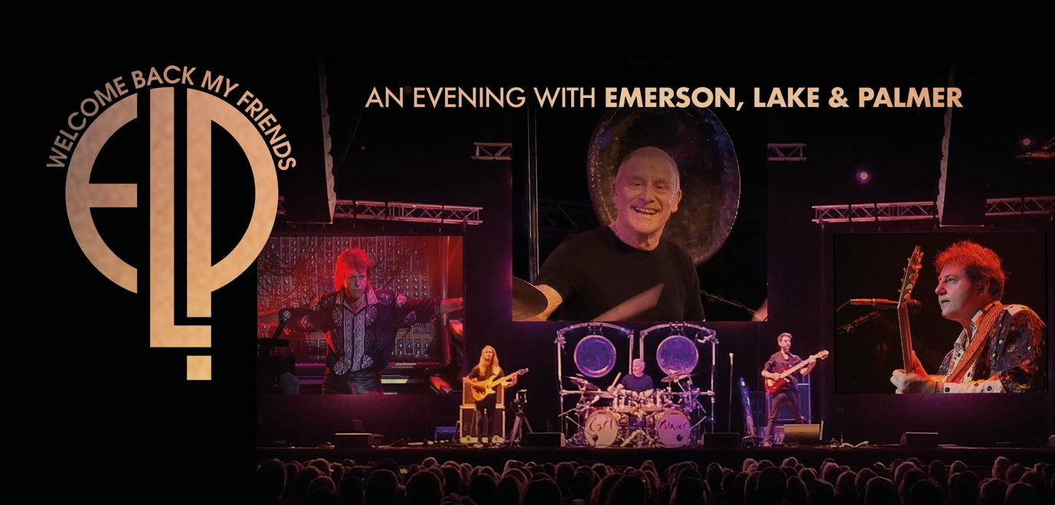

Ticket pre-sale 10am, Wednesday 29th April
Ticket general onsale 10am, Friday 1st May
All tickets available via ELPTickets.com

What if you could see Emerson, Lake & Palmer live again? Not a tribute. Not a cover band. The real thing.

An Evening with Emerson, Lake & Palmer is a one-of-a-kind live experience that brings one of the biggest bands of the 1970s back to the stage in a way that’s never been done before. Created by Carl Palmer and produced with the full support of the estates of Keith Emerson and Greg Lake, the show reunites all three members through a groundbreaking blend of live performance and state-of-the-art technology.

This is a full-scale, two-hour concert experience, featuring at least nine classic performances from the band’s legendary 1992 Royal Albert Hall show, with all three members appearing together on stage and screen, in perfect sync with the live band. On stage, Carl Palmer performs live with his ELP Legacy band, locking in seamlessly with iconic footage of Emerson and Lake. The result? A complete ELP show, powerful, authentic and genuinely emotional, capturing the energy and ambition that made the band such a force in their prime.

The UK run will see the show performed in three stunning, prestigious venues: The Glasshouse in Gateshead (Sun 7 Feb 2027), Liverpool Philharmonic Hall (Mon 8 Feb 2027) and London Palladium (Tues 9 Feb 2027), the perfect settings for a show of this scale and ambition.

And this isn’t just any band we’re talking about. Formed in 1970 in London, Emerson, Lake & Palmer weren’t just progressive rock pioneers, they were one of the biggest bands on the planet. With over 48 million albums sold and a string of era-defining records, ELP took rock music somewhere completely new, blending classical music, jazz and pure rock energy into a sound that filled arenas worldwide.

From their explosive breakthrough at the Isle of Wight Festival 1970 to headlining global tours, ELP delivered shows that were as ambitious as their music and helped define what a live rock spectacle could be.

The band’s final performance came in 2010 at London’s High Voltage Festival 2010, marking their 40th anniversary. Following the passing of Keith Emerson and Greg Lake in 2016, Carl Palmer remains the last surviving member, making this show not just a celebration of the music, but a powerful way to bring the band back together on stage once more.

And their influence hasn’t faded. ELP’s take on Peter Gunn has recently found a whole new audience after being featured in this year’s Super Bowl advert for Brad Pitt’s upcoming film The Adventures of Cliff Booth, a reminder that their sound still cuts through, decades on.

Originally developed and road-tested over the past three years in the United States, the show has already wowed audiences across the Atlantic as The Return of Emerson, Lake & Palmer, but the show has now evolved into An Evening with Emerson, Lake & Palmer, a refined, immersive celebration of the band’s music, legacy and enduring influence and February 2027 marks the first time it will ever been seen in the UK.

For longtime fans, it’s a chance to relive something extraordinary. For new audiences, it’s the perfect way to discover just how big and how brilliant ELP really were.

TOUR DATES:

Sun 7 Feb ’27 Gateshead Glasshouse
Mon 8 Feb ’27 Liverpool Philharmonic
Tues 9 Feb ’27 London Palladium

Tickets via ELPTickets.com

Carl Palmer is available for interviews.

All media assets available here.

For all media inquiries please contact warren@chuffmedia.com on 07762 130510

