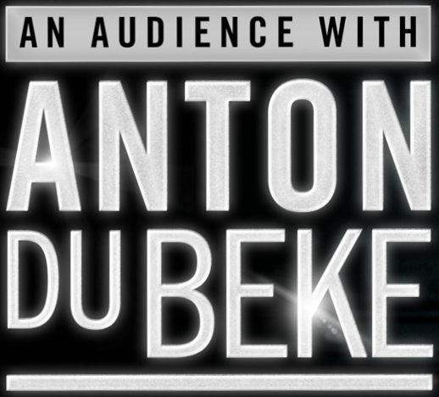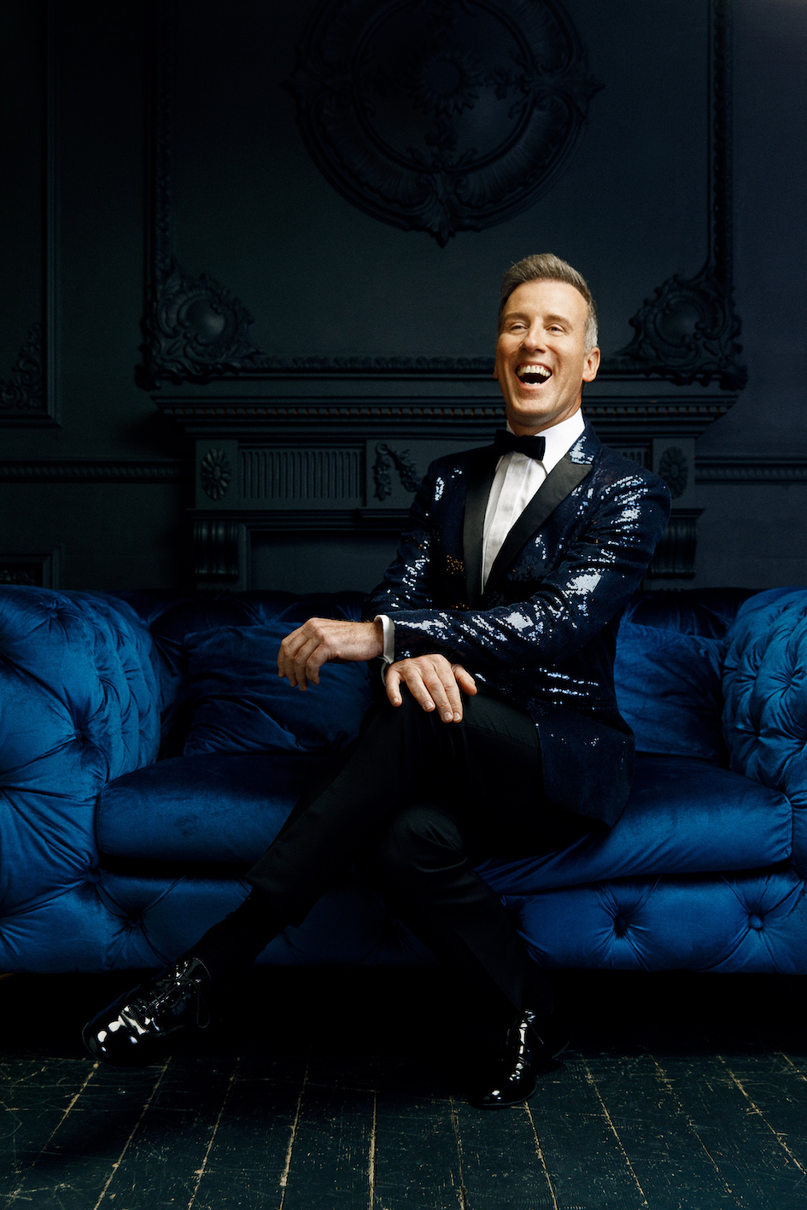
“An Audience with Anton Du Beke is going to be an intimate evening with myself, my wonderful band and my very good friend Lance Ellington! I’m going to tell you about my career and life (you can ask me any question you like) and we’re going to do it with song and dance... It’s going to be a great night!
I have so many wonderful Strictly memories, of which I shall talk about on the tour, but a couple of highlights are the moment I had with Brucie when we did Me and My Shadow, and when I opened the show on Musicals week with a great ensemble piece that I sang, it was called Anything Can Happen On The Strictly Stage. I absolutely loved that moment!
I’ve also had many classic moments with my wonderful partners, whether it’s falling down with Ruth Langsford at the end of the Paso Doble, flying Anne Widdecombe in or throwing her across the floor and skidding, performing the Viennese Waltz with Emma Barton or dancing with Katie Derham and making it to the final.
I’ve had so many incredible moments on Strictly and I can’t wait to share them with you at An Audience with Anton Du Beke.”

2022 TOUR DATES
5 May 7.30pm Grove Theatre, Dunstable
8 May 3.00pm Theatre Royal, Brighton
13 May 7.30pm Wycombe Swan, High Wycombe
14 May 7.30pm New Theatre, Peterborough
15 May 3.00pm Richmond Theatre, Richmond
22 May 3.00pm Churchill Theatre, Bromley

For more information please contact warren@chuffmedia.com on 07762 130510

