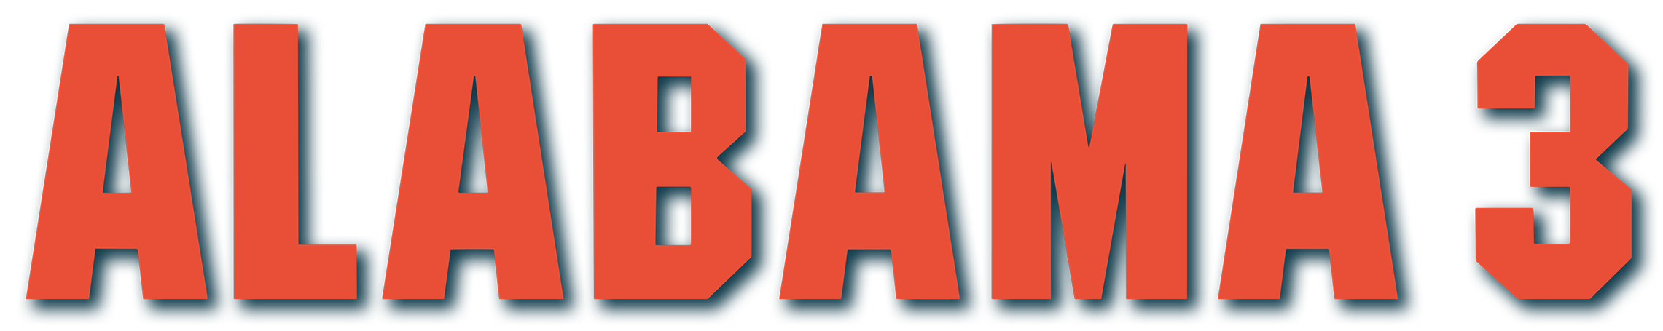
5 DATE LIVE TOUR THIS DECEMBER 2025
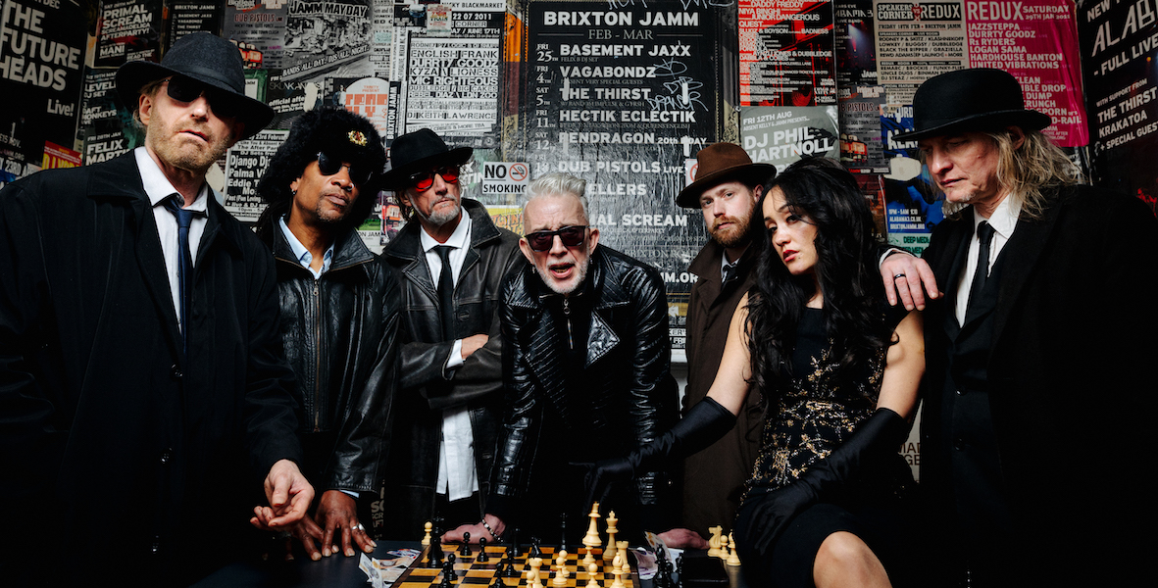
In anticipation of new music coming soon in the form a new EP, legendary genre-defying British band Alabama 3 is set to hit stages across the UK this December, bringing their unique blend of country, acid house, gospel, electro, blues, and dub to fans old and new. Known for their anarchic live shows, Alabama 3 have spent nearly 25 years building a devoted following with performances that feel like a Pentecostal meeting in a Manchester warehouse rave.
Fronted by the flamboyant Robert Spragg (aka Larry Love), Alabama 3 made their mark with a kaleidoscopic mix of satire, hedonism, and musical virtuosity. They achieved global recognition when “Woke Up This Morning” became the opening theme for HBO’s The Sopranos. Their early acid house-infused raves in Brixton drew attention from the music industry, leading to a record deal with Geffen Records and the release of their debut album, Exile on Coldharbour Lane.
Over the last two decades, Alabama 3 have toured relentlessly across the UK and America, building a fiercely loyal fanbase. Their reputation as the ultimate festival band was cemented with a legendary performance at Glastonbury in front of 5,000 fans, and they have received endorsements over the years from literary and cultural icons including Irvine Welsh, Howard Marks, Martina Cole, and Stephen King.
The band’s live shows are legendary for their theatricality, political satire, and communal energy. Alabama 3 has never shied away from activism; collaborations with organizations such as the RMT and the Miscarriages of Justice Organisation highlighting their commitment to social justice.
Their current lineup features a fascinating and eclectic mix of musicians, including Nick Reynolds (harmonica, vocals), Orlando Harrison (keyboard), Mark Sams (lead guitar), and Zoe Devlin Love (vocals). Each member brings their own distinctive energy to the stage, from Nick’s mischievous cockney wit to Zoe’s powerful, soul-infused vocals, often compared to legends such as Aretha Franklin and Etta James.
The band faced tragedy with the loss of Jake Black (aka Reverend D. Wayne Love) in 2019, yet they continue to carry his spirit forward.
This December, audiences can expect Alabama 3 at their unpredictable, boundary-pushing best, a night of riotous beats, powerful vocals, satirical lyrics, and moments of raw theatricality. From intimate venues to larger halls, the band’s live shows promise the full spectrum of their genre-bending sound and irreverent humour.
Tour Dates – December 2025:
4 Dec – Glasgow, SWG3 (+)
5 Dec – Manchester, O2 Ritz (+)
11 Dec – Coventry, HMV Empire (*)
12 Dec – Bristol, O2 Academy (*)
13 Dec – London, O2 Shepherds Bush Empire (*)

Plus Special Guests: the Jacques (+) & Forgotten Pharaohs (*)
Tickets available via www.alabama3.co.uk & www.ticketmaster.co.uk

For more information contact warren@chuffmedia.com in 07762 130510


