GOOD NEIGHBOURS
Announce the ‘Adolescence Tour’ for April ‘25

New single ‘Ripple’ out now
(Listen HERE /Watch HERE)

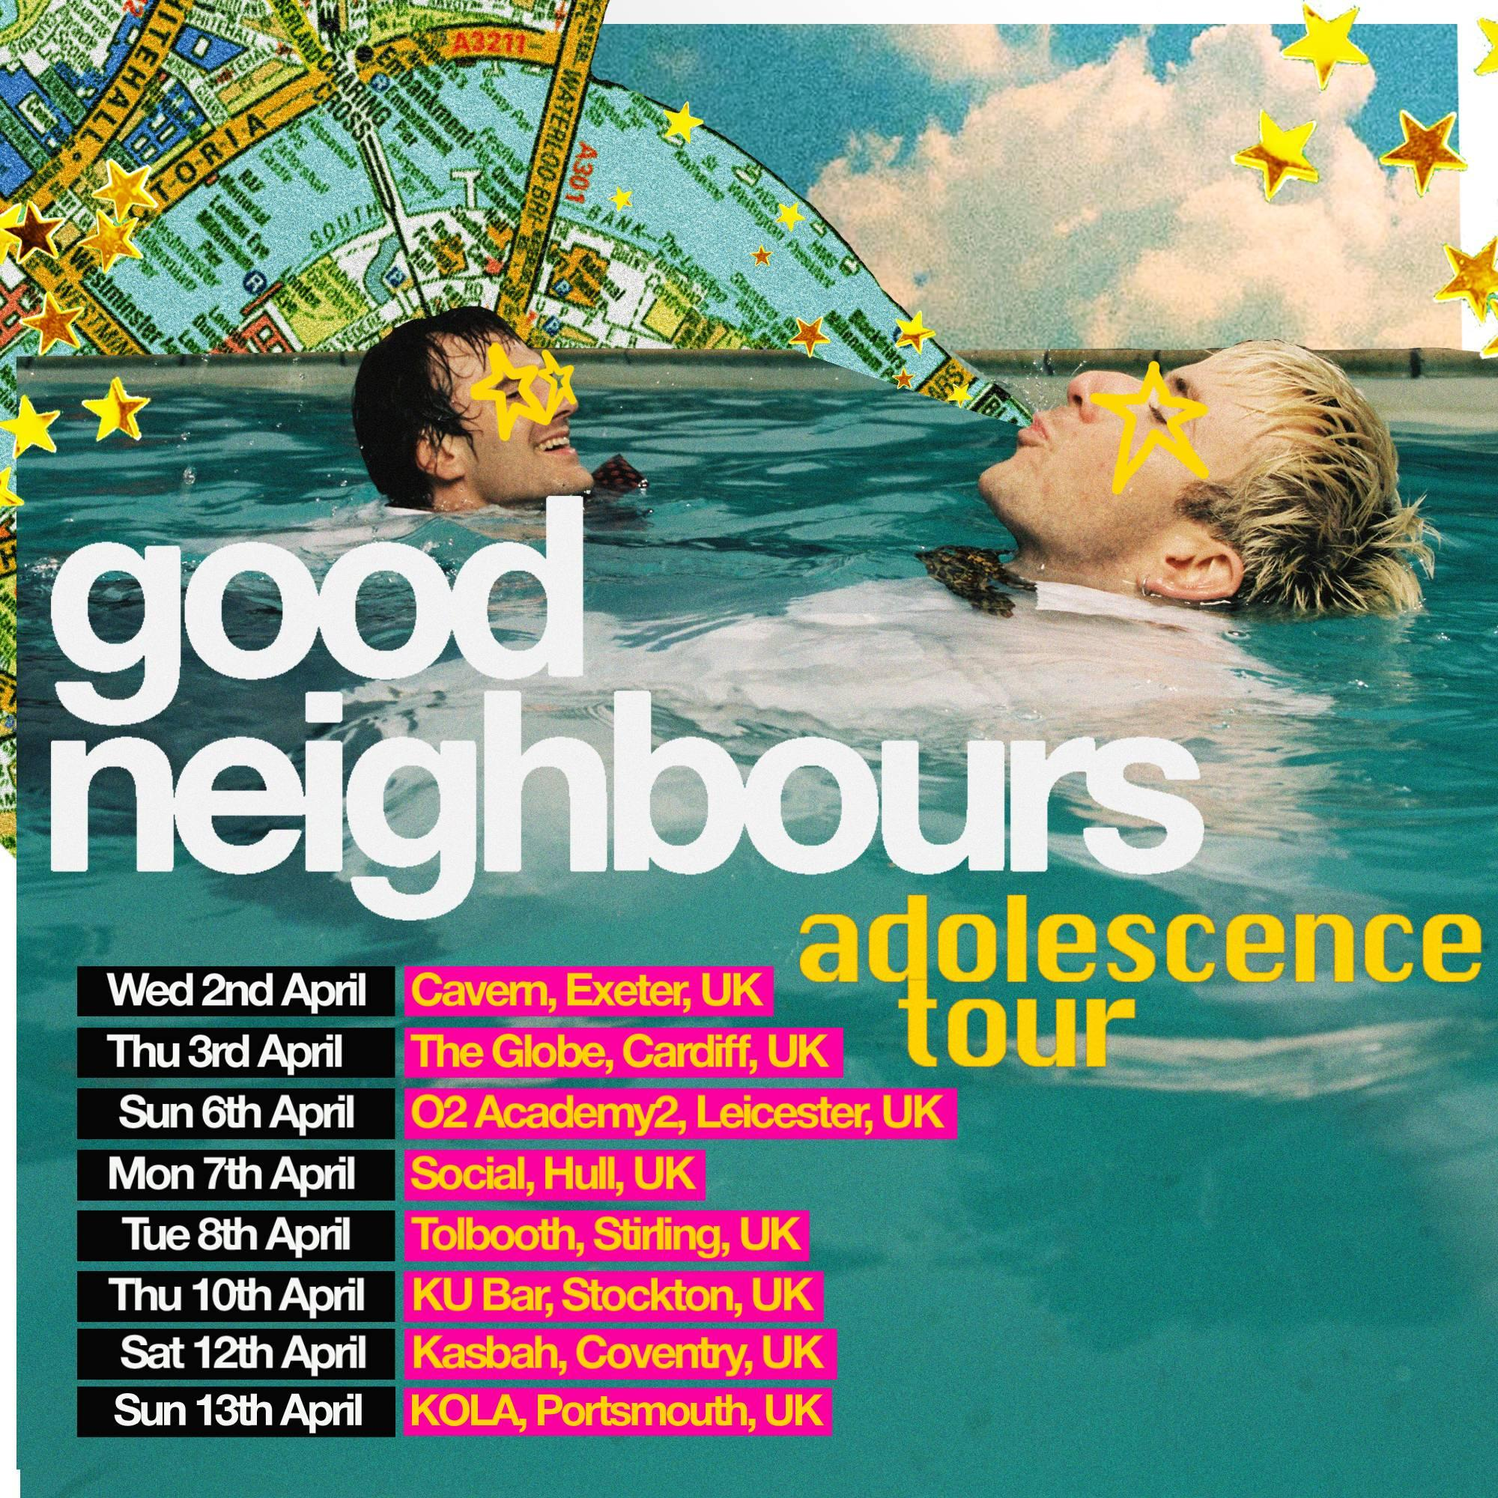
Riding high off their current single ‘Ripple’ enjoying successes across the globe (including BBC R1 B-list rotation), Good Neighbours are pleased to announce a short sharp run of live shows taking their feel-good vibes to a town or city near you this April.

Turning their attention to the people and places that often get overlooked on the traditional gig circuit when artists reach a certain level, Oli and Scott wanted to break that mold and dig deeper into where their fans exist and not continually ask them to trek too far from home to feel part of their family. They want to take the dance to their doorstep; be a good neighbour.

"There’s been a lot of bigggg mad moments in the last year, but as two boys from small towns, we realise we missed a couple stops. The adolescence tour is us making room for some places we haven’t yet been and letting us have some fun on the road.” Oli & Scott

Good Neighbours have enjoyed rapid success over the last 12 months or so since breakout hit ‘Home’ was first released which resulted in an exponential growth of their fanbase. However, the boys remain vividly aware of the need to pay thanks to the day ones who made that happen and take things back to basics while they still can.

The Adolescence tour kicks off on April 2nd in Exeter and takes in a run of university towns and cities across England, Wales and Scotland. They’ll visit Cardiff, Leicester, Hull, Stirling, Stockton and Coventry before wrapping up the tour in Portsmouth on April 13th.

Artist pre-sale opens at 10am Wednesday February 26th with tickets on general sale on Friday, February 28th at 10am.

Adolescence Tour:

April 2 Cavern, Exeter
April 3 The Globe, Cardiff
April 6 02 Academy2, Leicester
April 7 Social, Hull
April 8 Tolbooth, Stirling
April 10 KU Bar, Stockton
April 12 Kasbah, Coventry
April 13 KOLA, Portsmouth

Following this spring run, Good Neighbours are so far confirmed for the following global summer festivals with more expected to be announced in due course:

June 21 Summerfest, Milwaukee, WI (US)
July 11 TRNSMT, Glasgow (UK)
Aug 1 Hinterland Music Festival, Saint Charles, IA (US)
Aug 2 Osheaga Festival, Montreal, QC (CA)
Aug 15 MS Dockville, Hamburg, Germany (EU)
Aug 22 Rock En Seine, Paris, France (EU)

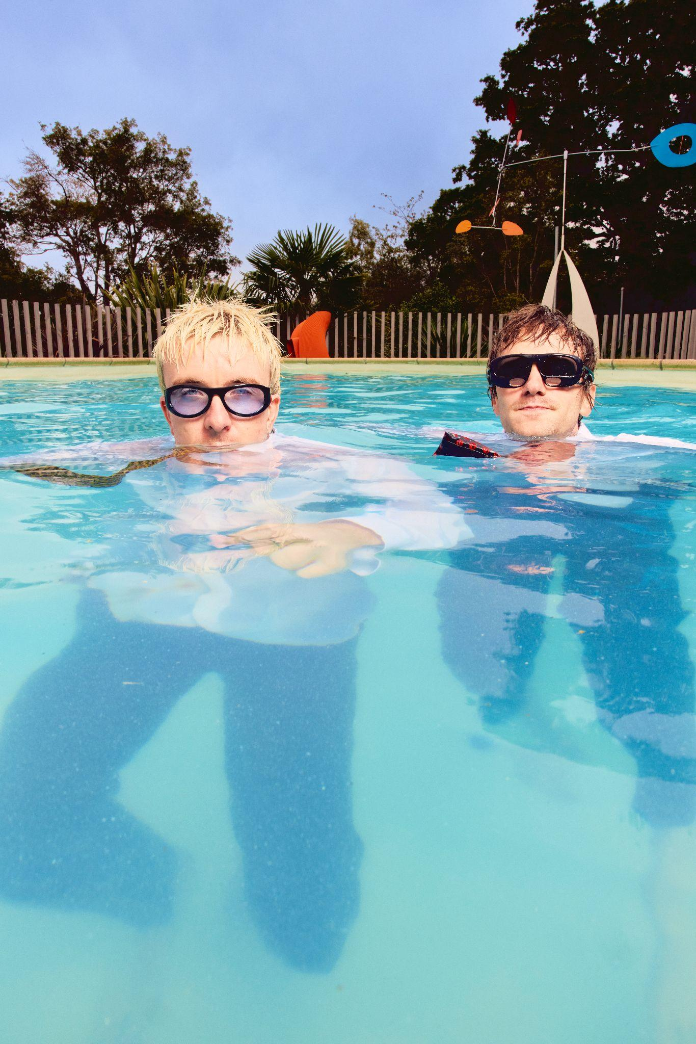
(Photo credit: Isaac Lamb)

Follow Good Neighbours
TIKTOK | INSTAGRAM | TWITTER/X | FACEBOOK | YOUTUBE

For more information and press enquiries please contact

Jenny Entwistle
Jenny@chuffmedia.com

