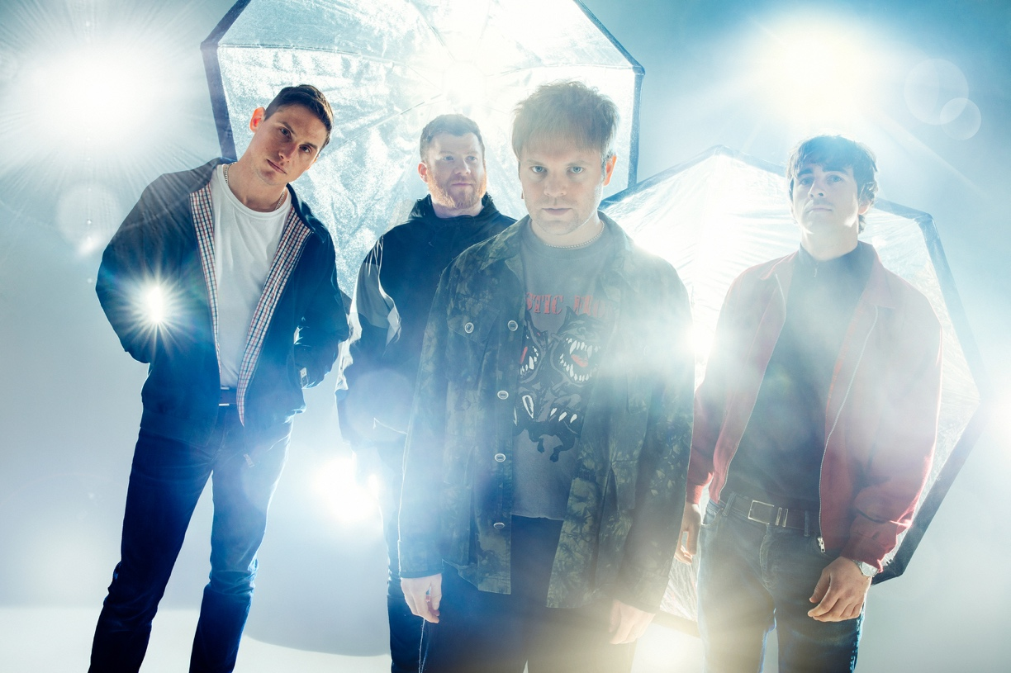
Download high res here. Credit: Tom Martin

‘LIVE AT VADA’ FILM RELEASED ON 16TH JULY

ENTER SHIKARI ALEXANDRA PALACE SELLS OUT, UK WARM UP SHOWS ADDED

ROU REYNOLDS FOURTH BOOK ‘A TREATISE ON POSSIBILITY’ RELEASED 16TH JULY

Enter Shikari will release a film ‘Live At Vada’ on 16th July, filmed recently at Vada Studios (the location of a lot of the tracking for ‘Nothing Is True & Everything Is Possible’), and directed by the band’s visual collaborator Tom Pullen. The live filmed set focuses on tracks from ‘Nothing Is True & Everything Is Possible’ and a selection of songs that are rarely played live, taken from their extensive back catalogue.

‘Live From Vada’ will be available to view for free on Friday 16th July. Watch the trailer here. Sign up for a free ticket here: entershikari.com/vada

There will be four showings of the film starting at 8pm local time available to watch for 4 hours: London, New York, Los Angeles & Sydney (17th July). Tickets are available worldwide for whichever showing suits the viewers needs best, and there is no restriction on how many showings the viewer may attend.

The week following Enter Shikari’s headline set at the Download Festival Pilot (“Enter Shikari reconfirm their status as one of Britain’s best live bands” Kerrang!) saw many of their UK and European tour dates sell out, including London’s 10,000 capacity Alexandra Palace.

Today the band announce four intimate warm up shows in November taking in Exeter, Northampton, Brighton and Bexhill. Tickets go on general sale Friday 9th July at 10am here, although a special pre order is available from Wednesday 7th July at

10am for members of the band’s Future Historians fan club and those who pre ordered ‘Nothing Is True & Everything Is Possible’ or ‘Moratorium’ physical formats via the band’s online store. Full dates and availability below.

Friday 16th July will also see the publication of frontman Rou Reynolds’ new book for Faber Music, ‘A Treatise On Possibility’. The 287 page book features lyrics from ‘Nothing Is True & Everything Is Possible’, plus photos taken during the recording of the album, paired with an extensively researched deep-dive into the themes of the album.

July was also due to be the release date of the 2xLP / 2xCD deluxe editions of ‘Nothing Is True & Everything Is Possible’ and its companion piece ‘Moratorium (Broadcasts From The Interruption)’ but, unfortunately, a perfect storm of Brexit and Covid-19 has seen vinyl pressing plants worldwide suffering delays. The albums physical formats will now be released Friday 27th August, though both albums are already available digitally here.

Full tour dates and availability below:

UK – November 2021 - Warm up shows
Weds 24th - EXETER - Great Hall
Thurs 25th - NORTHAMPTON - Roadmender
Fri 26th - BRIGHTON - Chalk
Sat 27th - BEXHILL De La Warr Pavillion

UK - December 2021
Sat 4th - LONDON - Alexandra Palace - SOLD OUT
Sun 5th - MANCHESTER - O2 Victoria Warehouse – SOLD OUT
Tues 7th - LINCOLN - Engine Shed
Wed 8th - HULL - Asylum
Thur 9th - BRISTOL - O2 Academy - SOLD OUT
Sat 11th - LIVERPOOL - Mountford Hall
Sun 12th - LEEDS - O2 Academy
Mon 13th - EDINBURGH - Usher Hall - SOLD OUT
Wed 15th - BIRMINGHAM - O2 Academy - SOLD OUT
Thur 16th - CARDIFF - Great Hall - SOLD OUT
Fri 17th - SOUTHAMPTON - O2 Guildhall - SOLD OUT
Sun 19th - MIDDLESBROUGH - Town Hall
Mon 20th - NOTTINGHAM - Rock City - SOLD OUT
Tues 21st - NOTTINGHAM - Rock City - SOLD OUT

Tickets available here

Special guests for all UK dates are Dinosaur Pile-Up and Nova Twins.

Official Website | Facebook | Twitter | Instagram

For more information and press enquiries please contact

Jenny Entwistle
Jenny@chuffmedia.com

