

RISING POP PHENOMENON HAIDEN HENDERSON
JOINS 5 SECONDS OF SUMMER ON THE UK LEG OF THEIR EVERYONE’S A STAR! WORLD TOUR

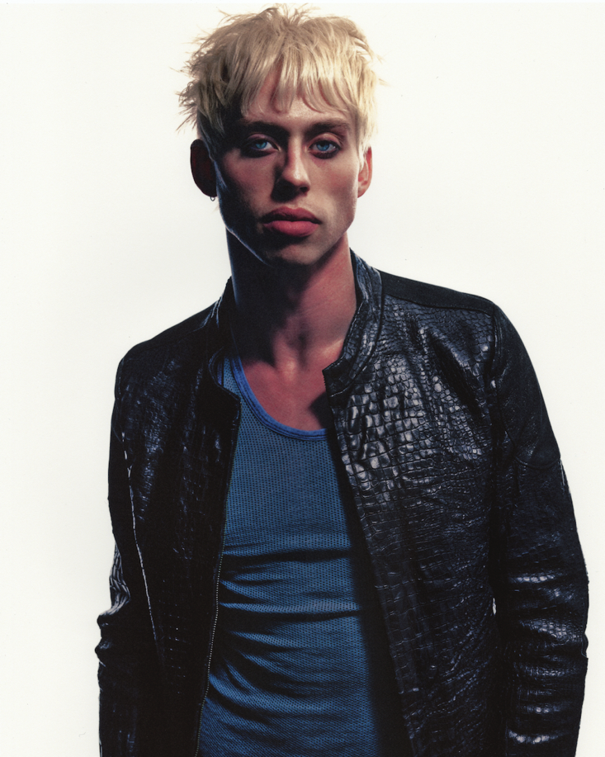
Download Image Here

tension (heightened) Deluxe EP Out Now
Today, Haiden Henderson has been announced to support multiplatinum Australian alt-rock band 5 Seconds of Summer on their EVERYONE’S A STAR! World Tour, joining the band for a string of UK dates, including a night at London’s famous The O2.

The news follows an incredible run for Haiden, coming straight off the back of his first-ever headline run, The Tension Tour, throughout North America, UK and Europe last year. The tour, which saw Haiden performing to a sold-out room at The Garage in London, celebrated the release of his tension EP, a project that has cemented his reputation as one of pop’s most exciting rising voices.

Now, Haiden is planning on taking that raw, emotional energy from packed rooms to arena stages, marking a huge milestone as he brings his electrifying live set to fans across the UK alongside one of the world’s hottest bands.

Haiden shared, “i learned how to sing by watching these guys make cover videos on youtube. i learned how to play guitar by seeing them live. i learned how to write songs by looping their albums. 5 seconds of summer is in the fabric of my artistry and opening for them was destined to happen.”

Dates for the EVERYONE’S A STAR! World Tour with Haiden Henderson can be found below.
Tickets HERE.

Monday 30th March – OVO Hydro, Glasgow
Tuesday 31st March – Utilita Arena, Birmingham
Thursday 2nd April – The O2, London
Saturday 4th April – Co-op Live, Manchester
Sunday 5th April – Utilita Arena, Cardiff

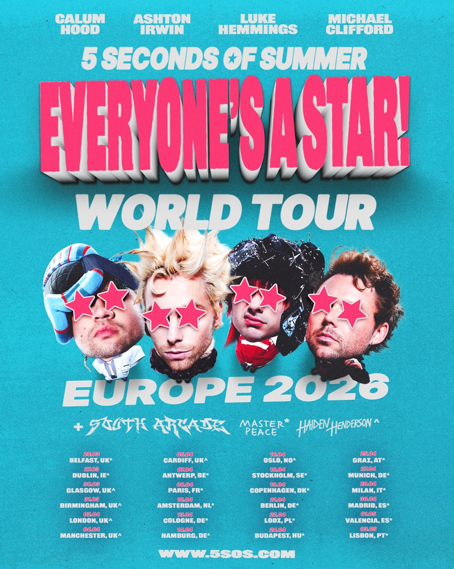
Download Press Assets HERE

ABOUT HAIDEN HENDERSON
By holding nothing back, Haiden Henderson has quietly incited a cult-level of adoration since his emergence in 2021. He initially buzzed with the Good Grief EP [2022] followed by the Choke on My Heart EP [2024] and the lover boy EP [2024]. The latter spawned “hell of a good time,” which popped off to the tune of 25 million streams. He sold out headline shows in addition to sharing stages with everyone from MICO to Landon Barker. Along the way, he received acclaim courtesy of PAPER Magazine, Rolling Stone, Vogue, and more. Simultaneously, he attracted a devout audience of acolytes affectionately dubbed “Haider Nation.” Thus far, he has clocked over 100 million streams, packed houses on tour, and earned tastemaker praise. However, he captivates more than ever before on the 2025 tension EP [LAVA/Republic Records]. Featuring fan favorites “lovesucker,” “lips,” and “sweat,” it sees him sharpen the edges of his signature stadium-size pop with down and dirty D.I.Y. rock ‘n’ roll. This is Haiden at his most unrestrained and undeniable. Experience tension now.
Follow Haiden Henderson:
Instagram | TikTok | YouTube

For more information and press enquiries please contact
Jenny Entwistle
Jenny@chuffmedia.com

