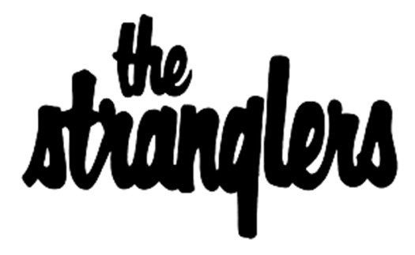
The Stranglers announce ‘51’ Autumn UK Tour 2025

Tour de force of British new-wave The Stranglers marked their 50th anniversary in 2024, and it has been full throttle ever since. This concise run of shows around the UK comes off the back of an unforgettable summer of shows that sees the inimitable quartet performing in front of huge crowds at open air shows at Southampton Guildhall Square, Lincoln Castle, Warwick’s St Nicholas Park and Dreamland, Margate.

The Stranglers’ 50th anniversary year was packed with celebratory sell-out tours across the world and headline slots at festivals worldwide, including a sell-out performance at London’s prestigious Royal Albert Hall. The ’51’ tour celebrates making it past the big five-o, and takes in major towns across the UK culminating in two nights at London’s iconic Roundhouse. The subsequent live album ‘Fifty Years In Black’ made history when it became the band’s 20th top 40 album in the UK.

First formed in 1974, The Stranglers no bullsh*t attitude was embraced by the punk movement of the late 70s. But their musicianship and menace transcended the genre, creating a sound unique to themselves. With their first three albums (Rattus Norvegicus, No More Heroes and Black and White) being released within an astonishing 13 months of each other, scoring hit singles with ‘Peaches’, ‘No More Heroes’ and ‘Walk On By’. Further success was to follow with ‘Always The Sun’, ‘Strange Little Girl’ and the mercurial ‘Golden Brown’, amongst many others, earning the group 24 top 40 singles in a career (so far) spanning six different decades.
The Stranglers’ 2021 album Dark Matters (peaked at #4 in the UK album chart) became the band’s highest charting album since Feline in 1983. This was the last album to feature the mercurial, unmistakable keyboard playing of the late Dave Greenfield, who passed away in 2020 due to Co-Vid related illness. In 2022, the elder-statesman, drummer and founder of the band Jet Black passed away. Testament to the band’s influence on rock music, tributes to Jet poured in from the likes of Duff McKagan (Guns n’ Roses), Ricky Warwick (Thin Lizzy) and Lol Tolhurst (The Cure).

Fans can expect to enjoy the charming interplay of bass playing icon Jean-Jacques Burnel and longest serving guitarist/vocalist Baz Warne co-fronting the band as they navigate their way through a varied set of six decades worth of hits, hidden gems and fan favourites. Cemented ever since the busy ‘Fifty Years In Black’ year, JJ and Baz are joined by mainstay Jim Macaulay on drums and newest member, the harmonically dexterous Toby Hounsham on keyboards.

The Stranglers are proud to welcome Buzzcocks as special guest for the UK tour (excluding Scottish dates). The Bolton-bred kings of the punk scene surely need no introduction after hits like "Ever Fallen in Love” and having a long-running hit music quiz show named after them! Since the tragic loss of songwriter Pete Shelley in 2018, the band, now fronted by co-frontman Steve Diggle, continue to go from strength to strength in Shelley’s memory.

The Stranglers ‘51’ UK Tour 2025
(w/special guest Buzzcocks)
Fri 17 Oct Leeds o2 Academy
Sat 18 Oct Manchester o2 Apollo
Tue 21 Oct Newcastle o2 City Hall
Thu 23 Oct Edinburgh o2 Academy*
Fri 24 Oct Aberdeen Music Hall*
Tue 28 Oct Bristol Beacon
Wed 29 Oct Brighton Dome
Fri 31 Oct London Roundhouse
Sat 1 Nov London Roundhouse

* Excludes Buzzcocks.

Tickets available from gigsandtours.com or ticketmaster.co.uk
For full tour details and more information visit www.thestranglers.co.uk

For more information please contact warren@chuffmedia.com on 07762 130510

