The Stranglers Announce 50th Anniversary UK & Irish Tour
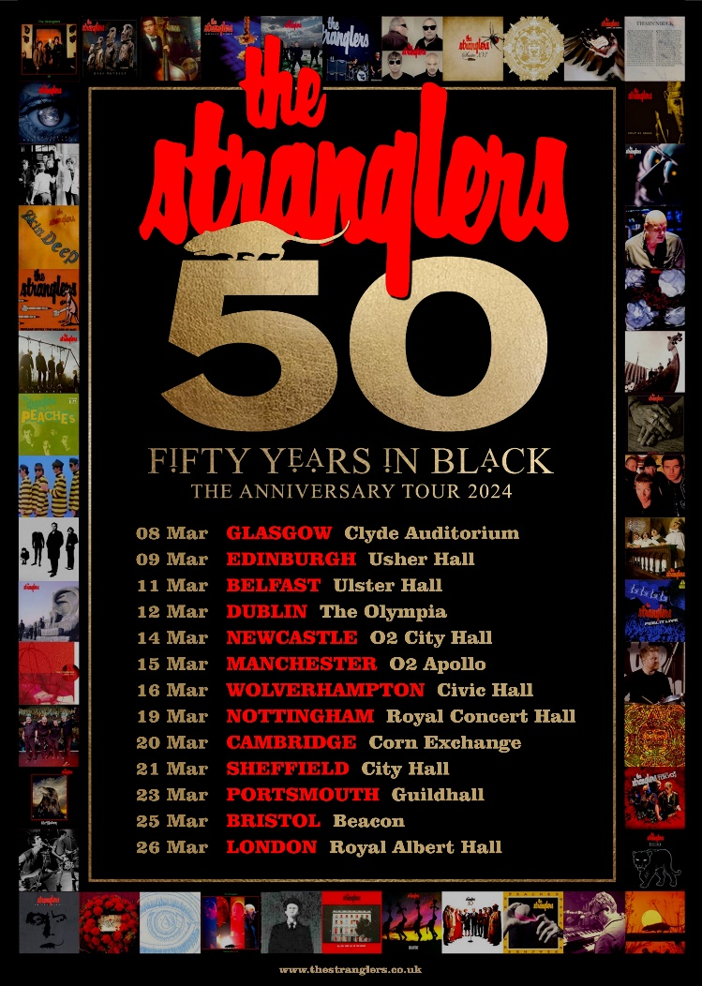

In 2024, The Stranglers, one of the most iconic and influential bands in British music history, are celebrating their 50th year anniversary with the following UK & Irish tour.
Since playing their last full-scale UK tour in 2022, the band has turned their minds to how they would like to celebrate their 50th anniversary with their fans. They have decided to embark on a short tour visiting some truly special and iconic venues to mark their golden anniversary.
First formed in 1974, The Stranglers uncompromising attitude was embraced by the punk movement of the late 70s but their musicianship and menace transcended the genre. They created their own unique sound and achieved over 25 Top 40 singles and 18 Top 40 albums, with their most recent release Dark Matters reaching number 4, their highest UK chart position since Feline in the early 80s and being acclaimed as their best in decades.
The Stranglers plan to make these milestone anniversary shows extra special with two sets featuring songs from the band's inception through to the present, showcasing their unique fifty year career. These truly special events will be unmissable for fans of the Meninblack.
Tour Dates:

08 Mar - GLASGOW Clyde Auditorium
09 Mar - EDINBURGH Usher Hall
11 Mar - BELFAST Ulster Hall
12 Mar - DUBLIN 3Olympia
14 Mar - NEWCASTLE 02 City Hall
15 Mar - MANCHESTER 02 Apollo
16 Mar - WOLVERHAMPTON Civic Hall
19 Mar - NOTTINGHAM Royal Concert Hall
20 Mar - CAMBRIDGE Corn Exchange
21 Mar - SHEFFIELD City Hall
23 Mar - PORTSMOUTH Guildhall
25 Mar - BRISTOL Beacon
26 Mar - LONDON Royal Albert Hall

Tickets for The Stranglers' 50th Anniversary UK Tour will go on sale on 19th May.
Don't miss out on this once-in-a-lifetime opportunity to celebrate one of the greatest bands in British music history on their 50th anniversary tour

For more info contact Warren warren@chuffmedia.com

