

ANNOUNCE SPRING 2026 UK + EUROPE HEADLINE TOUR IN

FOLLOWING SOLD-OUT DEBUT UK + IRELAND TOUR THIS OCT + ACCLAIMED DEBUT EP ‘SIREN’

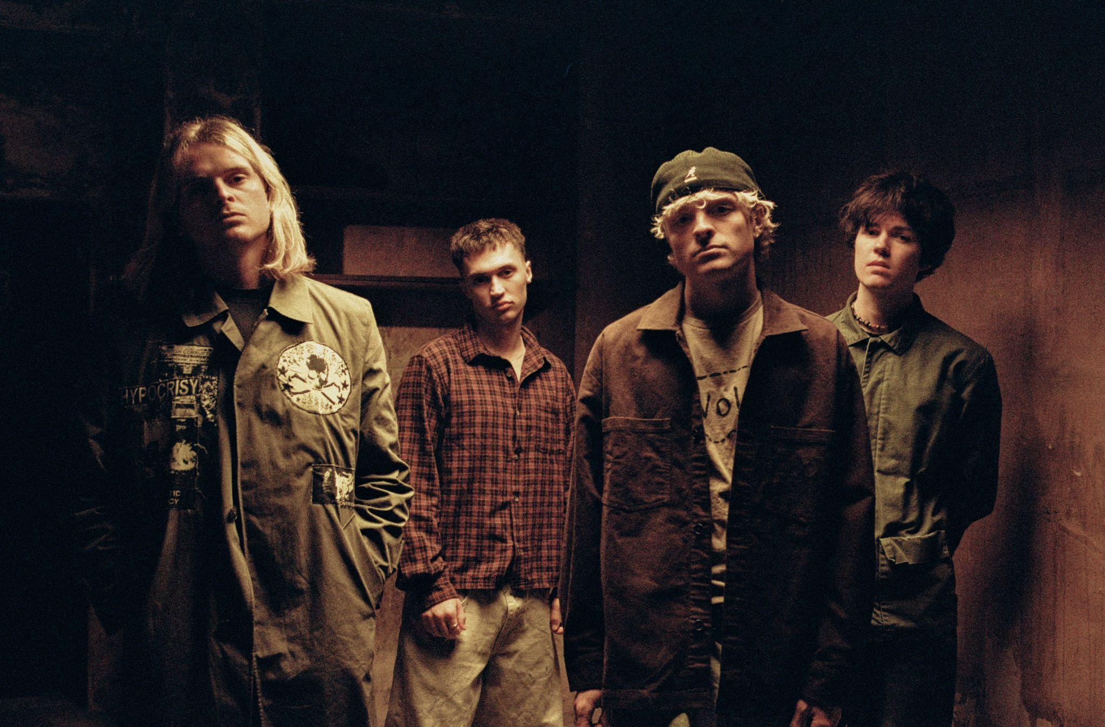
Photo credit: Hermione Sylvester

“A sound that has given UK guitar its biggest kick up the fretboard in years." - Rolling Stone UK
“Siren is a sensation” - Clash
“They seem to be scratching a long-unfulfilled itch.” - DIY
“Built on belief, buzz and bloody good songs…Keo are already that band” - DORK
Some artists don’t ask permission, they just land in your gut and stay there. Rising London four-piece Keo have spent the past year proving they belong firmly in the latter camp. After a breakout 2025 that saw their debut EP Siren captivate critics and fans alike, and their first October UK + Ireland tour sell out entirely, Keo now announce their most ambitious chapter yet: a 14-date headline tour spanning March and April 2026, that marks their biggest shows to date and their first step onto European stages.
Since the release of Siren, Keo have fast become one of the UK’s most visceral and uncompromising new bands. Across five tracks, from the blistering honesty of debut single ‘I Lied, Amber’ to the aching centrepiece ‘Hands’, 21-year-old frontman Finn Keogh led listeners through the emotional wreckage of youth, identity, and recovery with a rawness that resonated far beyond expectation. Support from Rolling Stone UK, NME, Wonderland, DIY, Dork, Clash, alongside spins across BBC Radio 1 and more, propelled the band from London’s underground to sold-out rooms and festival stages across the UK.
LISTEN TO ‘SIREN EP’ | LISTEN TO ‘HANDS’
Live shows have become at the heart of Keo’s story. Their debut headline run sold out in seconds, with over 5,000 tickets sold across the UK and Ireland in just hours. This Summer saw record-setting crowds at Reading & Leeds Festival, where the band drew the biggest audiences the BBC Introducing Stage has ever seen.
Now, Keo are scaling up for their biggest headline tour to date. The 14-date run kicks off in Birmingham on 5th March, 2026, before hitting major cities across the UK, Ireland, and Europe, including Manchester’s O2 Ritz, Glasgow’s SWG3, and a career-defining London show at the Electric Ballroom. From there, the band cross the Channel for their European shows, with stops in Berlin, Paris, Cologne, and Amsterdam, before wrapping in Antwerp.
“To be playing venues like these with only five songs out still feels surreal” comments Finn. “We always imagined we’d reach this level after years of supporting other bands, but somehow we’ve skipped that step. It’s mad, come March, our biggest indoor shows will have been our own. Electric Ballroom is a special one for me personally; I’ve seen some life-changing gigs there. To be on that stage this time around is going to feel unreal.”
While ‘Siren’ captured Keo’s first chapter, a raw portrait of youth in flux, the next promises something bigger and braver. With their announcement of their Spring 2026 tour across the UK, Ireland, and Europe, recent signing to Island Records and hints of new music on the horizon, Keo are stepping firmly into their next phase.

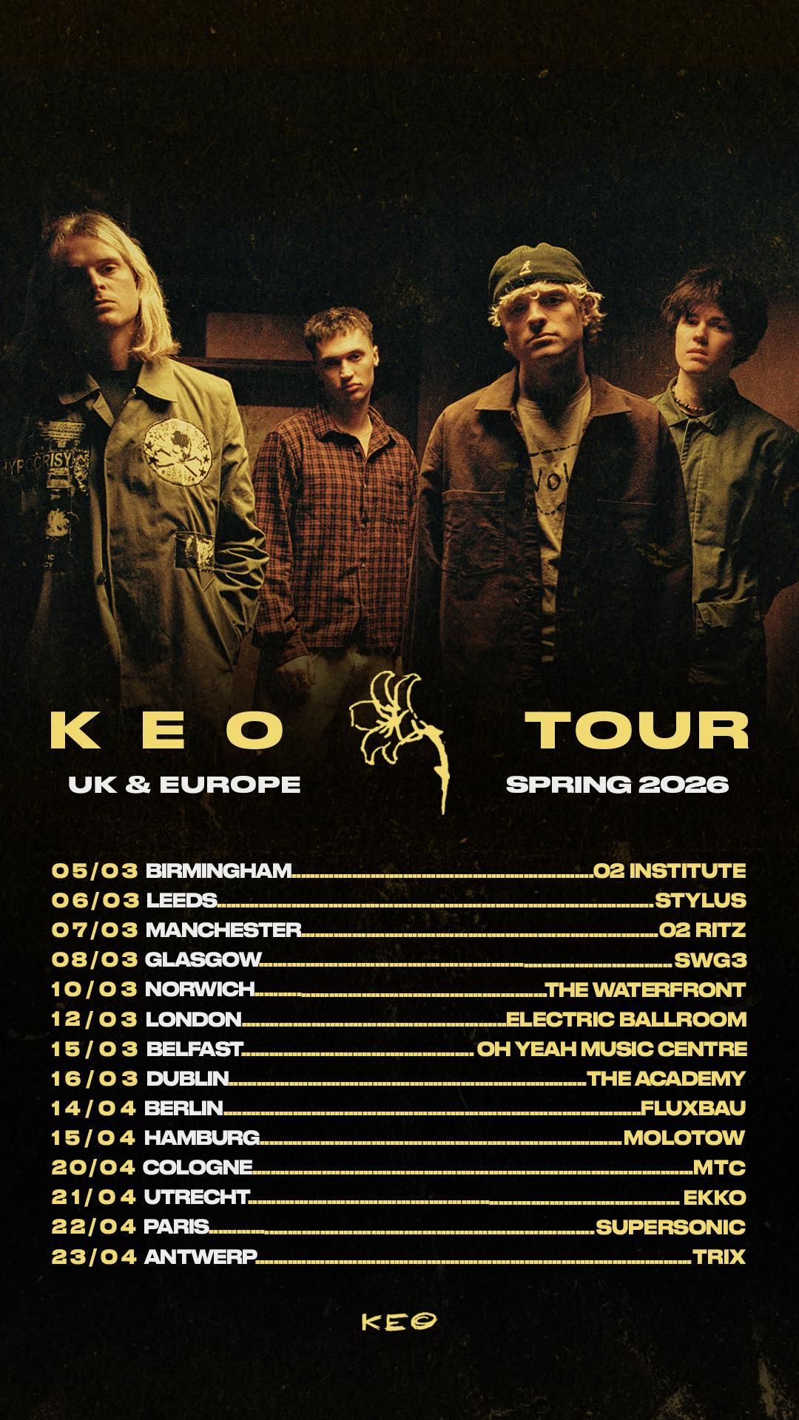

KEO SPRING 2026 UK & EUROPE TOUR DATES
March 2026
05/03 Birmingham, UK O2 Institute
06/03 Leeds, UK Stylus
07/03 Manchester, UK O2 Ritz
08/03 Glasgow, UK SWG3
10/03 Norwich, UK The Waterfront
12/03 London, UK Electric Ballroom
15/03 Belfast, UK Oh Yeah Music Centre
16/03 Dublin, IE The Academy

Further Praise for Keo:

"Keo has roused indie rock fans up and down the country, all looking for a new band to believe in." - Clash
"Keo's uncompromising raw sound is winning them fans in all the right places" - Rolling Stone UK
“This young band isn’t just one to watch, but one to follow closely.” - The Indie Scene

Keep up with Keo: Instagram / TikTok / YouTube / Facebook

For more information and press enquiries please contact
Warren & Harry
@chuffmedia.com

