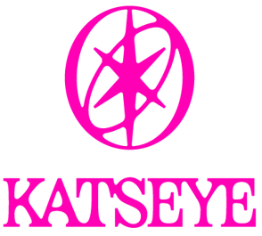

ANNOUNCES 2026 HEADLINE ARENA TOUR INCLUDING TWO DATES IN THE UK

TICKETS FOR KATSEYE: THE WILDWORLD TOUR GO ON SALE THURSDAY, MAY 21

NEW EP, WILD, SET FOR AUGUST 14 RELEASE VIA HYBE x GEFFEN RECORDS

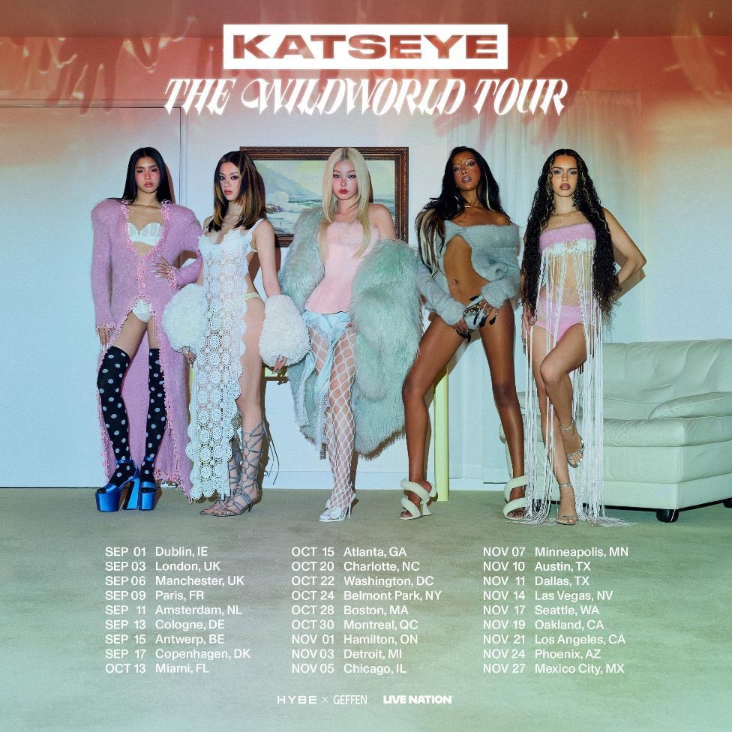
Download KATSEYE tour art here

Today, KATSEYE announced the WILDWORLD TOUR, a headline outing that will take the global girl group to arenas across the UK, Europe and North America this fall. Produced by Live Nation, the run will kick off on September 1 at Dublin’s 3Arena. The North American leg will launch October 13 in Miami, FL at Kaseya Center and include shows at UBS Arena in Belmont Park, NY (October 24) and Los Angeles’ Crypto.com Arena (November 21). The tour will conclude at Palacio de los Deportes in Mexico City on November 27. See below for itinerary.

Tickets will first be available starting with a Weverse Artist Presale (details below) beginning Wednesday, May 20, at 11:00 AM local time, followed by the Katseye.World Presale at 3:00 PM local time. The general on sale begins Thursday, May 21, at 3:00 PM local time at www.katseye.world.

The Weverse Artist Presale, available to paid Weverse membership holders, will take place on Wednesday, May 20, from 11:00 AM – 2:00 PM local time. Weverse membership holders must apply for the presale link HERE from today through Sunday, May 17, at 2:00 PM PT in order to participate.

The WILDWORLD TOUR will also offer VIP experiences to take your concert experience to the next level, available for purchase via KATSEYE Weverse Shop (EU, UK, MX, CA) and KATSEYE’s Official Store (US, with the exception of Las Vegas), beginning Thursday, May 21.

For the Europe and UK dates, fans can also register for presale access by pre-ordering KATSEYE's new EP WILD or by signing up—no purchase necessary. Those already preordered will automatically receive a code. This presale will take place on Wednesday, May 20, from 3:00 PM - 10:00PM local time.

On Monday, May 25, KATSEYE will perform at the 52nd American Music Awards, airing live from Las Vegas. The group is nominated in three categories – New Artist of the Year, Best Music Video (for “Gnarly”) and Breakthrough Pop Artist. Fan voting is now open via VoteAMAs.com and the @AMAs Instagram profile in all award categories.

Coinciding with the release of WILD, their third EP, KATSEYE will perform at the Citi Concert Series on “TODAY” on August 14. Releasing via HYBE x Geffen Records. WILD is the follow-up to the GRAMMY®-nominated group’s 2025 EP BEAUTIFUL CHAOS, (HYBE x Geffen Records), which debuted in the top five of the Billboard 200. Pre-save / pre-order WILD HERE.

Last month, the group made its Coachella debut to stellar reviews, with Rolling Stone, Pitchfork and numerous other publications hailing their performance among the best of Weekend One. The Los Angeles Times said, “[KATSEYE] proved no this ain’t their debut at their first Coachella performance…the girl group packed the festival field with Eyekons packed shoulder to shoulder as far as the Do LaB.” “Entertainment Tonight” highlighted their Weekend Two performance of “Gabriela,” noting “KATSEYE serves powerful vocals…” while “Extra TV” said, “In a word… gnarly!...The ladies brought it to the desert once again to perform for their #Eyekons!” Rolling Stone included the group in the feature “What Would Coachella Be Without Pop Girls?”

Formed through HYBE and Geffen Records’ Dream Academy and Netflix’s Pop Star Academy, KATSEYE’s members hail from across the U.S., Europe, Asia, and beyond, bringing a truly international perspective to pop culture. 2025 was a breakout year that saw KATSEYE crowned TikTok’s Global Artist of the Year and earn two GRAMMY nominations for Best New Artist and Best Pop Duo/Group Performance for “Gabriela.” Their latest single, the edgy, high-energy “PINKY UP,” expands the world KATSEYE has been building – confident, playful and always pushing pop forward. The song, which received its live debut at Coachella, turns chaos into celebration, capturing the group’s unmistakable energy and momentum.

KATSEYE - WILDWORLD TOUR UK
9/3 – London, UK – The O2
9/6 – Manchester, UK – Co-Op Live

Keep up with Katseye: Instagram / TikTok / YouTube / Facebook / Website

For more information and press enquiries please contact
warren@chuffmedia.com

