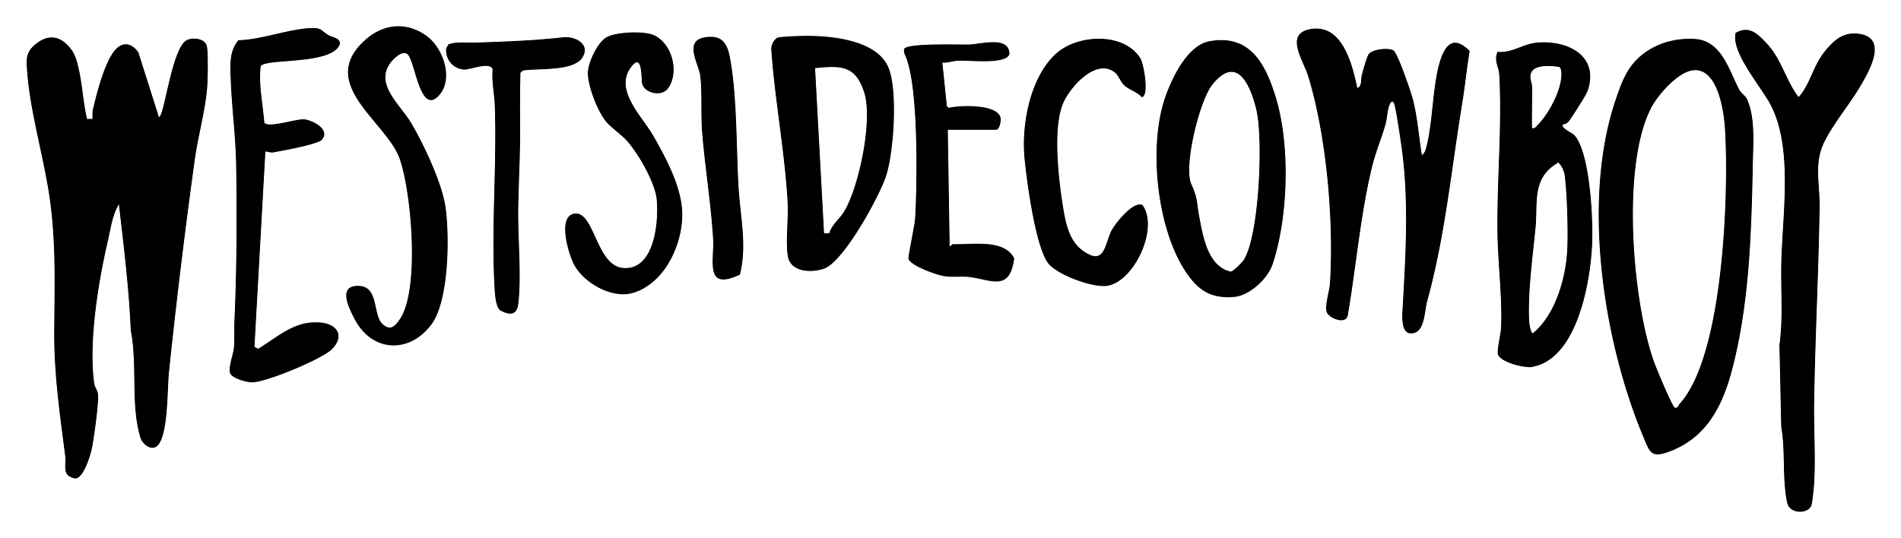
Westside Cowboy sign to Island Records imprint Adventure Recordings
Announce new EP So Much Country ‘Till We Get There for January 16th
New single ‘Don’t Throw Rocks’ out now

Headline tour November ’25 and January & February ‘26 ft.
London’s iconic Scala

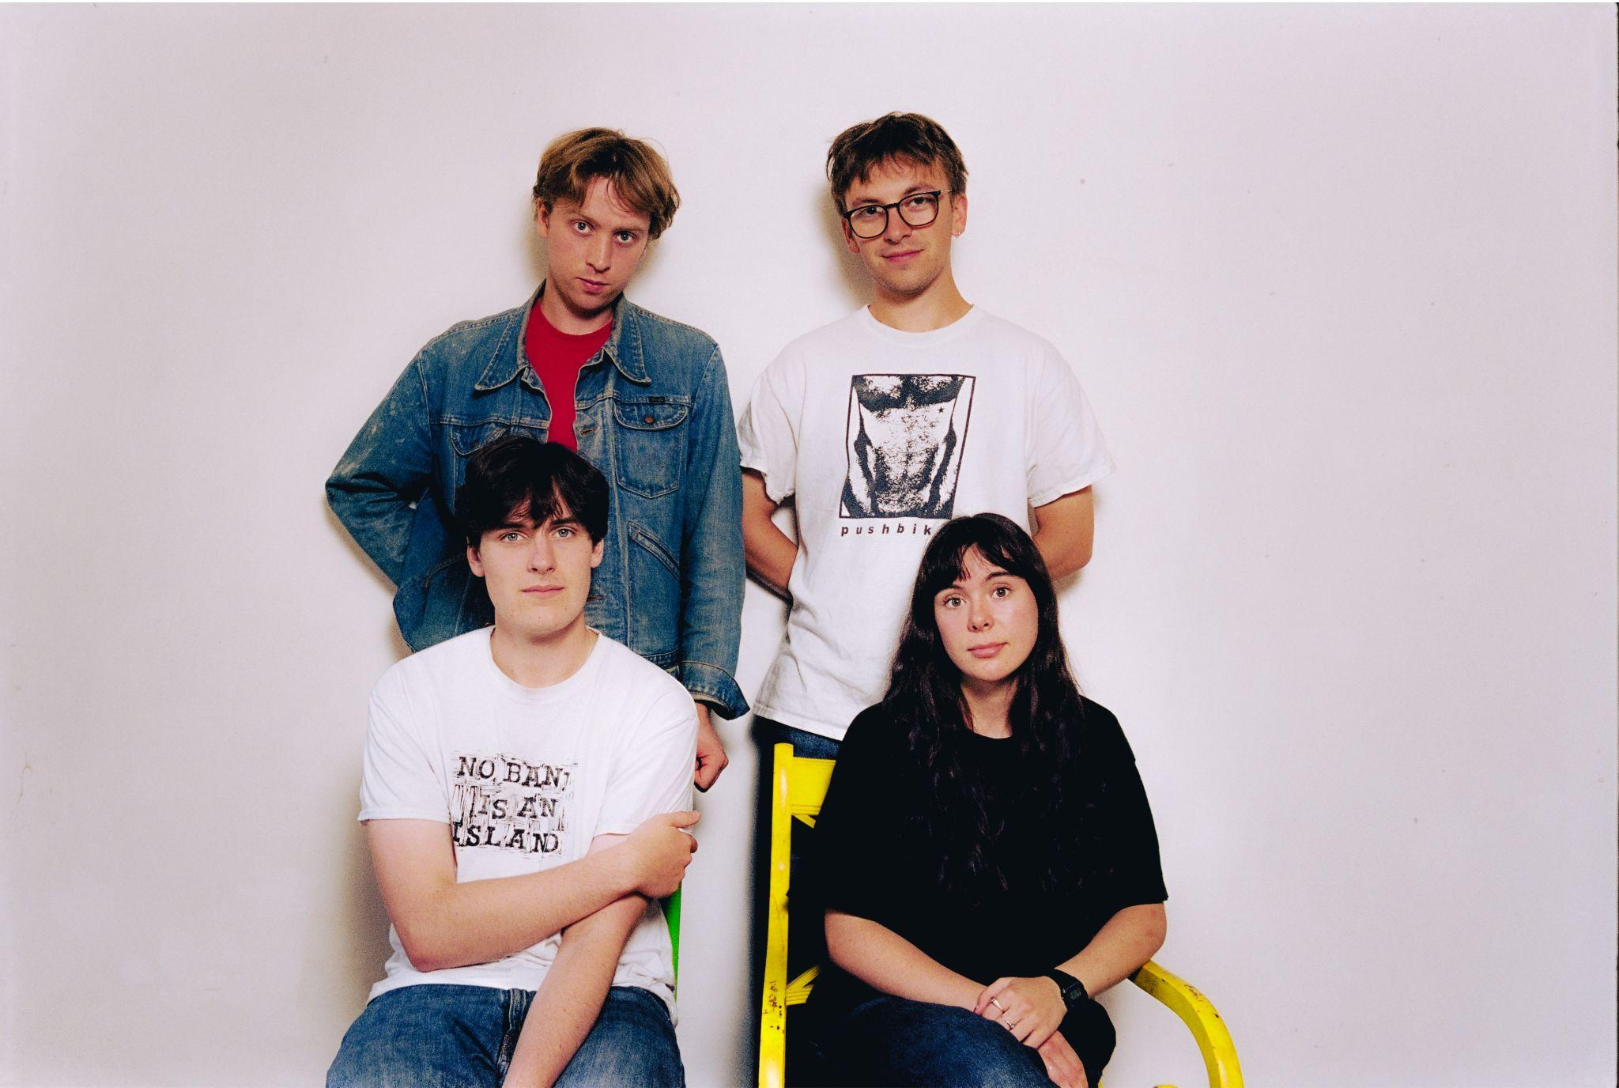
Photo Credit: Charlie Barclay Harris

Select Acclaim for Westside Cowboy:
“Thrilling - marked by a mood of ramshackle invention at odds with the studied, polished air of a lot of current alt-rock” Alexis Petridis - The Guardian

“Come for the urgent, wistful guitars, and stay for the heart-wrenching harmonies” Stereogum
“Rapidly climbing the rungs and notching up the wins, Westside Cowboy are the buzzy Britainicana newcomers determined to let down the ladder behind them” DIY
“One of the new acts heralding a gloriously ramshackle new era of ’90s-styled slacker rock” NME
–

Westside Cowboy sign to Island Records imprint Adventure Recordings and announce their second EP So Much Country ‘Till We Get There for release on January 16th. Live favourite ‘Don’t Throw Rocks’ is out now as the first taste of this sophomore effort following its premiere on BBC 6 Music by Huw Stephens.

It was recorded with Loren Humphreys in New York, who brought the same studio magic to the quartet’s self-styled ‘Britainicana’ sound as he has for Cameron Winter’s acclaimed Heavy Metal LP (alongside credits for Arctic Monkeys, Lana Del Rey, Wunderhorse and more).

Draped in golden hour nostalgia, ‘Don’t Throw Rocks’ embeds itself under your skin right from the initial guitar twinkles, before Jimmy Murphy and Aofie Anson O’Connell’s harmonies coalesce into a lead vocal which subtly grips hold of the listener. On the origins and themes of the track, the band say:

“This started life as a fuzzy drum machine demo that Jimmy made in his bedroom and eventually made its way into the practice room ahead of our first headline at Castle Hotel.

We tried it really fast and loud, with a new order disco beat across the entire thing basically. We finished it and were like ‘ This is good, right?’... none of us were really convinced. We were about to call it when we thought we’d have one last go. We kept the tempo but took the emphasis off of the snare and hats and instead onto the floor tom and its rims. This changed the feeling of the song a lot. All of a sudden, instead the song just being this 2 minute fog horn blare, it was now rumbling along and building.

Jimmy’s lyrics on this deal a lot in time and change, and how it, more often than not, moves out of our control and without niceties. We wanted the music to reflect this too. With each section, we wanted to add a new gear, to increase the intensity until it couldn’t be held onto anymore. I guess that’s where the outro comes in. This felt like the natural first single for So Much Country…, we all kinda knew once we’d heard it back.”

Much of the group’s reputation as leaders of a vital new wave of UK bands has come from a scintillating live set - which is already establishing an immersive mythos, replete with ‘I was there’ credentials, and if-you-know-you-know moments. Packed out stages at Glastonbury, Green Man, End of The Road and more is evidence of an outfit striking at the core of the scene.

The show is being taken on the road in support of Black Country, New Road through mainland Europe in October, before a string of headline dates through the UK and Ireland in November and January - featuring their biggest headline show so far at London’s Scala.

Around the release of debut EP This Better Be Something Great in August the band earned no shortage of admirers - personal invites to support English Teacher, Ezra Furman, mary in the junkyard, and Blondshell matched with early press praise from the likes of The Guardian, Stereogum, Uncut, NME, DIY, DORK, So Young, The Line Of Best Fit, Clash, Rolling Stone UK, Rough Trade and Paste. The four-piece have also landed primary support from Huw Stephens, Steve Lamacq, Nick Grimshaw, Lauren Laverne, Craig Charles, Deb Grant, Nathan Shepherd, Emily Pilbeam (BBC 6 Music) and Sian Eleri and Alyx Holcombe (BBC Radio 1), Jo Whiley (BBC Radio 2), Matt Wilkinson (Apple Music), KEXP and John Kennedy (Radio X).

Westside Cowboy’s second EP So Much Country ‘Till We Get There is out via Adventure Recordings on January 16th. ‘Don’t Throw Rocks’ is out now.

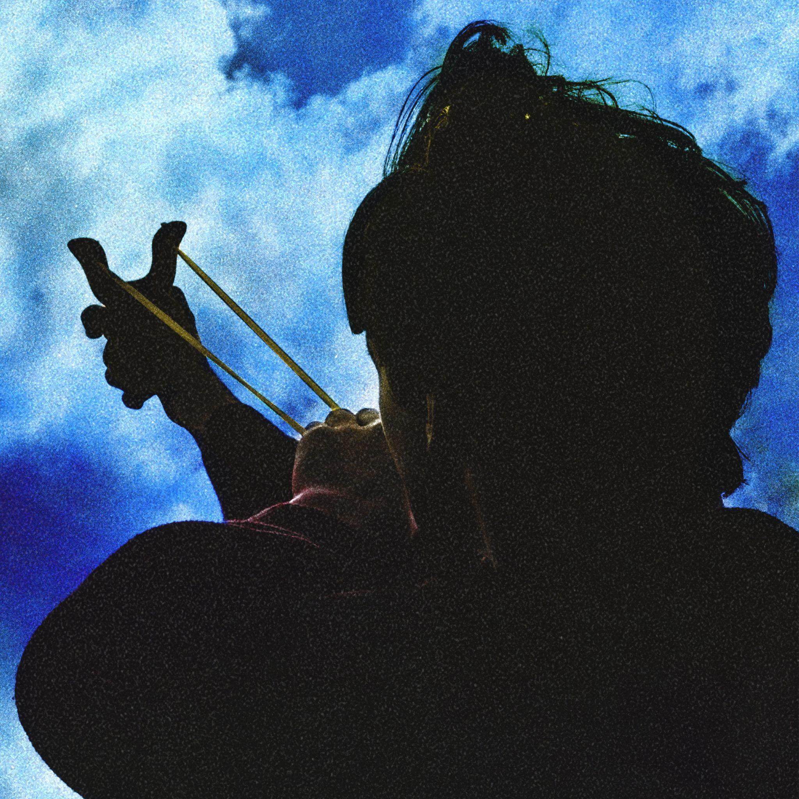
So Much Country ‘Till We Get There EP Artwork

2025/26 Live Dates
18 Nov - Norwich, Norwich Arts Centre
19 Nov - Birmingham, The Sunflower Lounge (Sold Out)
21 Nov - Cardiff, Clwb Ifor Bach (Sold Out)
22 Nov - Portsmouth, KOLA
25 Nov - Birkenhead, Future Yard
26 Nov - Hebden Bridge, The Trades Club (Sold Out)
27 Nov - York, The Crescent
28 Nov - Edinburgh, Cabaret Voltaire
28 Jan - London, Scala
29 Jan - Manchester, Gorilla
31 Jan - Dublin, Grand Social
2 Feb - Glasgow, King Tuts
3 Feb - Leeds, Brudenell Social Club
4 Feb - Nottingham, Bodega
6 Feb - Bristol, The Exchange
7 Feb - Brighton, The Hope and Ruin (Sold Out)
8 Feb - Oxford, The Bullingdon

